TEACHER EDUCATION FOR INCLUSION COUNTRY REPORT
AUSTRIA
1. Details about the authors
Report completed by: Ewald Feyerer, Irene Moser and Claudia Niedermair supported by Ivo Brunner and Lucie Bauer.
Author’s role/job title:
Ewald Feyerer: Head of the Institute of Inclusive Education, Intercultural Learning, Innovative Teaching- and Learning Culture at the Teacher Training College of Upper Austria, Linz
Irene Moser: National Co-ordinator, European Agency for Development in Special Needs Education/Teacher Training College of Salzburg
Claudia Niedermair: Teacher at Teacher Training College of Vorarlberg
Ivo Brunner: Head of Teacher Training College of Vorarlberg
Lucie Bauer: Representative Board member, European Agency for Development in Special Needs Education/Federal Ministry of Education (BMUKK)
Date: 15.03.2010
2. Wider policy framework supporting teacher education
Today, Austria can look back on a long tradition of inclusive schooling of pupils with special educational needs (SEN). We have solid data records that allow us to describe what needs to be changed, and make suggestions to improve the quality of inclusion (cf. Feyerer 2009).
Apart from their focus on educational standards, current educational policies are focused on the pilot project of the ‘New Intermediate School’. To this end, an expert commission produced two reports which aim to further develop the educational system towards more inclusive schools. As an example of this, we would like to quote from the ‘Categories for redesigning school and the educational system’ which aims at barrier-free inclusion of all pupils in a high-quality, all-embracing educational process:
- optimal quality of education for everybody – everyone has the right to ‘his or her’ education;
- generally comparable educational opportunities and accessibility to education for everybody;
- promotion of all talents, gifts and interests;
- commitment to performance, inclusion and compensation of top quality plus ‘we leave no one behind’;
- obligatory cross-sectional agendas embracing aspects of gender, inclusion of affected and involved persons, integration, inclusion, diversity and intercultural dimensions (bm:ukk 2007, 14).
The expert commission has also formulated principles and criteria supporting inclusive schools which serve as benchmarks for successful school reform (see ibid.18):
- all talents, gifts, potential and interests are recognised and taken seriously, appreciated and promoted;
- premature selection shall be avoided;
- school shall not seek failures and deficits, but develop individual learning programmes and support offers, and increase differentiation and permeability (course systems) etc.;
- ‘multi-professional’ support systems shall be developed which deal with problems directly where and when they appear.
The UN Convention on the Rights of Persons with Disabilities was ratified by Austria, including its Optional Protocol, in October of 2008. Up to now, this has been afforded little notice within the educational-political discourse. However, in a welcoming speech at a conference of inclusion scholars from the German speaking countries, the Austrian Minister of Education clearly committed herself to inclusion and the necessary further development of the school system:
‘We must not leave any child or adolescent behind or exclude them—neither because of educational reasons, nor due to social or economic reasons. (...) Even if we have already put into practice several important claims of the Convention in the Austrian school system through joint education in primary and lower secondary school for many years, we must seek not only further quality improvement in this field, but also elaborate the structural and organisational development of school to promote inclusive settings of education’.
In 2009, the Minister of Education and the Minister of Science commissioned a work group to produce wide-ranging, general recommendations for concerted teacher education. These rather general recommendations also included inclusive pedagogy, diversity management, German as a second language, and called for a sound balance of generalists and specialists employed in these fields.
The guiding concepts of the Austrian education system are established on several levels: in diverse school acts (as general educational objectives) and more precisely in the curricula. Specifically in the general didactic principles of primary school, in the guiding concepts of the curriculum of secondary school and in the educational principles, guiding concepts of inclusion have been formulated in a relatively clear way. Below, you can find those that seem to be relevant to inclusion.
Legal Principles – Selected Milestones
- Ratification of the UN Convention on the Rights of Persons with Disabilities by the Austrian Parliament in October 2008;
- National objective and non-discrimination clause in the Austria Federal Constitution: ‘No person may be discriminated against because of his or her disability. The Republic (Federation, Provinces and Municipalities) commit themselves to guarantee equal treatment of persons with and without disabilities in all areas of everyday life’. (Federal Constitutional Act, Article 7, 1997);
- The Federal Act on Non-Discrimination Against Persons with Disabilities (BGStG 2005) provides protection against discrimination, and bans discrimination against persons with disabilities by law.
School Organisation Act
- Primary School: Sec. 9/2: Primary school is to provide joint elementary education of all pupils in the first four grades, taking into account social inclusion of children with disabilities.
- Secondary School: Sec. 15/3: Complying with the principle of social inclusion, pupils with special educational needs shall be given education in compliance with the tasks of special school (Section 22), taking into account the educational requirements of the pupil so that he or she can attain the educational objectives of secondary school.
- General High Schools: Sec. 39 (3): On the junior level of general high school, the curriculum of general high school is applied insofar as it can be expected that the educational objectives of the respective subject are generally attained without overtaxing the child; moreover, the curriculum of special school corresponding to the respective disability is applied.
Decree by the Ministry of Education, Arts and Culture: Circular Note No. 18/2008: ‘Guidelines for the implementation and monitoring of quality standards in inclusive education of pupils with special educational needs’.
Compulsory School Act
- Section 8a. (1) Children of school-age with special educational needs are entitled to receive their compulsory education either in a special school or special school class appropriate for them or in a primary school, secondary school or junior level of a general high school (AHS) (para 2, last sentence) which complies with the regulations for SEN standards (...);
- (2) (...) If the parents or legal guardians wish their child to attend a primary school, secondary school or junior level of a general high school, the District School Board is to inform them on which is the nearest mainstream school that complies with their child’s special educational needs.
Curricula
The comprehensive educational mandate of primary school aims at the individual promotion of every child (joint elementary education considering children with disabilities). This shall provide a fundamental and balanced education embracing the emotional, social, intellectual and physical aspects of a personality. (Curriculum of primary school). This diversity shall be attained by balancing diverse methods of learning and teaching – within a continuum of teacher-centred to autonomous learning arrangements.
‘School provides experiences and activities in a multifaceted way – to pupils, teachers and parents. School reaches far beyond education. Apart from topical learning, school also always provides social learning in manifold ways and situations. This will be the case in particular when children with diverse educational requirements or children with disabilities (with identified special educational needs) or other needs are educated jointly’.
Inclusion: Inclusion of children with SEN is enshrined in all curricula (of primary school, secondary school and high school).
Intercultural learning is an important principle of both primary and lower secondary education. Here, social changes are accounted for (internationalisation of the economy, the process of European integration, migration movements):
‘In this context, cosmopolitanism becomes especially important when dealing with one’s regional, Austrian and European identity. Acceptance and mutual respect are important educational objectives, especially within intercultural learning. When pupils with various cultural backgrounds – for example, different mother tongues – are educated jointly, confident usage of the language of education and encounters of different cultures in everyday life become equally important’. Guiding principles of the curriculum of secondary school.
Participation – opportunities for co-determination and active participation. Participation in society is practised by democratic interaction at school.
‘Actively taking opportunities of democratic participation in diverse areas of life and society requires the ability to make up one’s own mind with regard to judgements based on knowledge and values and to take social responsibility. In order to develop these abilities, self-confidence and autonomous and self-organised learning and acting is to be highly promoted’.Guiding principles of the curriculum of secondary school.
Gender Mainstreaming as an educational principle featuring ‘education towards equal treatment’: This principle was established as the didactic principle of ‘conscious co-education’ in the year 2000 for secondary schools and general high schools.
‘Gender Mainstreaming at school means to establish the gender perspective in all areas of education and learning, in school organisation and in the acting of all involved, to allow gender-equitable learning’. (bmukk, Action Plan 2003)
As already mentioned above, the Ministries of Education and Science have commissioned an expert group to produce a position paper on the restructuring of teacher training. The final paper will be published and then discussed on a broad basis soon. At this moment, it cannot be forecasted what impacts it will have on the future.
3. Initial Teacher Education
First of all, it is important to point out that the Austrian teacher education system is a two-tier system: compulsory school teachers (primary, secondary, special school) are educated at teacher training colleges, high school teachers (junior and senior level) at universities. Since in Austria, there is virtually no inclusion of children and adolescents with disabilities at high schools and other types of schools of higher secondary education, the discussion on the enshrinement of inclusion in teacher education is rather confined to the teacher training colleges. This is why the present country report is focused on the field of teacher training for compulsory schools in Austria.
- Entry to teacher education
By regulation, the study commissions shall agree on the necessary qualifying requirements (Sec. 3, para 3). They shall in particular ‘specify the requirements for general personal qualification to work as a teacher complying with para 1 clause 1 in a way that no reasons are given in the person of the applicant for admission that would conflict with working as a teacher even after successful completion of teacher training’. (…) (Regulation on Accreditation to University (HZV) from Mai 15, 2007)
Entry requirements are:
- basic personal qualifications;
- knowledge of the German language (written and spoken), speech and voice power;
- musical and rhythmic qualification for primary and special school;
- physical and motor qualification.
The study commissions at the teacher training colleges have developed diverse procedures to assess the qualification of future teachers (on the basis of Section 3/HZV). Apart from the procedures to assess the professional qualification, the individual qualification and counselling interview (Sec 5/2) plays an important role. There are currently no data available, about whether and to what extent it is possible in these interviews to go into detail on the future field of activity and the heterogeneity of pupils that is to be expected.
In the framework of the information and orientation workshops (Sec 5/1 HZV), students get an overview of the diverse practical scope of activities of teachers.
The currently applied entry requirements give rise to several questions with regard to teacher education for inclusion, which must be subjected to fundamental clarification:
Physical and motor qualification: in its current version, this requirement entails discrimination against persons with physical disabilities and excludes persons with physical or sensory disabilities – who could actually assume important tasks in inclusive settings as ‘role models’.
Written and spoken knowledge of the German language: also this requirement obstructs students with migrant backgrounds and good, but not impeccable command of written and spoken German, in becoming a teacher. This is, in particular, the case in primary and special school teacher education, since these are carried out along the class teacher principle, with German being an integral part. Students with a migrant background rather opt for – if at all – becoming teachers at lower secondary school.
- Models of initial teacher education
In the interdisciplinary module of ‘Inclusion’ the conveyed contents and applied education methods have positive impacts on the students’ attitude towards joint education (Feyerer 2006). During the self-awareness project at the teacher training college of Salzburg (see Section 7) students have reported sustainable effects on their attitudes towards persons with disabilities. Marginal groups of society are perceived more as a natural part of society than was the case before the seminar had taken place.
In ‘school-practical studies’ at many teacher training facilities, students get the opportunity to work in a team with colleagues (of other fields of study) in inclusive classes. Gathering experience with quite heterogeneous pupil groups, teamwork, dealing with process-oriented support diagnoses and alternative assessment are great challenges for the students. They get the opportunity to get to know and apply pupil-centred forms of learning such as project education and workshop teaching. At the Teacher Training College of Salzburg, for example, student teams in their 6th semester carry out a project which is prepared by their professors in a seminar and subjected to diligent briefing and debriefing in their practical work.
At some training locations, students experience their training in classes comprising several grades with pupils with SEN or migrant backgrounds. They practise individual support options, apply co-operative learning methods and look into social processes within the group.
Educators at teacher training colleges are not obliged to apply methods that promote inclusion, such as various forms of education, autonomous learning, problem-solving methods etc. in their student groups. Freedom in teaching still permits methods of lecturing. Although team teaching during training would promote the team competences of students, the teacher training colleges offer teams as a model only to a certain extent. The reasons for this are in particular the difficulties in financing double staffing.
In the field of inclusive pedagogy at teacher training colleges, subject didactics experts, human science experts and experts from outside school often co-operate. At some colleges the collaboration within the modules is structurally well implemented, at others it is up to the voluntary participation of the teaching staff.
- The initial teacher education curriculum
The basis for the content of initial teacher education programmes is the Regulation on University Curricula (Hochschul-Curricula-Verordnung (HCV 2006)). It regulates the principles of organisation, and gives a compulsory framework for the areas of study (human sciences 39 ECTS, specialised subjects and specialised didactics 84, school-practical studies 36, ancillary studies 12, and bachelor thesis 9 ECTS). Within these guidelines the study commissions decide on the content of the curricula. Depending on the culture and tradition of the respective college, teacher educators have more or less autonomy/participation with regard to content.
The general educational objective of the Regulation on University Curricula (Sec 3/2) lists a series of foci with regard to content that essentially coincide with the guidelines mentioned below:
Sec 3 (1): Study programmes are to be organised as academically founded and occupationally related university studies, taking into account the social, pedagogical, economic, technological and educational developments. They must further pay attention to requirements such as, in particular, life-long learning, inclusive pedagogy, modern languages, German as a second language, individualisation and differentiation in education, support didactics, media pedagogy, application of modern information and communication technologies, acquisition of competences in e-learning, international, European and intercultural contexts, gender mainstreaming, promotion of social competences, inclusion of persons with disabilities and promotion of gifted and highly gifted children.
Moreover, in 2006, the Ministry of Education elaborated a position paper on ‘The Occupational Field of Special and Inclusive Education’ for initial and further training at teacher training colleges, which was presented to their heads. Given the fact that the study commissions autonomously decide on the contents of their curricula, this paper only has a recommendatory and advisory character.
In the academic year of 2008/09 the Ministry of Education carried out a survey at the teacher training colleges. The survey contained questions about the implementation of the position paper on initial and further training in the fields of special and inclusive pedagogy.
The representatives of twelve of the total of 14 teacher training colleges answered the question: ‘To what extent can students of all study programmes acquire the competences listed in the position paper currently – (Chapter 4.1. p. 17f). Have these contents become part of the curricula of all study programmes’?
The diverse answers of the college representatives only showed tendencies towards special and inclusive pedagogy as follows:
Within the Practical Studies most teacher training colleges refer to the topics of ‘heterogeneity, differentiation and individualisation, co-operative pedagogy, team building and teamwork, and concepts of progressive education’.
Most colleges cover the topics of heterogeneity/inclusion/individualisation/promotion of gifted pupils and open, project-oriented and pupil-centred methods in modules of human sciences and didactics of general teacher education. What is remarkable is that the term ‘inclusion’ is only used by four colleges in their curriculum.
Pedagogical diagnostics and the wide field of assessment seem to have a high significance, since they are brought up at all teacher training colleges. Intercultural learning and gender pedagogy are also referred to at all colleges, though often just in combination with elective modules. Training of competences in the field of reflection of one’s own values and attitudes seem to be part of education at more than 50 percent of the training locations.
At one teacher training college, the requirements placed on inclusive pedagogy are highlighted in the general principles of academic development.
In the survey by the Ministry of Education, no course contents but modular topics in the context of the ‘interdisciplinary approaches’ are listed. Around half of the colleges declare that they provide modules on this topic.
At almost all teacher training colleges, interdisciplinary modules are provided that structurally promote the collaboration of students. However, these are limited to a few areas (e.g. the introductory phase, modules on teaching and learning, how to deal with heterogeneity, school development and evaluation, fundamentals of academic research and writing), or are offered as electives courses. At one particular teacher training college
... a great number of topic-oriented interdisciplinary modules going beyond study programmes and subjects shall allow for an overview and interaction of the subjects with regard to the aspired competences and to promote the students’ ability to develop interactive thinking and cooperative action. (PH X)
Almost all teacher training colleges promote the collaboration of students in the ‘school-practical studies’ depending on what is actually possible at the location (number of available places for practical teaching), by giving them the opportunity to do team teaching at inclusive schools. Due to the autonomy of the universities, the opportunities for exchange and reflection are highly variable. Co-operation between the study groups (primary school, secondary school, special school) and also between the subject studies is only partially given. Usually, the course groups of the various school types are strictly separated in terms of organisation.
With regard to organisation, smaller colleges are forced to provide more interdisciplinary seminars and interdisciplinary tasks are taken over by individual educators. For example, at one particular teacher training college, students are accompanied by coaches during their complete study programme. Small coaching groups also provide the advantage that all participants can exchange opinions about all aspects of training – including its inclusive orientation.
A professor reported in a survey on this topic that she expects group work as an examination requirement in the subjects ‘heterogeneity’ and ‘exclusion-integration-inclusion’.
- Attitudes and values in initial teacher education
In this context, the position paper of the Ministry of Education demands the following:
‘It is one of the central tasks of the education of primary and lower secondary school teachers to stimulate them to critically discuss and reflect on their own attitudes and concepts of disability to overcome segregating attitudes.
Every student should get to know the relevant conceptual and operational approaches (paradigms) of special needs education and inclusive education, and their evolution in the historical context. Students shall be inspired to reflect upon the fundamental questions on ethics related to the respective paradigm, and to make deliberate value decisions’. (Feyerer/Niedermair/Tuschel 2006, 16)
In the context of team teaching, the position paper states that
‘this is the most important factor of successful inclusive schooling. On the one hand, students should become aware of their own expectations, their opinions and attitudes in this respect, and should learn various communication strategies in a separate seminar. On the other hand, basic skills necessary for cooperation, such as candidness, critical faculties, and to acknowledge that everyone within the team is equal, should be part of everyday life through the organisation of the study programme’. (ibid. 18)
The five domains of the EPIK project are regarded as ‘a complex bundle of abilities, skills and attitudes that sustainably determine the quality of school and education. They are vital for a successful educational practice and their further advancement in theory and practice’.
Although in the annex of Section 5 (chart of modules) the Regulation on University Curricula requires the description of objectives, contents and partial competences, it does not require attitudes. Regarding the regional curricula of the teacher training colleges, it can be said that these have established values and attitudes anyway, mostly as educational objectives and contents, putting an emphasis on diversity and heterogeneity of the pupil groups, active learning, pupil-centred learning, democracy and equality. However, it must also be said that the number of courses in which the students can reflect upon and regularly work with necessary behaviour changes and uncertainties is too small.
- Teaching practice
All students make their school-practical studies via student teaching once a week or in one block (one to two weeks’ practical work at school). At the beginning of their studies they sit in on practice classes. In the subsequent semesters they gradually assume more lessons, which are planned and held together with the practice teachers. Revision after the lessons promotes the reflection competence and self-assessment of the future teachers.
At the teacher training colleges, educators (didactics experts and human science scholars) are deployed to assess the quality of educational work and to make sure that students further develop their areas of competence.
In order to allow a close interaction of theoretical and practical training, topic-oriented modules often cross-link school-practical courses. One particular teacher training college explicitly states that the new conception of school-practical studies is oriented towards an innovative pedagogy that puts the focus on the child and the organisation of learning processes within heterogeneous learning groups. Moreover, forms of organisation are applied that make it possible to monitor and accompany processes – more than was the case before (e.g. whole-day practical experience with after-school supervision).
Now how are schools selected for teaching practice to ensure students gain experience of meeting the needs of all learners?
In most cases, the teachers of such practical classes must pass qualification courses before they are entitled to assist student teachers in their practical teaching experience. Emphasis is put on the co-operation with practice schools and teacher educators who work with innovative approaches.
In the subjects of didactics and human sciences the students are given study assignments which help, for example, further develop their support and diagnostic competences, promote problem-solving behaviour of the pupils, or apply and reflect upon various forms of education in practice. Interdisciplinary deployment in inclusive settings and teamwork also promotes these objectives.
4. Competences, assessment and accreditation
The legal foundation of teacher education is the University Act of March 13, 2006, which lists the following guiding principles that are to be respected (Sec 9):
‘12. non-discrimination against and equal treatment of women and men
13. equal social opportunities
14. special consideration of the requirements of persons with disabilities in compliance with the Federal Act on Equal Treatment of Persons with Disabilities, Federal Law Gazette No. 82/2005
15. special consideration of the requirements of especially gifted and interested students’
In Sec. 3 (para 3), the Regulation on University Curricula (HCV) of December 21, 2006, states that
‘... requirements such as in particular life-long learning, inclusive pedagogy, modern languages, German as a second language, individualisation and differentiation of education, support didactics, media pedagogy, application of modern information and communication technologies, acquisition of competences in e-learning, international, European and intercultural contexts, gender mainstreaming, promotion of social competences, inclusion of persons with disabilities and promotion of gifted and highly gifted children are to be taken into consideration’.
Sec 5 calls for a modular design and requires the description of assessable sub-competences within each module. Since teacher training in Austria is subject to the autonomy of the respective university, each teacher training college elaborates its own model of competences and its own curricula. In order to support this process, the Ministry of Education published a position paper in 2006 which demanded a redefinition of the role model of all teachers and the acquisition of the competences required for inclusive education:
Joint education of children with and without disabilities must be pupil-centred education. The teacher is not primarily imparting knowledge, but accompanying pupils in their personal and individual development within their social community. The pupils’ different levels of attention, different paces of work, needs for physical exercise and communication cannot be eliminated as disturbing factors, but must be regarded as individual learning conditions, and be integrated in teaching to make sure that each pupil can develop successfully. Therefore, inclusive education now requires all teachers to develop the following social, emotional and professional skills (cf. Feyerer & Fragner 1994, 45):
- internal differentiation of a most heterogeneous group of pupils through individualisation;
- open, project-oriented and pupil-centred forms of education;
- usage and production of new teaching materials, design of learning environments;
- process-oriented support diagnostics (using appropriate tools) and the design of individual education plans;
- new forms of assessment, feedback and evaluation of achievements which record the individual pupil’s learning progress and his/her individual learning conditions;
- close collaboration with one or more teachers – teamwork;
- adapting oneself and reacting to the actions of the respective partner(s);
- joint discussions of what has happened/will happen during education;
- reflection and adaptation of one’s own values, attitudes and action patterns;
- increased parental involvement;
- intercultural learning;
- promoting gifted students;
- gender education;
- interdisciplinary collaboration with other teachers, therapists and institutions within or beyond the school environment;
- autonomous and permanent further training via exchange of experience, literature, etc.;
- quality assurance and school development (e.g. using the Index for Inclusion);
- public relations together with all school partners to positively influence public opinions (Feyerer/Niedermair/Tuschel 2006, 16).
A survey on the implementation of this position paper carried out by the Ministry of Education in February 2009 showed that the above listed ‘new requirements due to inclusive education’ have been mostly established within the modules of ‘practical school studies’ and in human sciences, though to quite different degrees. An example of a competence model within the context of school practice can be found under Section 7 of this report; further competence models and curricula can be found on the websites of the teacher training colleges.
Furthermore, the Ministry of Education has launched the project EPIK on the development of professionalism in an international context. One of the five domains of professional teaching is the ‘ability to differentiate’, which embraces the ability to take the opportunities of a principally heterogeneous learning group and accept the challenges it poses.
In the curricula of the teacher training colleges, the description of assessable partial competences is to be included in each module (see Section 5 of the Regulation on University Curricula HCV). The form of assessment is put down in detail in the module descriptions. There are several possible forms of assessment: active participation of the students in the seminars, written or oral exams, oral assessments, term papers, portfolios, participation in virtual discussions and platforms on certain topics etc.
In school-practical studies, competences are often evaluated according to a catalogue of competences (see for example: Competences of the Teacher Training Colleges of Salzburg and Upper Austria – good practice example 2).
5. Teacher educators
Basically, in Austria, teacher educators at teacher training colleges must have seven years of work experience as a teacher (and, as a formal qualification, present a teaching certificate) so that they have gained experience at least in some relevant fields (behavioural disorders, children and adolescents with a migrant background, gifted children). At all teacher training colleges, trainers teaching human sciences or subject didactics have most diverse formal qualifications (primary, special school, secondary, high or technical school teachers, speech therapists, teachers with a series of additional qualifications). It is very likely that educators at teacher training colleges coming from primary or secondary school had been confronted with all the above mentioned aspects during their occupational practice, whereas teachers coming from high school, more likely had not.
At all teacher training colleges in Austria, educators with a teaching certificate for special schools and with experience in ‘joint education of pupils without disabilities and children with special educational needs’ can be found.
The Ministry of Education does provide specific training for teacher educators in the above mentioned fields, though quite unsystematically. As two examples we would like to mention the courses ‘Central Further Training Course on Intercultural Pedagogy for Human Sciences Scholars’ from June 3 to 5 2008 in Vienna, and the ‘Train-The-Trainer Workshop’ ‘Educational Diagnosis as a Prerequisite for Successful Teaching and Learning in an Individualised Educational Setting (focus on lower secondary education)’ from May 10 to 11 2010. Teachers use the opportunities and are supported to participate in further congresses, conventions and courses, according to the focus of the teacher training college and the educators’ interest.
As examples, some courses on the above mentioned topics are listed:
- Courses on educating highly gifted pupils: ECHA Diploma Course, ECHA Certificates (ECHA Austria);
- University courses on German as a foreign or second language (ÖDaf – Austrian Association for German as a foreign or second language);
- Further and in-service training courses on gender competence (bmukk: Project Gender Competence at School (GeKoS));
- Further training to become a school counsellor (diverse teacher training colleges);
- Train-the-Trainers further training and in-service professional development (in the framework of the project 25+: individual teaching and learning, bmukk);
- University courses on diverse focuses, for example, speech therapy.
Specific further training courses on the organisation of inclusive education:
Since the beginning of the 1990s, the Austrian provinces of Upper Austria and Styria have provided courses on the topic ‘integration teacher’ to an extent of 15 ECTS. In Upper Austria, this course was renamed ‘inclusive teacher’ two years ago. These offers were well-accepted until 2002/03; since then, the courses are – at least in Upper Austria – not held any more since usually fewer than 20 participants enrolled for them. Teachers in inclusive classes are not compelled by the school authorities to enrol in such further training courses.
6. Quality assurance and follow up of new teachers
All teacher training colleges provide modules (to a diverse extent) which promote a pedagogy of diversity (see section 3). Since teacher training colleges are autonomous, it is the study commissions who set the focus.
The survey of the Ministry of Education has shown that the teacher training colleges make efforts in particular in the field of school-practical studies to convey competences of inclusive pedagogy. Independent quality monitoring does not exist.
In the field of compulsory school teacher education, all teachers in service, including new teachers, attend further training seminars amounting to 15 lessons. Teachers can choosefrom a variety of further training programmes, but they are not obliged to deal with ‘heterogeneous learning groups’. Depending on the initiative of individual teacher training colleges and the provincial school boards, new teachers are motivated to sign up for further or in-service training seminars on topics relevant to inclusive pedagogy. An in-service induction phase is currently being contemplated for the restructuring of teacher training, and in some aspects is already at a pilot stage.
7. Representation from minority groups
According to the Central Bureau of Statistics, diversity data is not available for education. Staff data is based on administrative remuneration data and does not contain any information on the social background or individual orientation of the employed persons. Student data comes from the administrative context as well; there, the requested characteristics have not been recorded due to reasons of data privacy.
On the whole it can be said that there are only very, very few teachers with disabilities, and that teachers with a different ethnic, cultural, linguistic or religious background are in particular deployed as native support teachers (having a lower status than support teachers). Hence, there are only very few teacher educators and students from these groups. According to the National Education Report, in 2006/07 precisely 237 students at teacher training facilities (= 2.6 %) had a mother tongue other than German. Back in 1993/94 they were still fewer: 58 students (= 0.8 %). Taking a look at the Relative Risk Index with regard to mother language and school types shows that in 2006/07 0.9 % of all pupils with German mother tongue visited a teacher training facility or other facility of educational training; 0.09 % with Bosnian-Serbocroatian, 0.04 % with Turkish, 0.42 % with Polish, Czech, Slovak or Hungarian, and 0.27 % with yet another mother tongue. This is a significant underrepresentation (cf. Herzog-Punzenberger/Unterwurzacher 2009, 168f).
8. Policy into practice examples
Best Practice: Example 1
The project ‘From another point of view’ (‘Aus anderer Sicht’) is an integral part of the seminar ‘Integration/Inclusion’ in teacher training at the teacher training college of Salzburg. Complementary to academic knowledge transfer, compulsory school teachers-in-training experience everyday life and the living conditions of persons with disabilities as experts ‘in their own cause’.
Background/why this example shows innovative practice:
Direct inclusion of people with diverse disabilities as experts makes so-called marginal groups a natural part of our society. Beyond the usual curriculum contents, practical relevance thus becomes apparent, sustainably influencing the perspectives and attitudes of teachers and helping them to convey understanding of a multifaceted society later in their work.
Setting/situation of the example:
Students in their 3rd semester meet experts with disabilities in blocks of 4 units each. The groups comprise on average 10 people. The topics the groups deal with arise out of the diverse types of disabilities (impaired mobility, blind or visually impaired, deaf, psychological disabilities, learning disorders). The project takes place on the one hand in the familiar learning environment of the students (Teacher Training College of Salzburg), and on the other hand in the establishments of the disabled associations or everyday locations of persons with disabilities.
Partners involved:
Participating partner organisations come from the Advisory Board of Disability Related Affairs of the city of Salzburg, and comprise representatives of all persons with disabilities in Salzburg (Association of Deaf Persons, Association of Blind and Visually Disabled Persons, Association of Civil Invalids, Pro Mente, Laube (psychosocial assistance), Lebenshilfe (assisted living) ...).
Description of activity/approach being taken:
The activities in the group phase are subdivided into three areas: meeting and information – self-awareness – reflection.
Meeting and information: personal contact with people with disabilities creates a closer relationship, helping to break down barriers and to reduce uncertainties and prejudices. In a direct dialogue, students learn more about everyday life, existing barriers and possible opportunities of persons with disabilities.
Self-awareness: students experience the real life of people with disabilities, as far as this is possible, by hands-on activities; for example, being blindfolded and equipped with a white cane to explore the otherwise familiar environment by feeling, making a tour in a wheelchair, lip-reading and communicating in sign language.
Reflection: experiences made in the self-awareness seminars are discussed with the experts, open questions can be dealt with. Furthermore, students make a report, summarising their experiences.
Competences that are being developed:
Apart from professional competence through gaining knowledge of the most diverse types of disabilities and the encompassing barriers and opportunities, the acquisition of particular social competences and self-competences are the main objectives of the project. Via an enlarged understanding of concepts such as ‘disability’ and ‘accessibility’, the students’ attitudes and positions are sustainably influenced, which also influences their actual teaching practice once they have finished their training.
Impact/benefits for student teachers/learners/others:
Students often report a vital relation to practice, closeness through personal contacts and the expansion of their horizons as enriching benefits. As a consequence, also pupils to be instructed by these future teachers shall benefit from their position, characterised by an understanding of inclusion.
Identification of what can be learned from the study about teacher education for inclusion:
In order to make possible inclusive education, it is not just the natural participation of pupils with diverse disabilities as part of a class that is a pre-requisite. The integration of the competences with people with disabilities in teacher training and in everyday school life has proved successful in approaching the objectives of understanding ‘normal’ interaction on all levels.
Plans for further development/extension of this practice:
One of the objectives is the development away from a pilot project to a natural part of teacher training, beyond the borders of Salzburg.
Contact details for further information:
Christian Treweller, DAS, Dipl. Päd.
mail: christian.treweller@phsalzburg.at
tel.: +43/699/10109259
Comments on the best practice model 1: this type of model – providing opportunities of interaction between students and persons with disabilities during teacher training – can be found at several teacher training colleges. Also the encounter with parents of children with disabilities is part of this module. These encounters form an emotional basis for sensitising and in particular for reflecting patterns of thinking and acting.
Best Practice: Example 2
At the teacher training college in Linz, school-practical training is designed in a competence-oriented way with learning assistance via portfolios. This shall make possible the acquisition of the competences and attitudes required for inclusive education.
Background/why this example shows innovative practice:
If we take a look at the reform movement of teacher training in the EU or UNESCO, it becomes apparent that quality is universally related to the concept of competence. This approach starts with the individual person and asks: ‘Which (profession-specific) competences must a person develop or refine to be successful in an ever changing environment?’ (Kraler/Schratz 2007,7) This question shows that competence orientation is considered to be a reaction to changing conditions and challenges in the teaching profession.
Competence is meant to be the ability to achieve performance again and again in new situations in a target-oriented way, effectively, elegantly and complying with ethical rules. (cf. Heursen 1983; Jank/Meyer 2002, p. 159 ff; Terhart/Allemann-Ghionda 2006 zit. n. Meyer/Fichten 2007)
Competences :
- are personal pre-requisites to successfully deal with situations;
- contain cognitive, but also metacognitive and motivational aspects;
- are related to specific situations and contexts;
- can principally be learned and imparted.
(cf. Klieme & Leutner 2006; Sternberg & Grigorenko 2003; Weinert 2001 zit. n. Meyer/Fichten 2007)
Competence orientation in teacher education also corresponds to the current trend of competence orientation at school, which was launched through school achievement surveys oriented towards competences and standards. With regard to contents, it can be said that we are still in the phase of research regarding the design and formulation of competence-oriented teacher training models. The issue of finding the competences that will be relevant to teacher training has not yet been clarified in detail (cf. Kraler/Schratz 2007). School-practical studies are still considered to be a core element of teacher training, which renders a competence-oriented model of school-practical training obvious.
Setting/situation of the example:
The curriculum at the Teacher Training College of Upper Austria envisages school-practical studies at practice schools in each semester; in addition, in the first two semesters, accompanying seminars are held at the college. In particular, in these seminars students shall receive an introduction to the competence-oriented model and learn to keep a portfolio for learning and development. An essential role in counselling students along the model of competence development is played by the practice advisors.
Partners involved:
The traditional partners in the school-practical studies are involved: practice advisors, mentors and students. These shall be joined by all educators at the teacher training college who are in charge of the practice-accompanying seminars.
Description of activity/approach being taken:
The curriculum at the Teacher Training College of Upper Austria differentiates between the following fields of competences:
- ‘Becoming a professional in instruction’ (instructional competence);
- ‘Getting along well with young people’ (educational competence);
- ‘Having success in (working) life’ (self-competence);
- ‘Actively organising school’ (school development competence);
- Across these fields of competence, professional ‘dealing with heterogeneity’ is located.
On the basis of these five fields of competences, we have developed a competence development model for the school-practical studies. Here, we have broken down the individual fields of competence into various dimensions.
Competence is always staged. Competence stages describe to what extent knowledge, skills and judgements in a defined area are put into practice. The compass of the staging is described as the depth of competence. (Cf. Meyer/Fichten 2007)
In our concept, development takes place ideally in each of the competences via four developmental steps: naive action and copying – acting according to specifications – transferring and generalising – autonomous control. Not all students start their competence development at the first stage, and different competences are attained at different times, according to the students’ existing knowledge and their developmental progress. The fourth stage describes a developmental objective, which is often fully reached only after some years of work experience.
The stages are based on Bloom’s attainment target taxonomies which incorporate the occidental triad of critical thinking, moral evaluation and practical action which has been known since Immanuel Kant (cf. Meyer/Fichten, 2007). The staging criterion is the growing autonomy in a teacher’s actions and his or her reflection guided by theory:
In the field of instructional competence, educational competence and dealing with differences, development starts with action according to precise instructions and specification and reaches autonomous action. In the field of self-competence, the objective is the ‘reflective practitioner’, defining teachers who continually reflect upon and develop their occupation on the basis of new scientific and academic findings and their own demands. School development competence starts at the point of perceiving and describing schools as organisations with all their specific characteristics and aims at further developing school together with others in a team.

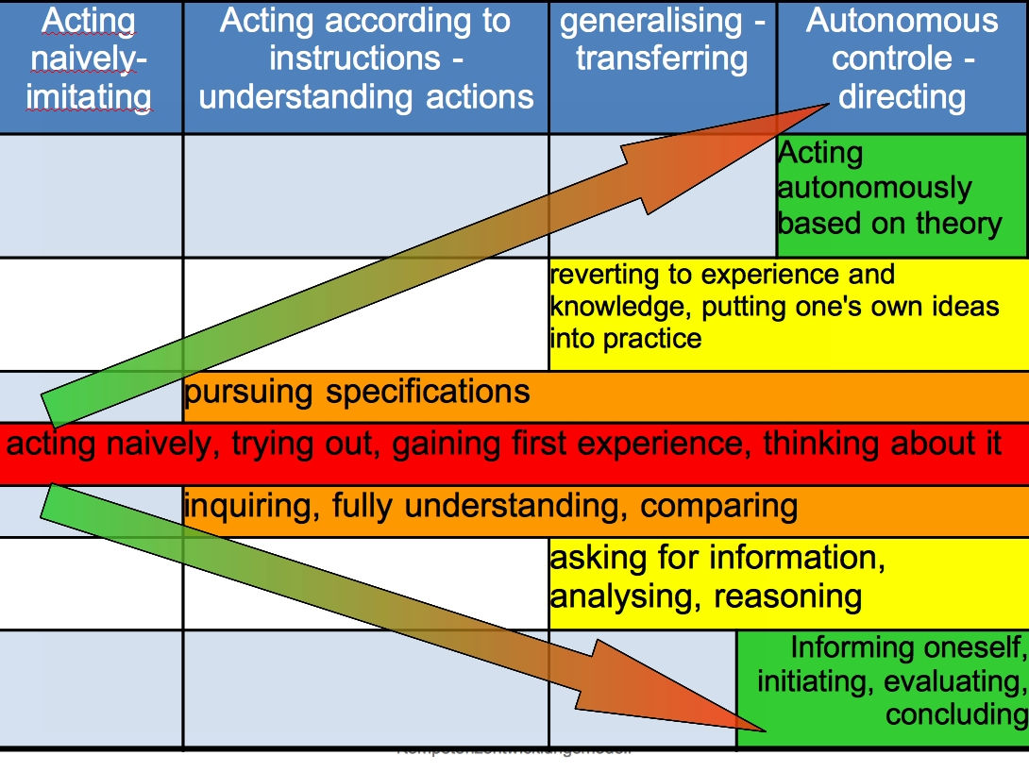
In order to continually develop their competences, teacher educators and practice advisors assign their students with challenging tasks corresponding to their current developmental stage, which get accordingly difficult and complex in line with the competence stages in the course of their training. Feedback on the attainment of their assignments gives students an orientation of their individual development.
Competences cannot be directly observed, but what is visible is the performance rendered on the basis of the respective competence. School-practical training gives a broad field of opportunities to test one’s competences. Competence-oriented teacher education promotes sustainable interaction of theory and practice, when theoretical contents of training are put into practice as soon as possible and are reflected upon, which prevents the situation that theoretical knowledge remains inactive knowledge.
In school-practical studies, students use portfolios to establish a link between theory and practice and to systematically reflect upon their acquisition of competences.
Competences that are being developed:
The following example illustrates the competences for the sub-domain of ‘educational competence’.

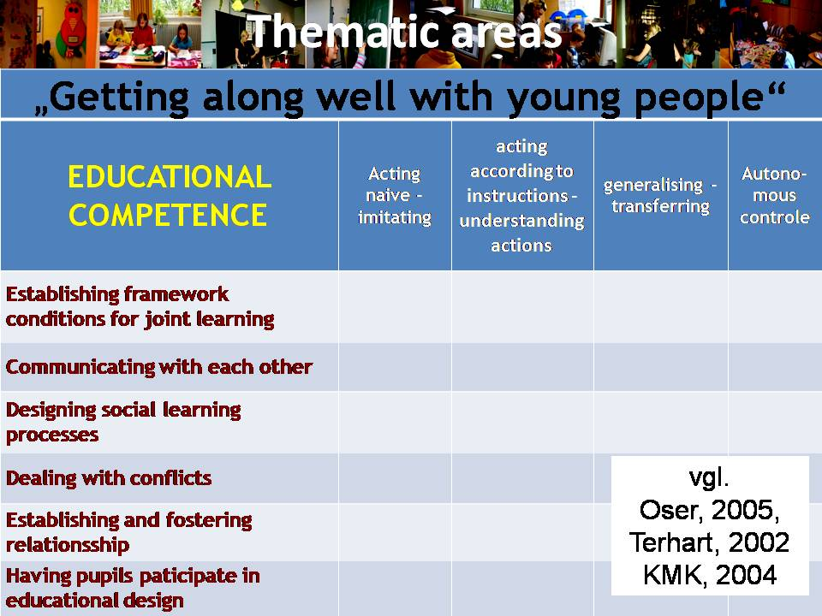

The following example makes evident how actions/partial competences – going ever more into detail – are reflected in the gain of students’ competences.

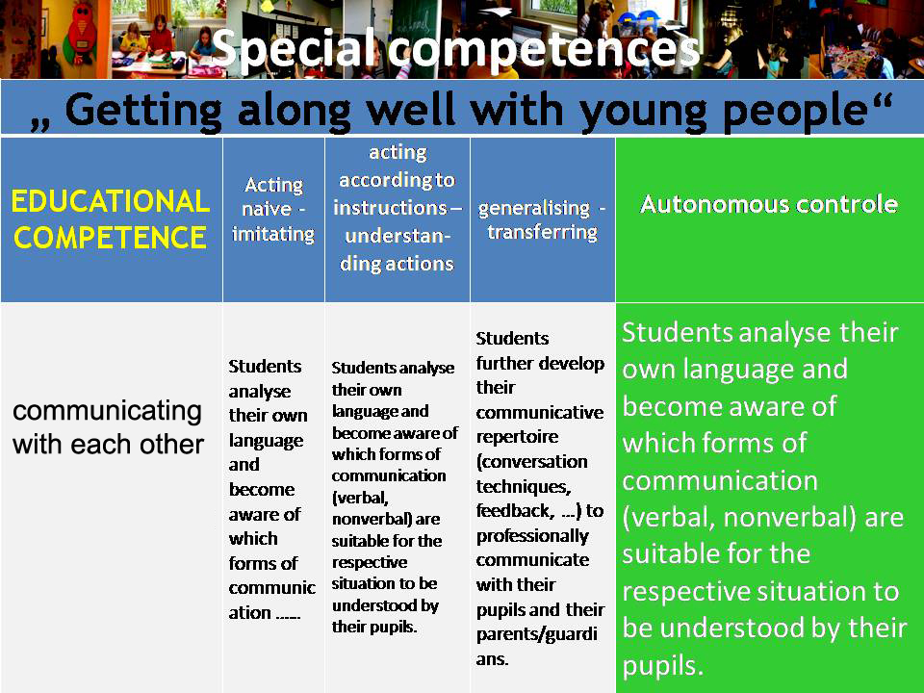

Impact/benefits for student teachers/learners/others:
This model is at a trial stage.
However, the following positive effects are expected when the competence development model is further refined:
- Increasing the autonomous control of one’s own learning progress through the knowledge of partial competences and competence depths;
- Improving adaptation of the learning environment to the competences and developmental needs of the students;
- Positioning a development model to get an overview of already achieved development steps or further development potential;
- Forming a basis for self-appraisal and reflection by the student;
- Providing improved and criteria-oriented feedback options for the trainers;
- Providing a description of the development path in a competence portfolio which can be applied for the ‘transition’ to further, in-job learning.
Identification of what can be learned from the study about teacher education for inclusion:
- In all fields of competences, the perception of work and dealing with differing needs and competences are included. The field of competence, ‘dealing with heterogeneity’ compacts this approach over again.
- Basic competences for inclusive classes (competence orientation, identifying developmental potential, criteria-oriented feedback, opportunities of self-assessment and assessment by others...) are trained and allow a reflection of one’s own experiences.
Plans for further development/extension of this practice:
Further development and evaluation by a project group, comprising teacher trainers, students, practice advisors and involved trainers at teacher training colleges.
Contact details for further information:
Eva Prammer-Semmler, Dipl. Päd.
mail: eva.prammer-semmler@ph-ooe.at
tel.: +43/732/7470-3105

Feyerer, E.: Qualität in der Sonderpädagogik: Rahmenbedingungen für eine verbesserte Erziehung, Bildung und Unterrichtung von Schüler/inne/n mit sonderpädagogischem Förderbedarf. In: Specht, W. (Hrsg.): Nationaler Bildungsbericht Österreich 2009. Band 2: Fokussierte Analysen bildungspolitischer Schwerpunktthemen. Graz, Leykam 2009, 73–97.
bm:ukk: ExpertInnenkommission Zukunft der Schule, Erster Zwischenbericht vom 14.11.2007
Cf. Härtel et al.: LehrerInnenbildung NEU. Die Zukunft der pädagogischen Berufe. Wien, 18. Dezember 2009
Feyerer, E.: Lehrerbildung für eine integrative/inklusive Schule. In: Erziehung und Unterricht. Österreichische Zeitschrift. Heft ½ 2006, 156. Jg. S. 57-64.
Feyerer, E./Niedermair, C./Tuschel, S.: Berufsfeld Sonder- und Integrationspädagogik. Positionspapier zur Aus- und Weiterbildung an den Pädagogischen Hochschulen. BMUKK 2006. Link: http://www.cisonline.at/fileadmin/kategorien/Positionspapier_Lehrerinnenbildung_8.4.08.pdf (1.3.2010) Feyerer, E./Niedermair, C./Tuschel, S.: Special Needs Education and Inclusive Education- Training and Professional Qualifications. Position paper on initial and further and in-service training at the University of Education. BMUKK 2006. Link: http://www.cisonline.at/fileadmin/kategorien/Position_Paper_Teacher_Training_14.5.2008.pdf (2010-03-01)
The detailed evaluation can be requested from the National Co-ordinator, Irene Moser.
Feyerer, E/Fragner, J.: Lehrer-Bildung als entscheidender Faktor für das Gelingen der schulischen Integration. In: Zeitschrift Behinderte in Familie, Schule und Gesellschaft, 17. Jg., Heft 1, 1994, 25–50
Feyerer, E./Niedermair, C./Tuschel, S.: Berufsfeld Sonder- und Integrationspädagogik. Positionspapier zur Aus- und Weiterbildung an den zukünftigen Pädagogischen Hochschulen. Wien: Bm:bwk, Abteilung I/8, 10.6.2006
The easiest way to find all Austrian Teacher Training Colleges is to browse to the following website of the Ministry of Education: http://www.bmukk.gv.at/schulen/bw/leb/index.xml
More information can be found at http://epik.schule.at/
Herzog-Punzenberger, B./Unterwurzacher, A.: Migration – Interkulturalität – Mehrsprachigkeit. Erste Befunde für das österreichische Bildungswesen. In: Specht, W. (Hrsg.): Nationaler Bildungsbericht Österreich 2009. Band 2: Fokussierte Analysen bildungspolitischer Schwerpunktthemen. Graz, Leykam 2009, 161–182
The description is based on the following paper: DeVerette, Ingrid/Neuböck-Hubinger, Brigitte/Plaimauer, Christine/Prammer, Willi/Prammer-Semmler, Eva/Soukup-Altrichter, Katharina/Winklehner, Elisabeth: Handout Portfolio für die Studierenden. www.ph-ooe.at [10.3.2009]
Kraler, Christian/Schratz, Michael (Hrsg.): Wissen erwerben, Kompetenzen entwickeln. Modelle zur kompetenzorientierten Lehrerbildung. Münster, New York, München, Berlin: Waxmann, 2007
Meyer, Hilbert/Fichten, Wolfgang: BLK-Abschlussbericht. Unveröff. Manuskript, Oldenburg, 2007

