teacher education for inclusion country report
Belgium (French speaking)
NB: A reflexion about the content of the courses from the teacher’s initial training started this year. Studies will become compulsory to become a teacher at a University level (5 years). I don’t know if there will be training about inclusion…
- Details of authors of report
Jean-Claude De Vreese
Inspector for Paramedical staff in specialised education
Date: 29th March 2010
- Wider policy framework supporting teacher education for inclusion
In Belgium reference is made to “integration” rather than to “inclusion” even though a couple of years ago, the law about integration of pupils with special needs allowed students to be included without going first into a special school.
The decree about specialised education allows pupils to receive help from the specialised schools without attending this school. (4 hours per week per child)
- Initial Teacher Education
- Entry to teacher education
In French-speaking Belgium there is currently no training for teaching in inclusive settings.
I include as an example the programme of the third study year in a pedagogical high school to show that the students only “hear” about specialised education at the end of their studies. This course is only for 30 hours and training in a specialised school is not compulsory.
- Models of initial teacher education
The IFC (Institut de formation en cours de carrière) is the centre for in-service training in the French Community. Last year it started two courses for teaching in inclusive settings provided by the ULB (Free University of Brussels/Prof. Detraux and Tremblay; please look the attached files for further information).
In initial teacher education, there is some collaboration between staff responsible for Special needs education, equality and diversity and staff on subject based courses but as there are no courses in inclusive education, collaboration is not possible.
- The initial teacher education curriculum
The content of initial teacher education courses is determined by individual schools of teacher education. No content as yet focuses on inclusive education or collaboration. The table below shows the content of the primary teacher education course.
Table 1: Content of the primary teacher education course
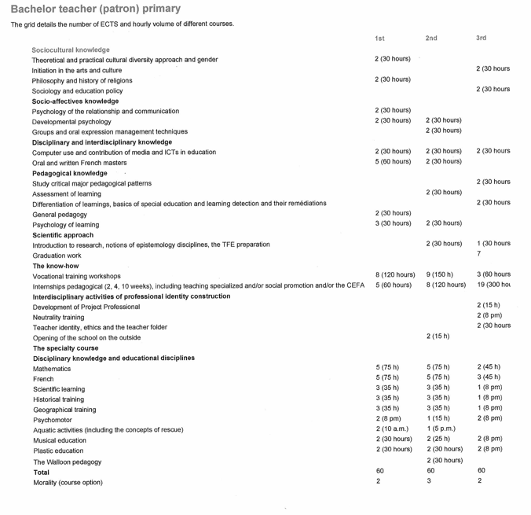
- Attitudes and values in initial teacher education
There is no guidance on attitudes and values for inclusion at present.
- Teaching practice
It is possible for students to do one week’s training in a special school but this is not compulsory. If this school organises integration with a mainstream school, the student will have a little information about this practice.
- Competences, assessment and accreditation
There are currently no competences for teachers.
- Teacher educators
There are few training courses for teacher educators and little relating to inclusion. Most of the information available is on the Net or in the literature (e.g. European agency or services like Inclusion international, etc.).
- Quality assurance and follow up of new teachers
There is no follow-up of new teachers.
- Representation from minority groups
There is no data available.

