Building Resilience through Inclusive Education Systems

**Guidance for Establishing a Culture of Effective Communication in Education**

**European Agency for Special Needs and Inclusive Education**

The European Agency for Special Needs and Inclusive Education (the Agency) is an independent and self‑governing organisation. The Agency is co-funded by the ministries of education in its member countries and by the European Commission via an operating grant within the European Union (EU) education programme.

Funded by the European Union. Views and opinions expressed are however those of the author(s) only and do not necessarily reflect those of the European Union or the European Commission. Neither the European Union nor the European Commission can be held responsible for them.

The views expressed by any individual in this document do not necessarily represent the official views of the Agency, its member countries or the European Commission.

© **European Agency for Special Needs and Inclusive Education 2024**

Editors: Margarita Bilgeri and Amélie Lecheval

This publication is an open-source resource. This means you are free to access, use, modify and disseminate it with appropriate credit to the European Agency for Special Needs and Inclusive Education. Please refer to the Agency’s Open Access Policy for more information: [www.european-agency.org/open-access-policy](https://www.european-agency.org/open-access-policy).

You may cite this publication as follows: European Agency for Special Needs and Inclusive Education, 2024. *Building Resilience through Inclusive Education Systems: Guidance for Establishing a Culture of Effective Communication in Education*. (M. Bilgeri and A. Lecheval, eds.). Odense, Denmark

This work is licensed under a [Creative Commons Attribution-NonCommercial-ShareAlike 4.0 International License](https://creativecommons.org/licenses/by-nc-sa/4.0/).

You are free to share and adapt this publication.

With a view to greater accessibility, this report is available in 25 languages and in accessible electronic format on the Agency’s website: [www.european-agency.org](https://www.european-agency.org/)

ISBN: 978-87-7599-093-1 (Electronic)

**Secretariat**

Østre Stationsvej 33

DK-5000 Odense C Denmark

Tel.: +45 64 41 00 20

[secretariat@european-agency.org](mailto:secretariat@european-agency.org)

**Brussels Office**

Rue Montoyer 21

BE-1000 Brussels Belgium

Tel.: +32 2 213 62 80

[brussels.office@european-agency.org](mailto:brussels.office@european-agency.org)

**Contents**

Icons used 5

Introduction 6

What is the aim of the guidance? 6

How to use the guidance 7

Where to find more information 7

Section 1: The Establishing a Culture of Effective Communication in Education Model 8

Core elements of effective communication in education 8

Description of the Establishing a Culture of Effective Communication in Education model 9

Section 2: Well-Being Framework 12

Section 3: Aspirations 14

How to use the aspirations 17

Aspiration A: Providing safe and secure psycho-social learning environments 19

Inspiring practice for Aspiration A 19

[Aspiration B: Being able to act proactively, feeling prepared for psycho-social   
emergencies 21](#_Toc164759402)

Inspiring practice for Aspiration B 21

Aspiration C: Creating supportive links in the community around learners and families 23

Inspiring practices for Aspiration C 24

Aspiration D: Using effective communication to address the needs of all learners 26

Inspiring practice for Aspiration D 27

Section 4: Reflection Tool 28

How to use the tool 28

Reflection tables for effective communication related to Aspiration D 29

1. Clarity 29

2. Accessibility 29

3. Trust 30

4. Transparency 31

Annex – Full Versions of Inspiring Practices 32

[Inspiring practice 1: Creating presence at a distance: experiences and success factors   
from distance learning 33](#_Toc164759416)

Description 33

Examples of effective communication 33

Outcomes 34

Inspiring practice 2: Communicating the arrangements for replacing final examinations during the COVID-19 school closures 35

Description 35

Examples of effective communication 35

Outcomes 35

Further comments 36

Inspiring practice 3: Parents’ café at a primary school in Frankfurt 37

Description 37

Examples of effective communication 37

Outcomes 37

Inspiring practice 4: The COVID-19 pandemic and lessons learnt in pre-schools 39

Description 39

Examples of effective communication 39

Outcomes 40

Inspiring practice 5: Whole-of-government strategy to improve the lives of people with disabilities and promote greater inclusion 41

Description 41

Examples of effective communication 41

Outcomes 42

Further comments 42

References 44

Icons used

Throughout this report, different icons indicate different types of information resources and support navigation. The icons are as follows:

|  |  |
| --- | --- |
| **Icon** | **Meaning** |
|  | Providing safe and secure psycho-social learning environments (Aspiration A) |
|  | Being able to act proactively, feeling prepared for psycho-social emergencies (Aspiration B) |
|  | Creating supportive links in the community around learners and families (Aspiration C) |
|  | Using effective communication to address the needs of all learners (Aspiration D) |
|  | Guiding questions |
|  | Key messages |
|  | Reality bites |

Introduction

This guidance for developing a culture of effective communication in education is the result of the [Building Resilience through Inclusive Education Systems](https://www.european-agency.org/activities/BRIES) (BRIES) activity, by the European Agency for Special Needs and Inclusive Education (the Agency).

In the early part of the COVID-19 pandemic, several countries published communication guidelines for different education stakeholders (European Agency, 2022). However, during the BRIES activity, teachers, learners, parents and policy-makers found there was still a lack of effective communication in education (European Agency, 2023). This had a negative impact on the well-being and resilience of stakeholders involved in the teaching-learning process and on adequately addressing the needs of all learners.

Six countries (Bulgaria, Estonia, Germany, Greece, Ireland and Sweden) participated in the BRIES peer-learning activities. In these activities, participants identified effective communication as a fundamental element that decision-makers should address to build all learners’ resilience and ensure their well-being. The [BRIES mid-term report](https://www.european-agency.org/sites/default/files/BRIES_Mid-Term_Report.pdf) contains further information on the process for identifying this focus (European Agency, 2023). Consequently, the BRIES activity focused on developing this guidance.

What is the aim of the guidance?

This guidance aims to **encourage decision-makers** (school leaders, policy-makers and public education authorities at all governance levels, depending on specific national contexts) to **reflect on the communication structures and processes** in place in their education systems. They are encouraged to determine how those processes could be improved.

A well-established culture of effective communication supports an education system in ‘normal’ times. In times of crisis, a well-established culture of effective communication is essential to mitigate the impact of significant risk factors for learners, including how the crisis affects their socio-emotional well-being and resilience.

The Agency’s [Key Principles](https://www.european-agency.org/resources/publications/key-principles-supporting-policy-development-implementation) strongly state the importance of increasing prevention measures in education policies to ensure support for all learners (European Agency, 2021). This guidance emphasises **prevention** by focusing on developing a culture of effective communication in normal times so that stakeholders are prepared to communicate effectively in times of crisis.

As such, a **culture of effective communication is a resource** all education stakeholders should be able to refer to, to enhance all learners’ well-being and resilience. At a policy level, this resource – if available immediately – can help to rapidly develop and implement policy responses in times of crisis:

To be feasible and implemented quickly, the development of a policy response to a crisis must rely on immediately available resources, but can also build on existing institutions to expand the scope of the emergency measures (Gouëdard, Pont & Viennet, 2020, p. 33).

A culture of effective communication can only be a meaningful resource in education if all involved in the teaching-learning process are considered. Decision-makers therefore must be able to identify communication structures and processes that need improvement. This guidance provides a basis for doing so. The pandemic has shown that investing in effective communication in education contributes to all learners’ resilience and well-being.

How to use the guidance

A country/municipality/region/school can use this guidance when working on communication structures and processes to support all learners’ well-being and resilience. The intention is to establish a culture of effective communication in normal times that allows stakeholders to be prepared for times of crisis. To do so, decision-makers (policy-makers, school leaders or local authorities) should aim to:

* identify gaps and challenges in existing communication structures and processes;
* be able to address all learners’ needs;
* increase all learners’ well-being and resilience.

To support this process, the guidance presents four interconnected sections, which are essential for establishing a culture of effective communication in education:

Section 1: A **model for effective communication in education**, based on the BRIES activity outcomes. The Establishing a Culture of Effective Communication in Education model provides a starting point for building resilience and fostering well-being.

Section 2: The model is embedded in the **well-being framework** offered by the capability approach (Sen, 2009, 2010; Robeyns, 2016), i.e. ‘the “capabilities” of persons to lead the kind of lives they value – and have reason to value’ (Sen, 2001, p. 18). With this approach, well-being and resilience are achievable if the valued aspirations of stakeholders involved in education are realised.

Section 3: To contextualise the effective communication model and well-being framework with different levels of stakeholders, **four aspirations** that emerged during the BRIES stakeholder discussions are presented. These aspirations represent stakeholders’ priority areas to improve the teaching-learning process during times of crisis.

Section 4: A **reflection tool** that supports reflection on communication processes and effective communication with stakeholders. This tool is based on the final aspiration: using effective communication to address the needs of all learners.

Where to find more information

The [BRIES report on methodology and theory](https://www.european-agency.org/resources/publications/BRIES-methodology-theory) (European Agency, 2024) is a supporting document to this guidance. The report offers users greater depth, background and understanding to make their own work more effective. It comprehensively explains the BRIES activities and the steps taken that supported the development of this guidance. It also includes details on the effective communication model and the well-being framework. The report presents theories and findings from other research that provide the theoretical basis for the BRIES outcomes.

Section 1: The Establishing a Culture of Effective Communication in Education Model

The Establishing a Culture of Effective Communication in Education model is informed by existing communication frameworks and theories and by the BRIES findings. It is based on the transactional model of communication, which the [report on methodology and theory](https://www.european-agency.org/resources/publications/BRIES-methodology-theory) explains. The report also sets out communication theory in more depth.

The model incorporates **core elements** of effective communication that were identified during the BRIES activity. It also includes relevant context areas and processes of communication adopted from existing communication models.

Core elements of effective communication in education

Communication is a process of sharing and responding to information between individuals, groups or organisations (Walaski, 2011). In this guidance, effective communication serves to improve communication processes. Using effective communication ensures that messages and decisions are communicated in a clear, accessible manner within and between education system levels. This, furthermore, feeds into building resilience and fostering the well-being of education stakeholders.

Effective communication is clear, transparent and accessible, conveys feelings of **trust** and belonging, and allows all stakeholders to participate in relevant communication and decision-making processes (Greenaway, Wright, Willingham, Reynolds & Haslam, 2015; Durkee-Lloyd, 2022). It therefore enables all those involved in and contributing to (inclusive) education systems to effectively address all learners’ needs. This leads to an inclusive culture of effective communication in education.

The BRIES activity identified four core elements of effective communication, which are interlinked and support each other:

* **Clarity** is essential for consistent and accessible information, thus highlighting the need for plain, easily understood language. The language must be suitable for the target audience. It should always aim to avoid complexity and confusion (Durkee-Lloyd, 2022; Lund-Tønnesen & Christensen, 2023; Glik, 2007).
* **Accessibility** means providing messages in accessible formats, language and channels. Accessibility ensures that information and communication are adapted to everyone’s needs, so that they are available to all (Durkee-Lloyd, 2022; Vakarelov & Rogerson, 2020). Accessible communication built through stakeholder participation leads to trusted, transparent and clear communication processes.
* **Trust** involves partnership between those involved in the communication process. Trust ensures that receivers are heard, and their comments, feedback and messages are valued and listened to (Greenaway et al., 2015; Kambouri, Wilson, Pieridou, Flannery Quinn & Liu, 2022; Walaski, 2011). Communication processes that are built on trust support the clarity, transparency and effectiveness of communication.
* **Transparency** means making sure information is readily available and released in a way that reaches different levels of stakeholders. It ensures that communication and decision processes are understandable and accessible. Trust, credibility, honesty and accountability are necessary to support transparency in communication (Vakarelov & Rogerson, 2020; Glik, 2007).

These core elements are the main **conversion factors** for turning existing communication into effective communication. The conversion factors become more meaningful and explicit in Section 2 where the Establishing a Culture of Effective Communication in Education model is aligned with the well-being framework.

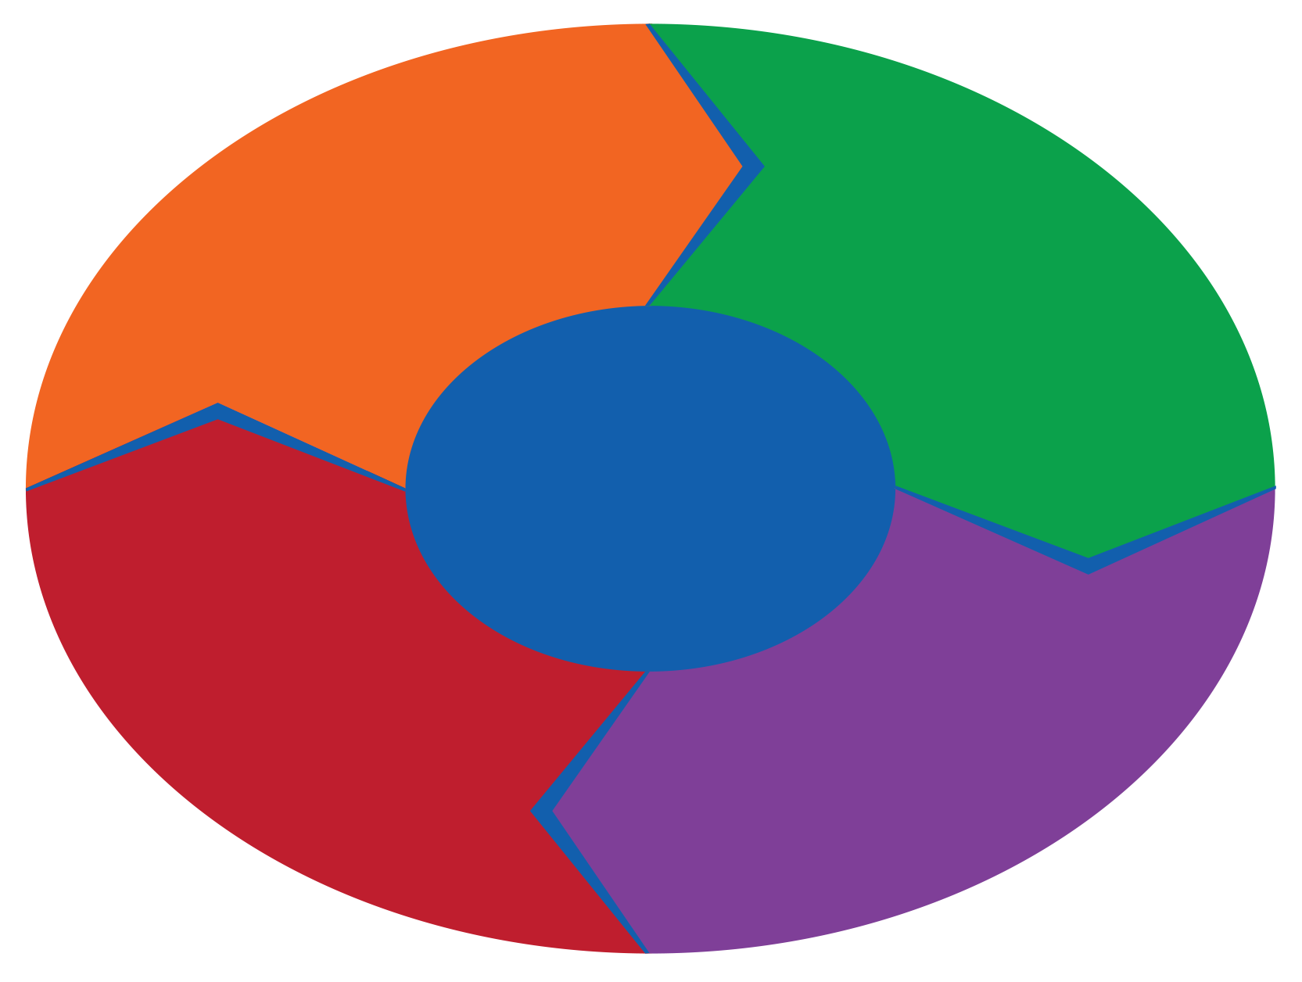

**CLARITY**

**TRUST**

**TRANSPARENCY**

**ACCESSIBILITY**

**Culture of effective communication in education**

Figure 1. The four core elements of effective communication in education

Description of the Establishing a Culture of Effective Communication in Education model

Building on [existing communication models and theory](https://www.european-agency.org/activities/BRIES), and on the four core elements of effective communication, the BRIES activity developed the Establishing a Culture of Effective Communication in Education model.

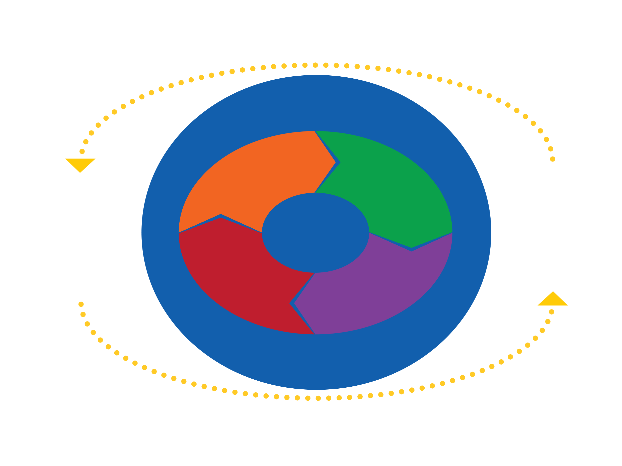

**Culture of effective communication in education**

**CLARITY**

**ACCESSIBILITY**

**TRANSPARENCY**

**TRUST**

**Communicators:**  
Learners  
Teachers  
Families  
Decision-makers

**Communicators:**  
Learners  
Teachers  
Families  
Decision-makers

**Context**   
(relational, cultural, social, physical, psychological)

**Context**   
(relational, cultural, social, physical, psychological)

**Multi-Channel Communication**

**Multi-Channel Communication**

Figure 2. Establishing a Culture of Effective Communication in Education model

In this model, all education stakeholders act as potential communicators. In all communication, the four core elements of effective communication and additional context areas play an essential role (Airenti & Plebe, 2017; Jones, 2013). Context can influence how content is transmitted and received. This is where context overlaps with the core elements of effective communication.

This model defines five main context areas, where the four core elements overlap:

* **Relational context** determines how communication happens based on the quality of the relationship between communicators. It influences how a person feels during the communication process. A trustful relationship, for example, will promote effective communication as it can be easier to address difficulties.
* **Cultural context** includes different aspects of identities (race, gender, nationality, ethnicity, sexual orientation, ability, etc.) that influence communication. Some identities lead to marginalised or dominant positions in communication. If communication processes consider power differences, effective communication becomes easier.
* **Social context** is related to rules or unstated norms that guide communication. Rules and norms are often learnt implicitly while being socialised in our communities (dos and don’ts). When the social context is transparent and respected, it can add to effective communication. Certain implicit social rules and norms can hinder effective communication as they might conceal actual problems and their root cause.
* **Physical context** looks at the environmental factors that influence communication (general environment, digital environment, size, layout, external conditions, temperature, etc.). Effective communication is facilitated when the chosen communication channels and environments are accessible and preferred by the intended audience.
* **Psychological context** refers to mental and emotional factors in communication (stress, anxiety, emotions, etc.). When the psychological context is considered, communication can be much more effective because it can be adapted to the needs of the people involved.

(Jones, 2013, pp. 19–22; Greenaway et al., 2014; Walaski, 2011)

As these definitions show, considering different contexts in communication processes supports the development of a culture of effective communication. While context is important, this guidance focuses on the core elements. They are the main conversion factors for turning existing communication resources into effective communication. They focus on the act of communication itself and the communicator can influence them to improve communication processes if needed.

As mentioned, another purpose of working towards a culture of effective communication in education is to support all learners’ well-being and resilience, especially in times of crisis. As such, the model is aligned with the well-being framework offered by the capability approach, as Section 2 explains.

Section 2: Well-Being Framework

The BRIES activity’s well-being framework is a simplified version of the capability approach (Sen, 2009, 2010; Robeyns, 2016; Evans, 2002; Ibrahim, 2017). The capability approach focuses on individuals’ potential quality of life and well-being, when they have the freedom and opportunities to reach what they value in life. The BRIES well-being framework was adapted to the context of effective communication leading to well-being and resilience. From this perspective, effective communication is a meaningful capability to achieve resilience and well-being (Schejter, 2022).

For stakeholders of all levels to be able to communicate effectively, a culture of effective communication must be in place for all. Using and implementing a culture of effective communication in education can support well-being and resilience in normal times and in times of crisis.

Applying the capability approach to communications shows that:

… communicating is a capability required to realize such functionings as participating in political, cultural, social, educational, and commercial life and is essential to promote belonging to a collective (Schejter, 2022, p. 1826).

The well-being framework offers the chance to view communication as an existing resource that can be converted into a culture of effective communication. It thereby supports a whole group’s well-being and resilience (Evans, 2002; Ibrahim, 2017).

The Establishing a Culture of Effective Communication in Education model’s core elements guide the process of converting existing communication into a culture of effective communication for all. Considering and implementing the core elements in communication processes supports the development of a culture of effective communication for all. The aspirations and the reflection tool presented below make this explicit.

Effective communication and the core elements feed into well-being and resilience in education:

‘Existing communication resources’ convert to ‘effective communication’ thanks to the conversion factors, which are ‘core elements for effective communication in education: clarity, accessibility, trust and transparency’. Effective communication is implemented to build and use a culture of effective communication that fosters well-being and resilience in education.

**Conversion factors**

Core elements for effective communication in education:  
clarity, accessibility, trust and transparency

**Effective communication**

**Building and using a culture of effective communication**

**Implement for …**

**Convert to …**

**Fostering …**

**Well-being and resilience**

**Existing communication resources**

Figure 3. Well-being framework and effective communication in education

To foster all learners’ well-being and resilience by improving communication processes, all stakeholders must implement and use a culture of effective communication. In this way, effective communication can help to achieve valued aspirations that add to all learners’ well-being and resilience.

For more information about the capability approach as a well-being framework, refer to the [BRIES report on methodology and theory](https://www.european-agency.org/resources/publications/BRIES-methodology-theory).

Section 3: Aspirations

In the BRIES activity, learners, teachers, parents and policy-makers from the participating countries defined four priority areas based on their experiences from the pandemic. (For more detailed information on methodology and participants, please refer to the [BRIES mid-term report](https://www.european-agency.org/sites/default/files/BRIES_Mid-Term_Report.pdf) and the [report on methodology and theory](https://www.european-agency.org/resources/publications/BRIES-methodology-theory)). The priority areas are presented as Aspirations A, B, C and D.

**Aspiration A**

**Providing safe and secure psycho-social learning environments**



**Aspiration B**

**Being able to act proactively, feeling prepared for psycho-social emergencies**



**Aspiration C**

**Creating supportive links in the community around learners and families**



**Aspiration D**

**Using effective communication to address the needs of all learners**



Figure 4. Aspirations

The aspirations describe processes that ultimately improve all learners’ well-being and resilience. As such, they are aims that stakeholders considered valuable. These can be achieved if all involved in the teaching-learning process use effective communication.

The following sections explain each aspiration in detail. Stakeholders’ experiences of communication processes during the early part of the pandemic provide context to the aspirations. The sections also describe situations in which effective communication could lead to improved well-being and build resilience for all learners.

To identify relevant communicators (stakeholders), this guidance has used the Agency’s eco-system model (see Figure 5), which places learners at the centre. All stakeholder levels communicate in certain ways with each other and can therefore be considered ‘communicators’. This leads to a complex environment of potential communication processes. On the outermost level, the guidance addresses decision-makers in general, including school leaders and public education authorities at all governance levels.

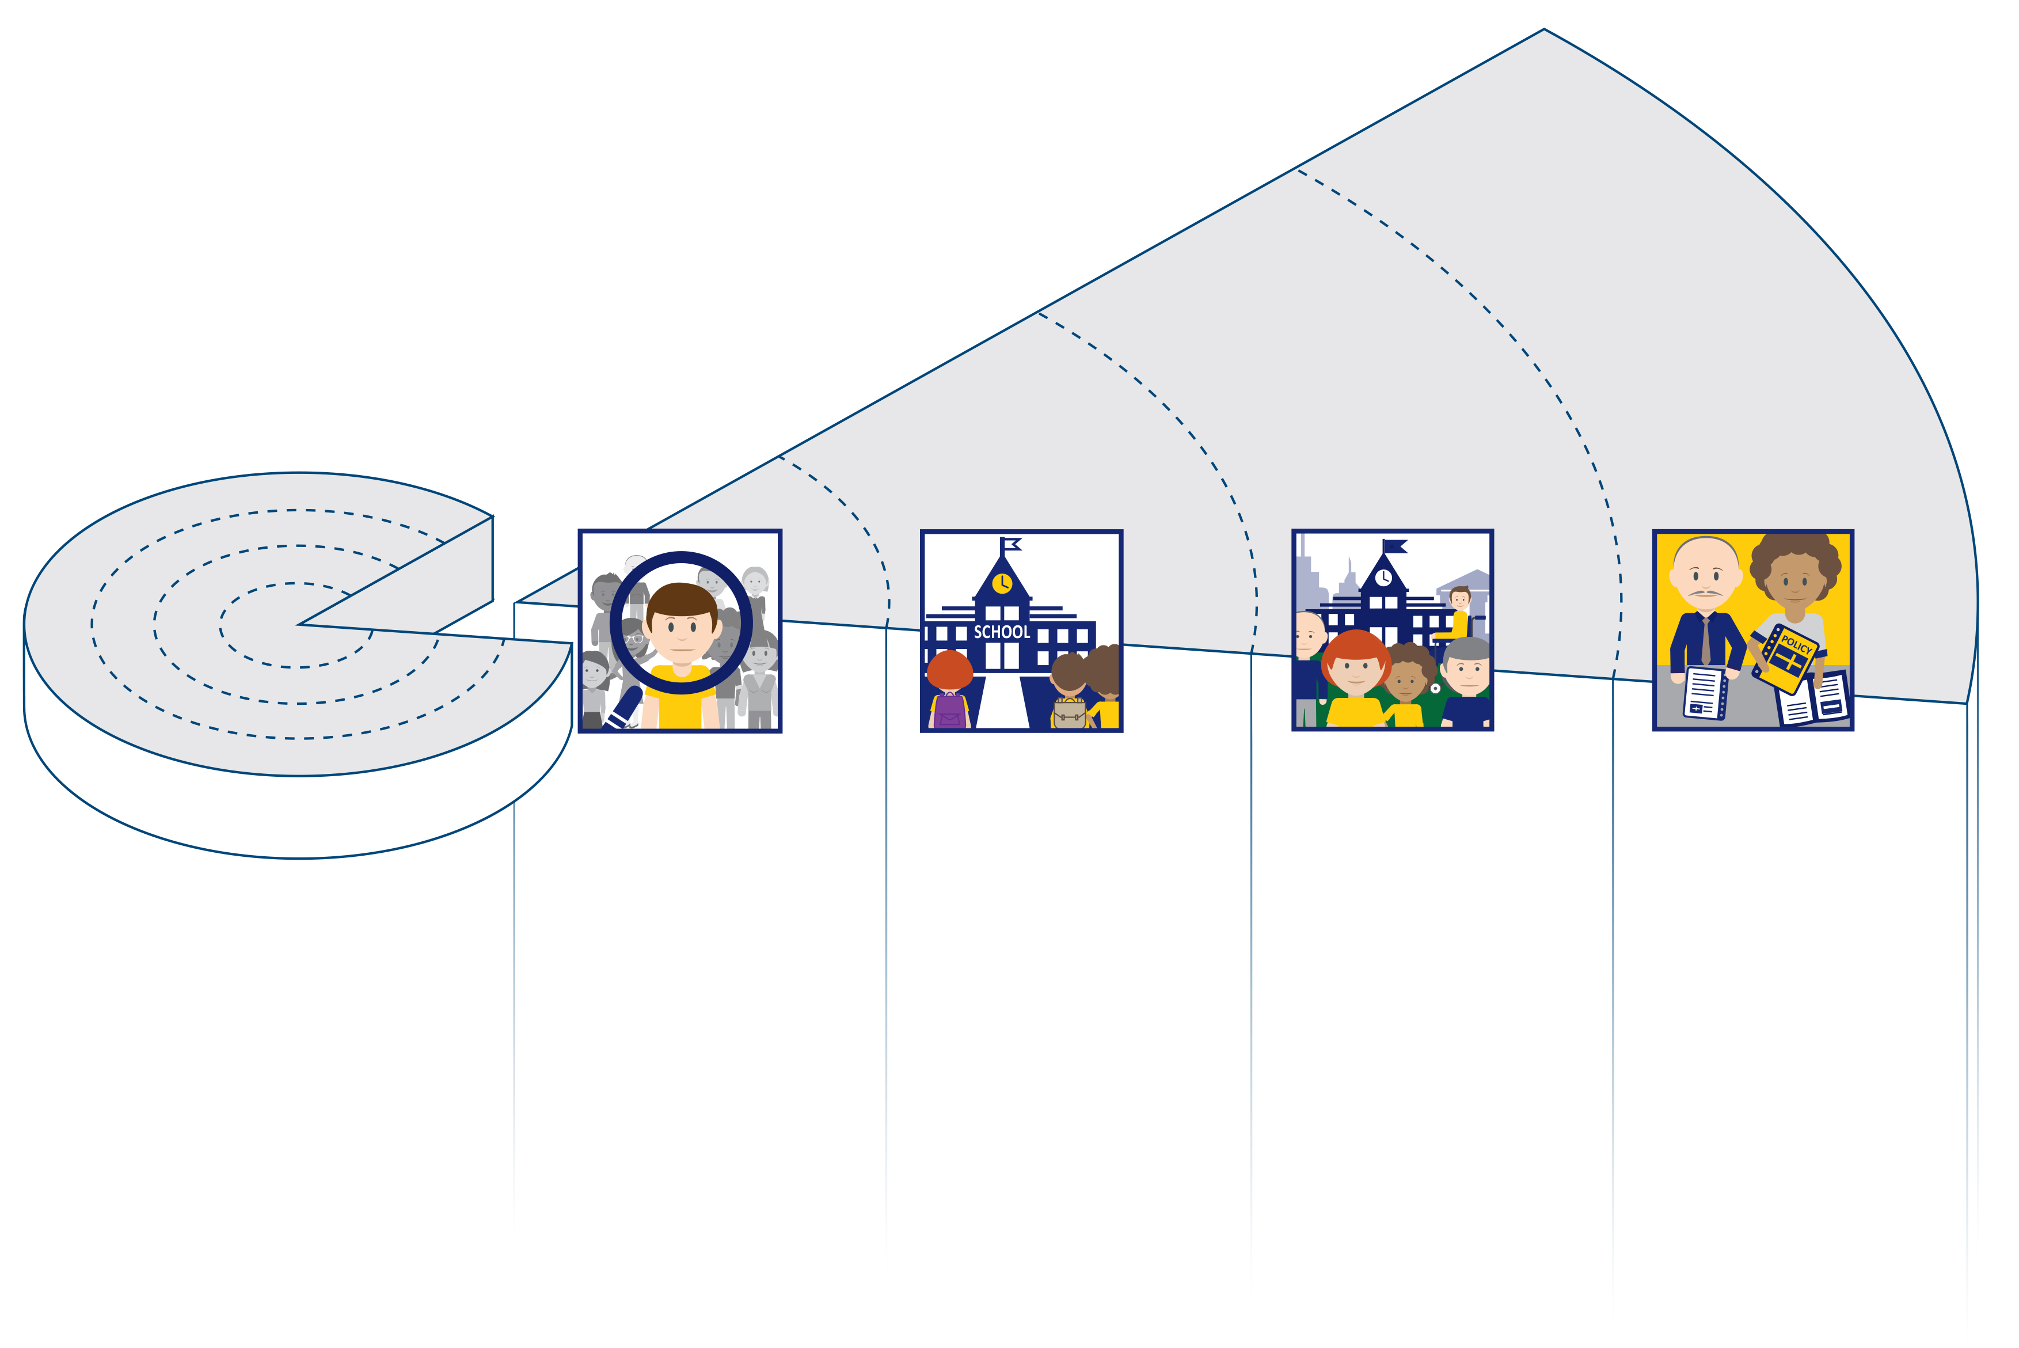

**Decision-makers**

National/regional level

**Parents/Families**

Community level

**Teachers**

School level

**Learners**

Individual level

Figure 5. Agency eco-system model

Each of the four aspirations is linked to one of the eco-system’s stakeholder groups. However, even though, for example, parents and teachers benefit from effective communication, the ultimate beneficiary is always the learner.

Table 1. Aspirations linked to stakeholder levels

| **Reality bite taken from:** | **Aspiration** |
| --- | --- |
| Learners | **A:** Providing safe and secure psycho-social learning environments (to support all learners’ well-being and resilience). |
| Teachers and schools | **B:** Being able to act proactively, feeling prepared for psycho-social emergencies (to support all learners’ well-being and resilience). |
| Families and community | **C:** Creating supportive links in the community around learners and families (to support all learners’ well-being and resilience). |
| Decision-makers | **D:** Using effective communication to address the needs of all learners (to support all learners’ well-being and resilience). |

How to use the aspirations

Each aspiration is presented along with an example of a communication challenge experienced by a stakeholder group. These examples are called ‘**reality bites**’ and were collected during the BRIES peer-learning activities. Each aspiration has the same structure:

1. The **reality bites** show a specific context in which ineffective communication in a crisis negatively affected the well-being and resilience of a certain group of stakeholders.
2. A **country example** of effective communication in the context of the respective aspiration is summarised for inspiration.
3. A **guiding question** is presented.
4. The guiding question leads to a **key message** that provides a first input for reflection on the respective aspiration.

Decision-makers can use the aspirations as examples to relate to situations at the grassroots level in which improved communication processes can influence learners’ resilience and well-being.

This, in consequence, can **encourage reflection processes** (in a school, municipality, region or country) on ways of communicating information and decisions to stakeholders or on involving different stakeholder groups in decision-making processes (e.g. developing and discussing emergency plans, communication guidelines and strategies, etc.).

Aspiration A: Providing safe and secure psycho-social learning environments

Safe and secure psycho-social learning environments are essential to ensure all learners’ (and teachers’) socio-emotional well-being, especially in times of crisis. Effective communication can create learning environments that give learners a feeling of belonging and of being heard and opportunities to ask for help or support. This also helps to build resilience.

The reality bites below are examples of the communication challenges learners experienced during the early crisis phase of the COVID-19 pandemic. They aim to show the reader where effective communication – if in place – could support learners’ well-being and resilience.

**Reality bites**:

* Learners reported **being unable to communicate immediately** with teachers when they encountered challenges.
* **Consulting support persons** was challenging. Some learners had never contacted the available psychologists/experts before, so they were **strangers** to them.
* Some learners had an extra burden because their parents were unable to take on certain **communication tasks**. This **added to learners’ stress** and was a result of **poor communication processes between schools and families**.

Inspiring practice for Aspiration A

In this example, an inclusive learning environment, where all learners could communicate safely, was facilitated.

**Creating presence at a distance: experiences and success factors from distance learning**

In Sweden, a study reflected on how teaching processes were affected by distance learning using digital communication during the COVID-19 school closures.

Interviews with teachers show that some learners felt more comfortable communicating through text messages and online chat than they were in a classroom setting with their peers. The study reports the different steps taken with small and larger groups of learners to develop more lively and meaningful communication.

The results show the importance of making sure everyone has a chance to use adapted means of communication. This ensures the flow of information and helps to reach all learners.

Find the full inspiring practice in the annex.

The **guiding question** and **key message** contextualise the topic of effective communication in relation to Aspiration A. The focus is **effective communication and learners**:



**How can a culture of effective communication in education support stakeholders in creating safe and secure psycho-social learning environments for all learners?**

*Key message*: A culture of effective communication in education ensures safe and secure psycho-social learning environments. Creating trustful relationships to enable effective communication is key to support all learners. It involves knowing the learners and their needs, as well as their background and family situation.

Aspiration B: Being able to act proactively, feeling prepared for psycho-social emergencies

Being able to act proactively and feeling prepared for psycho-social emergencies was one of the most important aspirations for teachers in the context of the pandemic and future crises. Not being able to (re-)act and not feeling prepared added to teachers’ stress and negatively impacted their well-being. Their limited ability to respond to all learners’ needs negatively affected learners’ well-being and resilience.

The reality bite below is an example of teachers’ experiences of communication challenges during the early crisis phase of the COVID-19 pandemic. It aims to show where effective communication – if in place – could support teachers’ work and learners’ well-being.

**Reality bite**:

* Teachers mentioned that the first phase of the pandemic was very difficult, as they had to wait for decisions and directions from higher levels. **This communication was ineffective, as it was slow and not transparent.** Teachers’ actions were blocked and they did not know about their options or communication systems that would enable them to act proactively in addressing all learners’ needs.

Inspiring practice for Aspiration B

In this example, information was provided when needed for teachers and other stakeholders to prepare them to act proactively.

**Communicating the arrangements for replacing final examinations during the COVID‑19 school closures**

During the COVID-19 school closures in 2020 in Ireland, the Department of Education developed communication plans to inform all stakeholders about the upper-secondary education final examinations and assessment arrangements.

The large audience involved was one challenge, as it was necessary to reach all learners, parents/guardians, school communities including school leaders and teachers, education sector stakeholders and representatives. Significant expertise was required to build clear communication. Multi-channel, multi-level communication was planned.

Monitoring the impact of the communication processes was key because it made it possible to adapt messaging and communication processes quickly when needed.

Find the full inspiring practice in the annex.

The **guiding question** and **key message** contextualise the topic of effective communication in relation to Aspiration B. The focus is **effective communication and teachers**:



****How can a culture of effective communication in education enable teachers to act proactively and be prepared when addressing the needs of all learners during psycho-social emergencies?**

*Key message:* Teachers can be enabled to act proactively and feel prepared for psycho-social emergencies when communication processes are transparent, and they are involved in decision-making. Enhanced communication and exchange among teachers and between stakeholder levels can support this development. Adequate competence development opportunities in communication and information technology skills are key to support teachers, especially in time of crisis.

Aspiration C: Creating supportive links in the community around learners and families

The COVID-19 pandemic has highlighted the need for support for families when it comes to education in times of crisis. Supportive links in the community played an essential role in providing this support when wider system support structures failed to do so.

The possibility of communicating effectively by using supportive links in (school) communities helps families and increases learners’ well-being and resilience, especially in times of crisis.

The reality bites below describe families’ communication challenges during the early crisis phase of the COVID-19 pandemic, offering insights into their lived realities.



**Reality bites**:

* The communication challenges parents encountered during the pandemic restrictions particularly related to the **way and timing of communicating decisions**. In some cases, media channels communicated decisions, but families had to wait for schools to implement these decisions. Families with migrant backgrounds and speakers of other languages experienced high levels of exclusion from information and decision communication.
* Parents referred to the **role of the community** as an essential part of communication during a crisis. There, they found opportunities to exchange information and discuss challenges in education during the crisis.

Inspiring practices for Aspiration C

In the following examples, families and school communities had opportunities to interact, leading to common understanding and strong connections.

**Parents’ café at a primary school in Frankfurt**

In Germany, teachers and a school leader began a parents’ café to improve the link between families and the school. The aim was to provide a space and a time to share experiences and opinions and overcome challenges.

Creating a friendly atmosphere strengthened the relationship between the school and its community. It was also key for involving new parents and enabling parents from non-German speaking backgrounds to interact with the school in a different way.

This project has proven to be very effective because of its unconventional method of communication. The exchanges took place in a friendly and intimate atmosphere, decoupled from performance, grades and assessments. Parents themselves chose the discussion topics, which were sometimes very personal. Personal exchanges between parents and teachers created a basis of trust. Communication channels became more direct.

Find the full inspiring practice in the annex.

**The COVID-19 pandemic and lessons learnt in pre-schools**

A study shows how teachers from Sweden, Norway and the United States handled pandemic restrictions in pre-schools. The article reports that a Swedish pre-school developed a detailed crisis action plan in collaboration with its staff and the parents’ advisory board. In Norway, parents and school staff were involved in developing a common understanding and strategy to share information and introduce safety guidelines.

These examples show how parents, as part of the community, can be involved at different stages of establishing a culture of effective communication.

Find the full inspiring practice in the annex.

The **guiding question** and **key message** contextualise the topic of effective communication in relation to Aspiration C. The focus is **effective communication and families**:



****How can a culture of effective communication in education enable families to refer to supportive links in the community to address the needs of all learners?**

*Key message:* Supportive links in the community around learners and families can be created by using effective communication to develop good partnerships between decision-makers and communities. Effective communication in education supports the development of relationships and trust among stakeholders. These are key elements for reaching all learners and families.

Aspiration D: Using effective communication to address the needs of all learners

Effective communication in education ensures that messages and decisions are communicated in a clear and accessible manner within and between education system levels. It involves different levels of stakeholders in decision-making processes. Furthermore, it supports transparency and uses a trustworthy basis for communication. This requires a well-established culture of effective communication.

Effective communication to address all learners’ needs increases learners’ well-being and resilience, especially in times of crisis.

In the reality bites, the Agency country representatives participating in the BRIES activity reflected on communication issues so far during the COVID-19 pandemic.



**Reality bites**:

* All countries involved in the BRIES activities have reported the **need for actions** related to communication with stakeholders in terms of being able to address the needs of learners vulnerable to exclusion in times of crisis.
* Countries have reported the importance of **using multiple ways to communicate** with stakeholders. A diversity of channels is considered a key element for communication at a policy-making level.
* Countries also stated that communication with stakeholders had **no direct effect on policy development**. Some attributed this to the sudden onset of the crisis and limited time for ensuring stakeholder participation. However, they were convinced that stakeholders should have the **opportunity to provide feedback** and **input** on policy development. This can help ensure that policies are responsive to stakeholders’ needs and are effective in addressing a crisis. Furthermore, because communication goes both ways, there is learning and impact from the communications.
* Countries stated that communication should be **transparent**, with stakeholders being provided with **as much information as possible** about the crisis, the policy development process, and the rationale behind policy decisions.

Inspiring practice for Aspiration D

This example ensures stakeholder involvement in policy-making processes and opportunities to communicate.

**Whole-of-government strategy to improve the lives of people with disabilities and promote greater inclusion in Ireland**

In Ireland, different stakeholder groups developed and implemented a National Disability Inclusion Strategy between 2017 and 2022. This policy development process created a platform that encouraged each stakeholder to participate and discuss and supported stakeholder communication in general.

The process for developing and implementing the strategy has shown ways of developing effective communication and collaboration. A ‘joined-up’ approach facilitated communication between stakeholders at national and local levels. This led to positive engagement and developed a common understanding of how to collaborate, communicate and work together.

Find the full inspiring practice in the annex.

The **guiding question** and **key message** contextualise the topic of effective communication in relation to Aspiration D. The focus is **effective communication and decision-makers**:



****How can a culture of effective communication in education support decision-makers in their aspiration to address all the needs of all learners?**

*Key message*: A culture of effective communication in education ensures that communication about decisions and decision-making processes involves stakeholders of all levels. Communication strategies that use multiple communication channels and define clear roles support stakeholders in their aspiration to address all learners’ needs.

Section 4: Reflection Tool

The reflection tool for effective communication in education is related to Aspiration D. ‘Using effective communication to address the needs of all learners’ feeds into ‘providing safe and secure psycho-social learning environments’, ‘being able to act proactively and feeling prepared for psycho-social emergencies’ and ‘creating supportive links in the community around learners and families’. Using effective communication is one step towards fulfilling all four aspirations, as the presentation of each aspiration in Section 3 shows.

The reflection tool presents guiding statements to support users to reflect on effective communication related to Aspiration D. The tool aims to begin a process that allows stakeholders to reflect on and revisit existing communication strategies and processes for decision-makers at school, regional, municipal and national levels.

How to use the tool

* The tool is a **suggestion** for countries **to bring up** and identify issues related to improving their culture of effective communication to prepare for times of crisis.
* The guiding statements are not exhaustive. There is **space** for users to **add their own statements** if needed.
* As countries differ substantially as regards their education systems and measures in place for future crises, users should **adapt the tool to their country context**.
* Users can **replace the term ‘stakeholders’** **with the name of a relevant group** of education stakeholders (e.g. learners, parents, teachers, school leaders), depending on how decision-makers intend to use the reflection tool.
* As the core elements of effective communication (**clarity, accessibility, transparency, trust**) are the main drivers for establishing a culture for effective communication, they form the basis for the **guiding statements** below.
* In the tables, a complex **general statement** for each core element is **followed by concrete statements** in bullet points that aim to break down the general statement into the properties of each core element.
* Users should place a tick in the corresponding column to indicate whether each **guiding statement** is ‘**in place**’ (2),‘**to be improved**’(1) or ‘**not relevant** for us’ (0).

Reflection tables for effective communication related to Aspiration D

|  |  |
| --- | --- |
|  | **Aspiration D:**  In our country/municipality/region/school, a culture of effective communication is in place to enable stakeholders to address the needs of all learners. |

Key: 0 = Not relevant for us, 1 = To be improved, 2 = In place

1. Clarity

| **Guiding statements** | **0** | **1** | **2** |
| --- | --- | --- | --- |
| **We communicate clearly with education stakeholders** about decisions and decision-making processes. |  |  |  |
| * We communicate **consistently** (regularly) with stakeholders. |  |  |  |
| * We **simplify** the information in our communications. |  |  |  |
| * We ensure that communication with stakeholders focuses on **key policy issues**. |  |  |  |
| * We have **clear and planned priorities** in our communication (e.g. prioritising communication related to well-being). |  |  |  |
| * We have **defined timelines** in our communication processes (e.g. focusing on the importance of time-bound responses). |  |  |  |
| * Other *(please specify)*: |  |  |  |

1. Accessibility

| **Guiding statements** | **0** | **1** | **2** |
| --- | --- | --- | --- |
| We communicate decisions and decision-making processes in an **accessible** way. |  |  |  |
| * We use **multiple, appropriate channels** when communicating with stakeholders (e.g. using the target group’s preferred channels). |  |  |  |
| * We use **accessible formats** in our communication processes. |  |  |  |
| * We use **appropriate and accessible language style and tone** in our communication with stakeholders (e.g. using inclusive language). |  |  |  |
| * We **adapt our language** to the receivers of the message (e.g. multiple languages, easy or easier language) in our communication processes. |  |  |  |
| * We **include** stakeholders in discussions about communication processes to make communication **accessible** and tailored to the target group’s needs. |  |  |  |
| * Other *(please specify)*: |  |  |  |

1. Trust

| **Guiding statements** | **0** | **1** | **2** |
| --- | --- | --- | --- |
| **We involve** stakeholders in decision-making processes. |  |  |  |
| * We invite stakeholders to **participate** in decision-making processes. |  |  |  |
| * We actively **listen** to stakeholders in decision-making processes. |  |  |  |
| * We **value** stakeholders’ comments and feedback by including these in decision-making processes. |  |  |  |
| * We give stakeholders **feedback** on their input on decision-making processes and communication strategies. |  |  |  |
| * We commit to providing **timely responses** in our communications. |  |  |  |
| * We **explain** to stakeholders how we value their input on decision-making processes and communication strategies. |  |  |  |
| * We **act** upon stakeholders’ input and feedback in decision-making processes and communication strategies. |  |  |  |
| * Other *(please specify)*: |  |  |  |

1. Transparency

| **Guiding statements** | **0** | **1** | **2** |
| --- | --- | --- | --- |
| We make decision-making processes and communication strategies **transparent** to stakeholders (when decisions are taken, who is involved, informing stakeholders about opportunities for participation). |  |  |  |
| * We ensure that **sufficient** information about decision-making processes is available (in different channels and formats) for relevant stakeholders. |  |  |  |
| * We communicate relevant information for stakeholders **openly and honestly**. |  |  |  |
| * We explain to stakeholders who is **accountable** for communication strategies and communicated information. |  |  |  |
| * We facilitate discussions between decision-makers and relevant stakeholdersabout the **quality and evaluation** of our communication strategies. |  |  |  |
| * Other *(please specify)*: |  |  |  |

Annex – Full Versions of Inspiring Practices

The BRIES activity collected inspiring practices from the participating countries. They may serve as inspiration for improving communication processes in times of crisis.

Click on the links below to access the full versions of the examples:

1. Creating presence at a distance: experiences and success factors from distance learning
2. Communicating the arrangements for replacing final examinations during the COVID-19 school closures
3. Parents’ café at a primary school in Frankfurt
4. The COVID-19 pandemic and lessons learnt in pre-schools
5. Whole-of-government strategy to improve the lives of people with disabilities and promote greater inclusion

Inspiring practice 1: Creating presence at a distance: experiences and success factors from distance learning

Description

Country

Sweden

Source

[Creating presence at a distance: experiences and success factors from distance learning in upper-secondary schools in Gothenburg, spring 2020](https://goteborg.se/wps/wcm/connect/bd3a6a31-1b2c-4c13-bfdd-f3f01b0ad406/Att+skapa+n%C3%A4rvaro+p%C3%A5+distans.pdf?MOD=AJPERES) (Center för skolutveckling, 2020) [in Swedish].

This study describes the experiences of distance education during the school closures of spring 2020; these experiences can be used for future teaching.

Aim

The study aims to answer the following questions, via individual and group interviews:

* How does distance learning affect teachers’ leadership?
* What strategies do teachers use to deal with the different situations that occur?
* How do learners experience distance learning?
* Are there methods and approaches that can persist after the pandemic?

Stakeholders involved

Teachers and learners in Gothenburg’s upper-secondary schools, the national programme of adapted upper-secondary schools and *Studium* (adult education).

Examples of effective communication

A teacher explains how chat/messaging groups involving learners, guardians and mentors can contribute to frequent follow-ups that give the learner increased opportunities to achieve their learning goals. Another teacher speaks about the difficulties of whole-class online teaching and the advantages of being able to divide into groups. These digital work groups contribute to a more efficient use of class time and may also be useful in future learning situations.

**Distance education offers opportunities** for more personal communication routes. Several teachers describe, for example, that learners who were difficult to reach before suddenly began to express themselves more frequently via chat and messaging functions. This was also true of learners who normally feel secure in a classroom. They, too, asked questions in a different, more open way than when they did so verbally in a classroom. When learners can reflect and communicate their thoughts with their teacher or in a smaller group before it is raised for discussion in the larger group, the discussion becomes livelier and more meaningful.

Using chat and messaging features to communicate with learners enhances their learning opportunities.

Outcomes

The interviews indicate that the switch to distance learning strengthens clarifying pedagogy. Clarifying pedagogy is an approach that aims to make school more comprehensible, meaningful and manageable for learners, whereby the teacher gives answers to questions that the learners do not ask.

In the interviews, the teachers stated that they developed competences and working methods that could supplement their regular teaching. For example, they will use **digital communication** **tools** in a teaching context **more frequently in the future**.

Inspiring practice 2: Communicating the arrangements for replacing final examinations during the COVID-19 school closures

Description

Country

Ireland

Sources

[Calculated Grades – A Guide for Leaving Certificate Students 2020](https://www.gov.ie/en/publication/06a3c-calculated-grades-a-guide-for-leaving-certificate-students-2020/) (Department of Education, 2020)

[Implementation of Ireland’s Leaving Certificate 2020-2021: Lessons from the COVID-19 Pandemic](https://www.oecd.org/education/implementation-of-ireland-s-leaving-certificate-2020-2021-e36a10b8-en.htm) (OECD, 2023)

[The Impact of COVID-19 on Primary and Secondary Education](https://data.oireachtas.ie/ie/oireachtas/committee/dail/33/joint_committee_on_education_further_and_higher_education_research_innovation_and_science/reports/2021/2021-01-14_report-on-the-impact-of-covid-19-on-primary-and-secondary-education_en.pdf) (Joint Committee on Education, Further and Higher Education, Research, Innovation and Science, 2021)

Aim

Communicate the arrangements for replacing the upper-secondary education final examination during the COVID-19 school closures in 2020 (Calculated grades as a replacement for the Leaving Certificate Examination).

Stakeholders involved

Upper-secondary final and penultimate year learners and their parents/guardians; school communities including principals, teachers and guidance counsellors; education sector stakeholders; media; elected representatives.

Examples of effective communication

During the COVID-19 school closures, it was necessary to communicate with the 2020 final-year school learners, and audiences around them, to explain the arrangements for a form of assessment that would allow them to progress from upper-secondary education to their next stage (further or higher education, training or work).

Outcomes

* A structured **communications plan**, that was well-designed, resourced and executed, was put in place.
* **Significant expertise** was employed to ensure clear communication that was targeted to reach key audiences where they are – for example, targeted digital campaigns tracking key demographics; targeted broadcast campaigns aimed at parents and educators.
* A **multi-level, multi-channel**, tiered and paced campaign was planned and developed.
* This communications planning **built on a strong foundation of consultation and engagement with stakeholder representatives** to reach the policy solution. The stakeholders were then encouraged and requested to use their own channels to amplify key messages, including in media and in all their direct channels.

Further comments

Measurement was key, because there was a **direct call to action** – it was necessary to register for the calculated grades process. The level of registration was **evidently impacted by frequency of message delivery**: there were high levels of engagement following radio adverts, and a clear impact of emails to schools and emails to learners. Because it was possible to measure effectiveness, and align activity to reach certain sectors, this was used effectively.

Agility and the ability to change quickly and adapt messaging was important.

Feedback and analytics use was essential – stakeholders’ opinions and views were key in preparing and presenting messaging, advertising and communications material. User testing and review fed hugely into the materials developed and enhanced their effectiveness greatly.

The multi-channel approach was key. The audience was stratified and there was no one way to reach everyone – but it was necessary to reach them all. This meant that every approach undertaken was important and valued.

Inspiring practice 3: Parents’ café at a primary school in Frankfurt

Description

Country

Germany

Source

Ludwig Weber Schule, Frankfurt

Aim

The parents’ café was initiated to build a communication bridge between parents and school stakeholders. The aim was to provide a space for straightforward and direct communication, decoupled from any personal communication about learners’ performances or anything related to teaching and learning.

Stakeholders involved

Teachers, parents, school leader, after-school care provider.

Examples of effective communication

Two teachers began this project in co-operation with the school leader. The after-school care provider was also involved by offering a room – in this case, it was the cafeteria, where the learners ate lunch.

Once a week, on Fridays from 08.00 to 10.30, parents would gather in the cafeteria and bring snacks. The school provided water and hot beverages.

The gatherings would start like an afternoon tea with friends. Everybody would speak to the person next to them, smaller children would play, and everybody would have a cup of coffee and a snack. Most of the time, parents brought homemade cakes or dishes to share, so that everybody got a glimpse of other families’ cultures.

Parents themselves chose the discussion topics, which could be anything from school-related to personal topics. From time to time, topics or questions came up that all participants were interested in. The teachers then responded or discussed these, or arranged for a suitable speaker to join a future session.

Some examples of the topics were inclusive education, transition to secondary education, logotherapy, occupational therapy, leisure time, pocket money, and how to deal with the use of computer games.

There was no agenda unless speakers had been invited.

Outcomes

This project has proven to be very effective because of its **unconventional method of communication within schools**. The exchanges took place in a **friendly and intimate atmosphere**, decoupled from performance, grades and assessments. Parents themselves chose the topics, which were sometimes very personal. Personal exchanges between parents and teachers created a basis of trust. Communication channels became more direct.

The school felt more like a ‘home’, rather than an impersonal institution.

Inspiring practice 4: The COVID-19 pandemic and lessons learnt in pre-schools

Description

Country

Sweden

Source

[The Coronavirus Pandemic and Lessons Learned in Preschools in Norway, Sweden and the United States](https://doi.org/10.1007/s13158-020-00267-3) (Pramling Samuelsson, Wagner & Eriksen Ødegaard, 2020)

This article describes how head teachers and staff in pre-schools and kindergartens in three countries (Sweden, Norway and the United States) handled pandemic restrictions. It also outlines how they communicated within the school and with parents regarding health and conditions for online activities (when these were called for). The article presents three separate case studies, focusing on one pre-school per country.

Aim

Teachers report their experiences and actions in specific early childhood education settings, across the three national contexts: Sweden, Norway and the United States.

Stakeholders involved

Pre-school teachers and head teachers.

**Sweden**: Information from the head teacher in a state-subsidised parent-co-operative pre-school.

**Norway**: Report by staff members from an urban pre-school.

**United States**: Report by staff members from a private, non-profit laboratory/demonstration school with year-round programming for pre-school through to 8th grade.

Examples of effective communication

**Sweden**: The pre-school’s first priority was to develop a **detailed crisis action plan**, in collaboration with its staff and the parent advisory board. The plan required **significant changes regarding parent participation levels**, health and sanitation protocols, enrolment patterns, and teacher roles. Staff members revisited the plan every two weeks, amending it when the Swedish Public Health Agency issued new directives or if they found better ways to make the pre-school environment safer. The plan ensured daily pre-school life was as consistent as possible for the children.

**Norway**: Staff members sought to **develop a common understanding** of the health authorities’ requirements and how to achieve them. They met union representatives and the parent co-operation committee. They undertook an infection control course. In **reflection sessions**, they discussed their thoughts and feelings about the pandemic situation, how they were coping, and their strategies for meeting the children’s and families’ needs. Staff **shared information** about each child to make sure that the various communication strategies were reaching all of them.

The health and education authorities **introduced safety guidelines** for pre-schools. Pre-schools had to implement several health protocols. The Norwegian Directorate for Education and Training **established rules** for staff to follow when pre-schools reopened.

**United States**: The pre-school was one of a few in the state (and, perhaps, in the country) to offer three hours of real-time, online programming per day for children aged between two and five. Teachers **emailed parents/guardians with detailed information** about virtual classroom activities and the expected learning outcomes.

Outcomes

These examples highlight how pre-school benefits children’s overall well-being, social development and early learning, and its important role in providing childcare for working parents despite the pandemic.

Inspiring practice 5: Whole-of-government strategy to improve the lives of people with disabilities and promote greater inclusion

Description

Country

Ireland

Source

[National Disability Inclusion Strategy 2017-2021](https://www.gov.ie/en/publication/8072c0-national-disability-inclusion-strategy-2017-2021) (Department of Children, Equality, Disability, Integration and Youth, 2017)

Aim

Ireland’s National Disability Inclusion Strategy (NDIS) (2017-2021) is a national, whole-of-government approach aiming to improve the lives of people with disabilities and promote their inclusion in Irish society. It began in 2017 and was planned to run until 2021 but was extended until 2022. The NDIS consists of eight themes, one of which is education.

Stakeholders involved

Advocacy bodies, non-governmental organisations, disability organisations and representatives, persons with disabilities/the lived experience, and the parents of children with disabilities engaged as members of the Disability Stakeholder Group (DSG).

The DSG is a voluntary group of individuals with expertise and lived experience of disability, founded over 16 years ago. It plays an important role in monitoring the government’s disability policy and strategies, including the NDIS. The group is selected following an invitation from the Minister for Disability for expressions of interest to participate in the group. Appointments are on a three-year cycle. The current DSG is the sixth cycle. It currently has 25 members, representing a crosscut of the disability community, and includes an independent chairperson.

Examples of effective communication

At national level, a steering group, the National Disability Inclusion Strategy Steering Group (NDISSG), chaired by the Minister of State with responsibility for Disability, carried out monitoring and communication on the NDIS’s implementation.

NDISSG membership consisted of representatives of government departments, the National Disability Authority, other agencies and members of the DSG – providing a unique opportunity to present one voice to the government in respect of monitoring the NDIS.

The NDISSG met on a quarterly basis to review progress across all actions and sectors under the NDIS. As part of that process, twice yearly, all government departments completed a written progress report on each of their actions that included a colour code on the level of completion (on track, delayed, etc.). As a result, the document, referred to as the ‘traffic light update’, was shared with all stakeholders.

Under the NDISSG national oversight framework, each government department was also obliged to separately establish a departmental Disability Consultative Committee (DCC). DCC membership consisted of departmental and agency body representatives, along with a cohort of DSG members. The remit of each departmental DCC was to monitor progress on NDIS actions at a departmental level and to report on progress to the full DSG and onwards to the NDISSG. Each DCC was chaired at departmental level. DCCs met quarterly, approximately one month before the corresponding NDISSG meeting.

The DCC platform provided a unique and effective way for stakeholders to meet regularly with departmental and agency body officials, providing the opportunity to discuss progress and concerns on departmental strategy commitments. It was also an opportunity for meaningful communication and engagement on policy development and emerging issues that sometimes delayed or affected action progression.

Outcomes

Both the NDISSG and the DCC platform:

* provide for **real and meaningful dialogue between stakeholders**, department officials and agency body representatives on policy development and delivery across a broad range of sectors under the NDIS framework, including transport, health, education, housing, etc.;
* have constructed a **broad communication platform** between stakeholder, policy-maker and service delivery.

In the education sector, the DCC platform has:

* formed a very effective means of communication and collaboration between Department officials and stakeholders;
* developed very positive engagement as the relationship between stakeholders and Department of Education and agency representatives has grown;
* facilitated robust discussion on progress and areas of concern for stakeholders, particularly from the perspective of the ‘lived experience’ of persons with disabilities across a broad range of education issues;
* facilitated, first hand, ‘an understanding’ on the part of both the official and the stakeholder on the position of each in a way that might not be as well understood outside of this open communication format;
* contributed to the implementation of approximately 25 actions addressing a range of issues, including access (buildings, information, digital, etc.), communications, special education delivery and reform (School Inclusion Model), special needs assistants provision, guidance, assistive technology, school buildings, teacher education, guidance, progression and transitions in and beyond education.

Further comments

The NDIS ended in December 2022. Work on a successor strategy is underway.

The **open and positive engagement** both at departmental level (DCC) and at national level (NDSSG) **has created a connectivity and channel of communication** between stakeholders and officials that was not in place before the NDIS began. It means that **stakeholders can make ‘direct contact’ with department officials across a range of areas and issues**, without the same degrees of formality and constraint that may have existed previously. It has **strengthened a ‘joined-up’ approach** between stakeholders and officials that will develop and continue in the work of the Department of Education and at a national level in the context of policy development and implementation.

While stakeholders welcomed the ‘joined-up’ approach, they repeatedly reported via the DSG Chair that, given the large number of actions in the NDIS, navigating the twice-yearly report on progression of over 120 actions across government, was unwieldly, cumbersome and unsatisfactory. They asserted that a **better model of reporting would need to be considered**.

The Department of Education’s experience was that the **engagement** at DCC level **was more effective** in the context of providing a forum for stakeholders to ‘drill down’ into the progress reports on specific actions, to ask questions, seek clarification and **form a clearer understanding** than might be afforded via the traffic light update.

A particularly positive development within the education DCC meetings, was the introduction in 2020 of agenda items on ‘thematic and topical issues’. Under this item, several ‘thematics’ were held involving the participation of a broad range of officials and agency bodies, as well as academia. **These sessions were constructive, resulting in unique opportunities to discuss** specific issues of interest, e.g. teacher education to support additional needs and inclusion, universal design in school buildings, assistive technology, transitions planning, guidance in education, etc. They also **facilitated an expansion of contacts** between stakeholders, officials and other providers.

In 2023, the National Disability Authority in Ireland [evaluated and reported on the implementation of the NDIS](https://nda.ie/publications/mid-term-review-of-progress-under-the-national-disability-inclusion-strategy-indicators) overall.

References

Airenti, G. and Plebe, A., 2017. ‘Editorial: Context in Communication: A Cognitive View’ *Frontiers in Psychology*, 8, 115. [doi.org/10.3389/fpsyg.2017.00115](https://doi.org/10.3389/fpsyg.2017.00115) (Last accessed January 2024)

Center för skolutveckling, 2020. *Att skapa närvaro på distans: Erfarenheter och framgångsfaktorer från distansundervisning på gymnasiet, gymnasiesärskolans nationella program och Studium i Göteborg vt 2020* [Creating presence at a distance: experiences and success factors from distance learning in upper-secondary schools in Gothenburg, spring 2020]. Gothenburg: Center för skolutveckling. [goteborg.se/wps/wcm/connect/bd3a6a31-1b2c-4c13-bfdd-f3f01b0ad406/Att+skapa+närvaro+på+distans.pdf?MOD=AJPERES](https://goteborg.se/wps/wcm/connect/bd3a6a31-1b2c-4c13-bfdd-f3f01b0ad406/Att+skapa+n%C3%A4rvaro+p%C3%A5+distans.pdf?MOD=AJPERES) (Last accessed January 2024)

Department of Children, Equality, Disability, Integration and Youth, 2017. *National Disability Inclusion Strategy 2017-2021.*   
[www.gov.ie/en/publication/8072c0-national-disability-inclusion-strategy-2017-2021](http://www.gov.ie/en/publication/8072c0-national-disability-inclusion-strategy-2017-2021) (Last accessed January 2024)

Department of Education, 2020. *Calculated Grades – A Guide for Leaving Certificate Students 2020*. [www.gov.ie/en/publication/06a3c-calculated-grades-a-guide-for-leaving-certificate-students-2020](https://www.gov.ie/en/publication/06a3c-calculated-grades-a-guide-for-leaving-certificate-students-2020/) (Last accessed January 2024)

Durkee-Lloyd, J. L., 2022. ‘Analyzing Communication Strategies Used in Long Term Care Facilities during the COVID-19 pandemic in New Brunswick, Canada’ *Journal of Primary Care & Community Health*, 13, 1–8. DOI: [10.1177/21501319221138426](https://doi.org/10.1177/21501319221138426) (Last accessed January 2024)

European Agency for Special Needs and Inclusive Education, 2021. *Key Principles – Supporting policy development and implementation for inclusive education*. (V. J. Donnelly and A. Watkins, eds.). Odense, Denmark.   
[www.european-agency.org/resources/publications/key-principles-supporting-policy-development-implementation](http://www.european-agency.org/resources/publications/key-principles-supporting-policy-development-implementation) (Last accessed January 2024)

European Agency for Special Needs and Inclusive Education, 2022. *Inclusive Education and the Pandemic – Aiming for Resilience: Key European measures and practices in 2021 publications*. (L. Muik, M. Presmanes Andrés and M. Bilgeri, eds.). Odense, Denmark. [www.european-agency.org/resources/publications/BRIES-report](https://www.european-agency.org/resources/publications/BRIES-report) (Last accessed January 2024)

European Agency for Special Needs and Inclusive Education, 2023. *Building Resilience through Inclusive Education Systems: Mid-Term Report. Peer-learning activities to develop a tool to support educational resilience*. (M. Bilgeri and M. Presmanes Andrés, eds.). Odense, Denmark.   
[www.european-agency.org/sites/default/files/BRIES_Mid-Term_Report.pdf](http://www.european-agency.org/sites/default/files/BRIES_Mid-Term_Report.pdf) (Last accessed January 2024)

European Agency for Special Needs and Inclusive Education, 2024. *Building Resilience through Inclusive Education Systems: Methodology and Theoretical Background*. Odense, Denmark. [www.european-agency.org/resources/publications/BRIES-methodology-theory](https://www.european-agency.org/resources/publications/BRIES-methodology-theory) (Last accessed April 2024)

Evans, P., 2002. ‘Collective capabilities, culture, and Amartya Sen’s *Development as Freedom*’ *Studies in Comparative International Development*, 37, 54–60. [doi.org/10.1007/BF02686261](https://doi.org/10.1007/BF02686261) (Last accessed January 2024)

Glik, D. C., 2007. ‘Risk Communication for Public Health Emergencies’ *Annual Review of Public Health*,28 (1), 33–54. [doi.org/10.1146/annurev.publhealth.28.021406.144123](https://doi.org/10.1146/annurev.publhealth.28.021406.144123) (Last accessed June 2023)

Gouëdard, P., Pont, B. and Viennet, R., 2020. ‘Education Responses to Covid-19: Implementing a way forward’, *OECD Education Working Papers*, No. 224. Paris: OECD Publishing. [doi.org/10.1787/8e95f977-en](https://doi.org/10.1787/8e95f977-en) (Last accessed January 2024)

Greenaway, K. H., Wright, R. G., Willingham, J., Reynolds, K. J. and Haslam, S. A., 2015. ‘Shared Identity Is Key to Effective Communication’ *Personality and Social Psychology Bulletin*, 41 (2), 171–182. [doi.org/10.1177/0146167214559709](https://doi.org/10.1177/0146167214559709) (Last accessed June 2023)

Ibrahim, S., 2017. ‘How to Build Collective Capabilities: The 3C-Model for Grassroots-Led Development’ *Journal of Human Development and Capabilities*, 18 (2), 197–222. DOI: [10.1080/19452829.2016.1270918](https://www.tandfonline.com/doi/full/10.1080/19452829.2016.1270918) (Last accessed January 2024)

Joint Committee on Education, Further and Higher Education, Research, Innovation and Science, 2021. *The Impact of COVID-19 on Primary and Secondary Education*. Dublin: Houses of the Oireachtas. [data.oireachtas.ie/ie/oireachtas/committee/dail/33/joint_committee_on_education_further_and_higher_education_research_innovation_and_science/reports/2021/2021-01-14_report-on-the-impact-of-covid-19-on-primary-and-secondary-education_en.pdf](https://data.oireachtas.ie/ie/oireachtas/committee/dail/33/joint_committee_on_education_further_and_higher_education_research_innovation_and_science/reports/2021/2021-01-14_report-on-the-impact-of-covid-19-on-primary-and-secondary-education_en.pdf) (Last accessed January 2024)

Jones, R.G., 2013. *Communication in the Real World*. Minneapolis: University of Minnesota Libraries Publishing

Kambouri, M., Wilson, T., Pieridou, M., Flannery Quinn, S. and Liu, J., 2022. ‘Making Partnerships Work: Proposing a Model to Support Parent-Practitioner Partnerships in the Early Years’ *Early Childhood Education Journal,* 50, 639–661.   
[doi.org/10.1007/s10643-021-01181-6](https://doi.org/10.1007/s10643-021-01181-6) (Last accessed June 2023)

Lund-Tønnesen, J. and Christensen, T., 2023. ‘Learning from the COVID-19 Pandemic: Implications from Governance Capacity and Legitimacy’ *Public Organization Review*, 23, 431–449. [doi.org/10.1007/s11115-023-00705-5](https://doi.org/10.1007/s11115-023-00705-5) (Last accessed June 2023)

OECD, 2023. ‘Implementation of Ireland’s Leaving Certificate 2020-2021: Lessons from the COVID-19 Pandemic’, *OECD Education Policy Perspectives*, No. 73. Paris: OECD Publishing. [doi.org/10.1787/e36a10b8-en](https://doi.org/10.1787/e36a10b8-en) (Last accessed January 2024)

Pramling Samuelsson, I., Wagner, J.T. and Eriksen Ødegaard, E., 2020. ‘The Coronavirus Pandemic and Lessons Learned in Preschools in Norway, Sweden and the United States: OMEP Policy Forum’ *International Journal of Early Childhood*, 52, 129–144. [doi.org/10.1007/s13158-020-00267-3](https://doi.org/10.1007/s13158-020-00267-3) (Last accessed January 2024)

Robeyns, I., 2016. ‘Capabilitarianism’ *Journal of Human Development and Capabilities*, 17 (3), 397–414. DOI: [10.1080/19452829.2016.1145631](https://doi.org/10.1080/19452829.2016.1145631) (Last accessed January 2024)

Schejter, A. M. 2022. ‘“It is not good for the person to be alone”: The capabilities approach and the right to communicate’ *Convergence*, 28 (6), 1826–1840. [doi.org/10.1177/13548565211022512](https://doi.org/10.1177/13548565211022512) (Last accessed January 2024)

Sen, A., 2001. *Development as Freedom*. Oxford: Oxford University Press

Sen, A., 2009. *Inequality Reexamined.* Oxford: Oxford University Press

Sen, A., 2010. *The Idea of Justice.* London: Penguin Books

Vakarelov, O. and Rogerson, K., 2020. ‘The Transparency Game: Government Information, Access, and Actionability’ *Philosophy & Technology*, 33, 71–92.   
[doi.org/10.1007/s13347-019-0340-z](https://doi.org/10.1007/s13347-019-0340-z) (Last accessed January 2024)

Walaski, P., 2011. *Risk and crisis communications: Methods and messages*. New Jersey:John Wiley & Sons, Incorporated