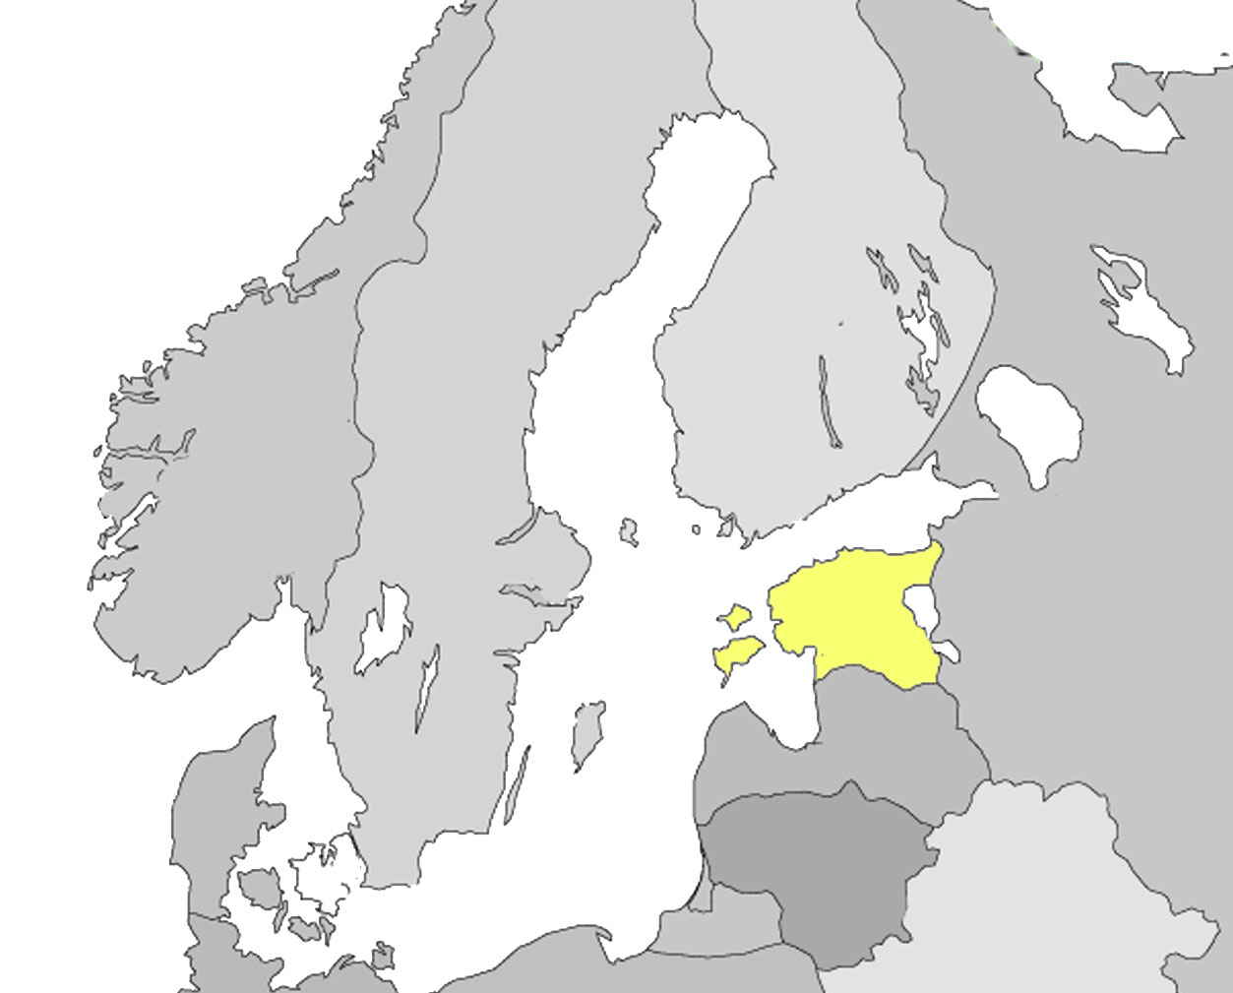
Capital city: Tallinn
Official language: Estonian
Population 2007: 1 342 409
The biggest language minority groups: Russians, Ukrainians.

1. Population / Definition

Estonian legislation does not apply the term ‘immigrant’. The terminology with regard to immigration is based on citizenship. The Aliens Act defines the term ‘alien’ as a person who is not a citizen of Estonian Republic. In legislation on education (National Curriculum for Basic and Secondary School, 2002) the term ‘pupil who has arrived from abroad’ is used, referring to a pupil whose mother tongue or home language differs from the instruction language of the school and who has been living in Estonia for less than 3 years.

The current Estonian population is 1 342 409 people. The State language of Estonia is the Estonian language. Official statistics contain data on the mother tongues of the population. 69% of the population defines themselves as being Estonians.

Citizenship is one of State's main characteristics. The expansion of Estonian citizenship and the closer integration of non-citizens into the society have been important issues since Estonia regained its independence in 1991. According to the Census 2000, citizens of 75 states live in Estonia as permanent residents. The majority of residents (98,7%) are distributed into 3 major groups:
- Estonian citizens (80 % of population)
- Russian citizens (6,3%)
- Aliens with unspecified citizenship (12,4%).

Currently the situation is slightly different: the number of aliens with unspecified citizenship and Russian citizens has decreased and the number of citizens of other states has slightly increased.

Table 1: Estonian residents per citizenship in 2007
 | 2007
Estonian citizens | 83%
Aliens having unspecified citizenship | 9%
Citizens of other states | 8%

The composition of the citizenry of a state is connected to the number of residents of foreign origin and their integration into society. Among the permanent population of Estonia, 81 % of the people are born in Estonia. Except for the people who are born abroad, the population with a foreign origin includes the second generation who is already born in the State of residence. Given this fact, the proportion of the native population is significantly small in Estonia. People who are born in Estonia and have at least one parent who is born here constitute less than 75 % of the permanent population in 2000.

Although the number of Estonian citizens among the permanent population is close to the number of persons born in Estonia (about 1.1 million), these population groups are not entirely identical. Many people who have been born abroad have acquired Estonian citizenship by naturalisation (passing language and citizenship test and living in Estonia more than 5 years etc) or due to being descendants of native-born Estonians. At the same time, part of the second generation of immigrants who have been born in Estonia, have not yet acquired citizenship.

Integration of the immigrant society depends on how compact or scattered the immigrant communities are among the native-born. Estonia, as well as other European immigration destinations, is characterised by a very uneven distribution of immigrants in the country. This also has an influence on the composition of citizenship in different regions. Non-citizens of Estonia live mostly in towns. Estonian citizens constitute 79% of the urban population and 95% of the rural population. Estonian citizenry is relatively young (see table 2).

Table 2: Average age by citizenship
Citizens | Non-citizens
38 years | 41,4 years

Immigrants can be divided into 3 groups:
- EU citizens, citizens of EEA and Swiss Confederation
- asylum seekers and refugees
- citizens of third countries

Different conditions and requirements for granting resident and work permits are applied to different groups. The Immigration quota is applied to immigrants from third countries. During recent years the quota has been 0,05% of the Estonian overall population. The immigration quota is not applied to citizens of the United States of America and Japan. The quota also covers family members, incl. children.

During the last decade a relatively small number of people have applied for asylum or international protection in Estonia (see Chart 1). In most cases, the asylum applications have been rejected (see table 3).

16 % of asylum seekers or applicants for international protection have arrived from Iran, 15 % from Russia, 13 % from Turkey, 6% from Afghanistan and Pakistan, 5 % from Belarus and Georgia, 4 % from Nigeria and 1–4 persons respectively from 18 different countries.

Among asylum seekers, there were 16 Children and youths up to 18 years during 1997–2007. 3 of them studied for a short period in a basic school close to Asylum Seekers Centre.
Chart 1: Number of asylum seekers 1997–2007.
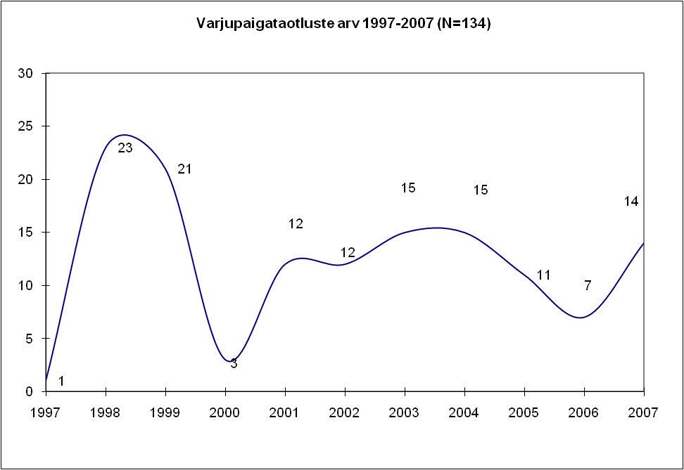

Table 3: Decisions on asylum 1997– 2007.
Asylum | 6
Subsidiary protection | 12
Rejection | 23
Refusal | 49
Procedure has been completed or terminated | 30
 | 120

2. Data

Based on the constitution of the Estonian Republic, the State is obliged to ensure all people the possibility to acquire education. Everyone has the right to receive instruction in the Estonian language (Constitution, § 37). In Estonia, basic education is the compulsory level of schooling.

Pre-school educational institutions, basic schools (grades 1–9) and private schools can choose any language to be the language of instruction, based on the decision of the owner.

In secondary level (grades 10– 12) the language of instruction is Estonian.
Currently in Estonia it is possible to acquire education in Estonian, Russian, English and Finnish.

Pre-primary education:
78,4% institutions - language of instruction is Estonian
13 % - Russian
0,2 % - English
8,4 % - Estonian and Russian.

Basic and secondary education:
83% Estonian language medium schools
16,5% Russian language medium schools
3 English language medium schools
1 Finnish language medium school
1 sign language medium school

In the academic year 2007/08 19% of pupils studied in Russian language medium
schools According to official statistics, in Estonian language medium schools there
were approximately 5200 pupils whose mother tongue was different from the
language of instruction of the school; most of them had Russian as their mother
tongue. In Russian language medium schools there were 640 pupils whose mother
tongue was different from the school’s language of instruction.

According to official statistics in the academic year 2007/08, 79 pupils in basic schools arrived from abroad (cf. Table 4).
Table 4: Recent immigrants in Estonian schools in 2007/2008
Mother tongue | Estonian | Language immersion - Estonian | Grand Total
Abkhaz | 2 |  | 2
Armenian | 1 |  | 1
Estonian | 22 |  | 22
Estonian/Russian | 2 |  | 2
Spanish | 4 |  | 4
English | 9 |  | 9
Italian | 14 |  | 14
Norwegian | 1 |  | 1
Polish | 1 |  | 1
German | 4 |  | 4
Finnish | 3 |  | 3
Russian | 15 | 1 | 16
Grand Total | 78 | 1 | 79

In 2004, the distribution of citizenship among pupils in general education schools was as follows:
- 82 % pupils had Estonian citizenship
- 15% had unspecified citizenship
- 2% had another citizenship

According to the Estonian Information System on Education, there are currently no children of foreign origin learning in special schools or classes.

Based on a survey of school heads (2007), there were 6 (Roma, Latvian, Russian) pupils studying in special schools in the current academic year who are born outside Estonia and whose mother tongue is other than the instruction language of the school. However, as they have been living in Estonia longer than 3 years they cannot be classified as ‘pupils arrived from abroad’.

In the academic year 2006/07, 4.6 % of basic school pupils studied in special schools, 11 % of pupils had special needs and studied in mainstream classes and 1 % of pupils had special needs and studied in special classes inside mainstream schools.

Russian speaking pupils with special needs have the opportunity to receive Russian language instruction also in special schools and classes. However, the availability and quality of Russian language special education is regionally different, and in regions where the number of the Russian speaking population is small, parents of a Russian speaking pupil with special needs usually opt for an Estonian language school for their child.
Table 5: Number of pupils in special schools according to language of instruction
Language of instruction | Estonian | Russian | Total
School for children with SEN | 3726 | 884 | 4610

There are 48 schools for students with special needs in Estonia (7 % in general education schools): 2 for students with hearing impairments; 1 for students with multiple disabilities; 1 for students with physical disabilities; 1 for students with visual impairments; 5 for students with behavioural difficulties and psychological problems; 3 for students with health disorders and the rest for students with learning disabilities.

Proportion of special needs pupils has been constantly increasing in daytime study. More and more special needs pupils study in mainstream schools, the number of pupils in special schools has remained stable. In 69 mainstream schools (11 % of schools), classes for special needs pupils have been established. The overall number of pupils in general education in Estonia is decreasing, as it is in many European countries.

Table 6: Number of pupils with special needs in general education
2003/2004–2004/2005-2005/2006
Type of special need | 2003/04 |  |  | 2004/05 |  |  | 2005/06
Type of special need | Special school | Mainstream school |  | Special school | Mainstream school |  | Special school | Mainstream school
Type of special need | Special school | Mainstr.class | Special class | Special school | Mainstr.  class | Special class | Special school | Mainstr.  class | Special class
Specific learning difficulties | 807 | 5686 | 892 | 827 | 6538 | 862 | 772 | 7320 | 833
Mild intellectual disability( simplified curriculum) | 2058 | 343 | 243 | 1866 | 394 | 267 | 1776 | 420 | 267
Moderate and severe intellectual disability | 602 | 33 | 97 | 637 | 56 | 88 | 708 | 20 | 84
Profound intellectual  disability | 157 |  | 57 | 171 |  | 67 | 175 |  | 43
Hearing impairment | 168 | 49 | 10 | 173 | 36 | 10 | 148 |  | 11
Physical disabilities | 97 | 113 |  | 137 | 92 |  | 253
Speech disorders | 229 | 13809 |  | 226 | 13801 |  | 1750 | 10012
Visual impairment | 72 | 65 |  | 83 | 62 |  | 52
Emotional/psychological and behaviour problems | 138 | 154 |  | 142 | 211 |  | 147 | 23
Behaviour difficulties | 131 |  | 560 | 162 |  | 611 | 148 |  | 542
Chronic health problems | 606 |  |  | 510 |  |  | 354 | 1831
TOTAL | 5065 | 20252 | 1859 | 4934 | 21190 | 1935 | 6283 | 19626 | 1780
Proportion from basic school pupils | 2,6% | 10,5% | 1,0% | 2,7% | 11,5 | 1,0% | 4,6% | 11,3% | 1,0%
Source: Estonian Information System on Education.
3. Provisions

3.1. National legislation, services provided to pupils with special needs
A pre-school institution for children with special needs is generally a mainstream nursery school [‘'lasteaed]’ (630), and in certain cases a nursery school for children with special needs (there are only 3 of these). In a child care institution, children with special needs may attend an integration group (1-2 children together with healthy children) or a special group (children who need special care and instruction). In 137 pre-school institutions there are special groups for children in need of special care and instruction.

At the basic education level pupils with special needs study in mainstream classes or special schools/classes. In Estonia, the legislation on education is based on the principles of inclusive education. However, inclusive provision is enforced step by step as indicated by education statistics on special needs pupils in mainstream and special schools (see p 2).

In Estonia, a wide definition of special educational needs is applied, covering all pupils whose special talent, learning difficulty, behaviour or health problem, disability etc. causes a need to make changes or adaptations in the contents or arrangements of their studies or in their learning environment (study form, facilities, study material, methods, language of instruction, specialised teachers, support staff).

Studies of special need pupils are organised according to the Basic and Secondary School Act and Education Act. According to the Education Act, each child has the right to attend the school closest to their residence and follow a suitable curriculum (the national curriculum for basic schools ([''põhikool'']) and upper secondary schools ([''gümnaasium'']); the simplified national curriculum; the national curriculum for students with moderate and severe learning disabilities) and receive different kinds of support. Classes for children with special needs shall be established in mainstream schools. This requirement applies to all pupils irrespective of their mother tongue and time of arrival to Estonia.

To ensure the integration of children with special needs into society, they shall be taught within mainstream education, if possible. The aim of support systems is the personal development of a student, considering his or her individual peculiarities in organising schooling and education.

According to the Basic and Secondary School Act, compulsory school attendance can also be effected while studying at home. Arrangements for home studies are provided by law.

In groups (nursery schools, schools) for children with special needs, national curricula of the education level concerned are applied as general framework study programmes.

Schooling and education in pre-school childcare institutions should be based on the framework study programme of pre-school education. Children have the right to get assistance of teachers in acquiring the content determined by the curricula.
In basic schools [‘põhikool’] and upper secondary schools [‘gümnaasium’], the national curriculum for basic schools and upper secondary schools is valid also for students with special needs as framework curriculum. In addition, the simplified national curriculum (for students with mild intellectual disabilities) and the national curriculum for students with moderate and severe intellectual disabilities have been adopted by the regulation of a Minister of Education and Research. For students with special needs, also an individual curriculum may be compiled on the basis of the national curriculum to take into account their abilities and peculiarities.

The duration of study and daily timetables for pupils with special needs is established by the regulation of the Minister of Education and Research.

The duration of study in stages of basic school [‘põhikool’] curriculum:
- for students with speech impairments is 10 years; the duration of study in the first stage of study (years 1–3) is 4 years;
- for students with hearing impairments it is 11 years; the duration of study in the first and second stages (years 1–3 and 4–6) of study is 4 years each;
- for deaf students it is 10 years, the duration of the second stage of study is 4 years;
- for students with visual impairments it is 10 years; the duration of the third stage of study (years 7–9) is 4 years;
- for students with learning difficulties who study on the basis of a simplified curriculum, the duration of basic education may be prolonged by one year;
- for students with severe learning difficulties who study on the basis of a national curriculum for students with moderate and severe disabilities, the duration of basic education may be prolonged by 3 years;
- for students with profound learning difficulties who study on the basis of a national curriculum for nursing schools, the duration of basic education may be prolonged by up to 3 years.

The weekly study load of pupils is 20 hours in the first stage of the study, 22 hours in the second stage of study and 24 hours in the third stage of study.

In schools for pupils with chronic health problems, the timetable determined in the national curriculum of basic and upper-secondary education is applied, while taking into account the needs of students.

In Estonia, there are no special provisions for special needs pupils who have arrived from abroad. This approach has been justified by the small number of pupils (and no special needs pupils) arriving from abroad. However, there are the following possibilities for support services in schools, which are available to all pupils:
- individual curriculum;
- remedial groups for providing learning support for students with learning difficulties;
- speech therapy;
- long day groups;
- studying at home (with the possibility to attend lessons of music, arts, handicraft and physical education);
- classes for pupils with behaviour problems;
- boarding school facilities for children who have social problems;
- support of special education teacher, social teacher, psychologist ;
- remedial learning to overcome learning difficulties;
- smaller classes (in classes for children with special needs, the number of students is smaller);
- additional learning and rehabilitation subjects (music therapy, etc.)
- communication support (sign-language interpreter, study material in Braille, adapted study material, etc.).
Differentiated and oral assessment is prescribed in the case of students with special needs, and they have the right to an adjusted learning environment.

Pupils who have arrived from abroad have mainly benefited from individual curriculum, remedial teaching and speech therapy due to insufficient skills of the language of instruction and differences in the content of curriculum in different countries.

Table 7: Support services applied to pupils who have arrived from abroad
(number of cases per grade)
Support measure | 1. | 2. | 3. | 4. | 5. | 6. | 7. | 8. | 9. | Grand Total
Extra classes of Estonian as a second language | 13 | 7 | 4 | 3 | 2 | 1 | 2 | 1 | 2 | 35
Individual study plan | 2 |  |  | 3 |  | 2 |  | 1 |  | 8
Speech therapy | 7 | 2 | 7 | 2 | 2 |  | 1 |  | 3 | 19
Counselling | 1 |  |  |  |  |  | 1 |  |  | 2
Remedial teaching | 2 |  | 4 | 1 | 1 |  | 1 | 1 | 4 | 14
Support person | 1 |  |  |  |  |  |  |  |  | 1
Grand Total | 26 | 9 | 15 | 9 | 5 | 3 | 5 | 3 | 9 | 79

3.2. Teaching methods and instruments
Instruction has to correspond to the individual needs of a student. Physical and mental activity of students is encouraged and developed. Students with visual impairments are supplied with books in the Braille system and other study materials. While teaching deaf students, sign language is used in combination with oral instruction (bilingual teaching). Students with hearing disabilities are taught orally and the duration of study is extended for 1–3 years. In upper secondary schools, vocational schools and higher education institutions, sign language interpreters are used. In the case of students with physical disabilities, special methods (e-study, IT support, etc) are used to guarantee the acquisition of schooling. In the case of severe and multiple disabilities, methods such as imitation learning, modelling, etc. are in use.

3.3. The Information provided to the parents / Admission conditions, choice of school
Conditions for supporting the development of all pupils have been established, and the pupil together with his/her parents shall be involved in the decision-making concerning their studies. Parents can choose an educational institution for their child, provided there are available places in the school of their choice (§ 18, Basic Schools and Upper Secondary Schools Act). This means that the parents can choose a school for the child, but each child also has the right to be admitted to the school which is located nearest to his home.

There are no special information materials on study opportunities for parents of pupils arriving from abroad. On the website of the Ministry of Education and Research, there is information on the Estonian education system in English and Russian, incl. a short introduction to special education issues and support systems. Additional measures concerning language development can be applied to pupils arriving from abroad.

In basic school (years 1-9) the student moves forward along with his age group, provided that his performance meets the requirements of the curriculum. In a case of learning difficulties (due to language, social, psychological or other factors) individual support is provided according to the needs of pupil concerned. In a case of a pupil who has arrived from abroad, the teachers’ council of the school decides which year a pupil will continue his or her studies.

3.4. Curriculum
Each school prepares its own curriculum on the basis of the national curriculum (§ 1).
The Estonian school stands for the preservation and development of the Estonian nation, supports the cultural identity of ethnic minorities residing in Estonia, the mutual understanding and co-operation of people residing in Estonia and considers the integration of Estonia into Europe. The substance of study represents the culture of mankind, Europe, Estonia, incl. the national minorities living in Estonia.

Teaching Estonian as a second language
Estonia ensures the possibilities for learning the Estonian language in all non-Estonian public educational institutions and study groups. In a school or class where instruction is not given in Estonian, Estonian language instruction is compulsory beginning from the first year.

Teaching the native language
In co-operation with the State and the relevant local government, schools shall offer students who are acquiring basic education and whose native language is different from the language of instruction at the school the opportunity to learn their native language and to learn about their national culture with the objective of preserving their national identity. The conditions and procedure for offering students the opportunity to learn their native language and to learn about their national culture were established in 2003 by Regulation No. 154 of the Government of the Republic.

Non-Estonian children with special needs are subject to all provisions (rights of learners, obligations of educational institutions etc) on equal basis with Estonian children.

3.5. Financing
Since January 2008, transition to a new model of financing of education started in Estonia. Studies of special needs pupils are funded on equal bases compared to mainstream pupils plus an additional amount according to the need for special support. In addition, there is additional funding for complementary lessons according to the special curriculum.

Table 8. Additional funding per special need pupil
Type of special education | Special class* | Special education  (adapted curricula, 4 hours) | Home studies | TOTAL (additional lessons per week)
Mainstream class, simplified curriculum | - | +2 lessons | - | 2
Mainstream class, curriculum for pupils with moderate and severe learning difficulties (MSLD) | - | +4 lessons | - | 4
Special class, MSLD | +1 lesson | - | - | 0 – 1
Special class, simplified curriculum | +1 lesson | +2 lessons | - | 2 – 3
Special class, MSLD | +1 lesson | +4 lessons | - | 4 – 5
Home studies for health reasons, mainstream curriculum | +1 lesson | - | +4 lessons | 4 - 5
Home studies, simplified curriculum | +1 lesson | +2 lessons | +4 lessons | 6 - 7
Home studies, MSLD | +1 lesson | +4 lessons | +4 lessons | 8 - 9
Immigrant | - | +4 lessons | - | 4

4. Support measures

The Estonian Information System for Education provides information on support systems applied to pupils in mainstream education, incl. special needs pupils. In the framework of national monitoring, there has been a study on the results on study outcomes of different support measures applied in mainstream schools. However, the study did not differentiate among pupils with and without special needs. The study indicates that irrespective of the applied measures there is no significant improvement in study outcomes. At the same time, it is not possible to establish clear connections between the application of support measures and study outcomes, i.e. causal connections.

Due to the very small number of pupils arriving from abroad, there has been no special research on studies of immigrant pupils, i.e. immigrant pupils with special needs.

In 2004-2005 a study was conducted among parents of disabled children, in order to map the situation and expectations of parents towards the education system. The study indicates that in theory parents support the principles of inclusive education. However, in practice they prefer to choose a special school or class for their child. Parents pointed out that mainstream schools are not ready to provide the necessary support to disabled children. Parents believe that special schools are better prepared to develop their children and to provide suitable learning environment (special study material and physical environment). Mainstream schools are favoured because they ensure better integration into society and prevent the development of acquired helplessness syndrome. However, neither teachers nor learning environment are perceived as ready to welcome pupils with special needs. It generates a sense of frustration and seclusion both in children and parents.

In 2006 a survey was conducted, in order to get an overview of readiness of schools and local governments as school owners to welcome pupils arriving from abroad. In the survey, no special attention was paid to immigrant children with special needs. The results of the study show that only 13% of local governments (and no county governments whatsoever) and 35% of educational institutions consider it to be a very important or rather important subject. It is predicted that the subject will take on slightly more significance within the next few years, but this change will not be noteworthy. 13% of local governments, 30% of county governments and 33% of schools had had experience with children of new immigrants. Children of recent immigrants are currently studying in 28% of Estonia’s general education institutions. All of the stakeholders involved in the study (county and local governments and educational institutions) show some dissatisfaction with the organisation of the integration of the children of new immigrants into the education system. The most negative assessment comes from school representatives, who feel that they have been forced to bare full responsibility and that no complete approach to the field as a whole has been adopted. The adequacy of curricula in terms of actual needs, teacher training in higher education institutions, development of a support network for children’s integration, the statistics and reporting system, and the movement and availability of information were all given relatively negative assessments. The parties expressed greatest dissatisfaction with the current state of the principles and resources for financing, and of teaching materials. The legal framework, the educational model for children of new immigrants and the way the system of in-service training for teachers works all received a more positive assessment compared to other parts of the education organisation system.

In addition to the substantive problems, relatively negative assessments were also a result of the different expectations of the stakeholders and the lack of detailed information related to the tasks and duties of different institutions and existing opportunities.

The majority of parties had not had active experience working with partners on the integration of the children of new immigrants into the education system. Closer co-operation has taken place between the main stakeholders – ministry, local government and schools. Those county and local governments and schools that had had experience in working together found the co-operation successful. 5% of educational institutions assessed their level of preparedness as very good, 10% as good, 21% as satisfactory and 30% as bad. In a comparison of different levels of education, preparedness is generally positive. Work with the ministry, local governments and schools were considered to be rather good, while co-operation with service providers and international partners also received a positive assessment. Partnerships with the private sector were given a more negative assessment.

In the view of those who participated in the study, 50% of county governments and 44% of local governments are well or satisfactorily prepared for admitting the children of new immigrants.

A major problem in improving preparedness for both county and local governments and schools is the lack of knowledge and skills among staff. In the case of local and county governments there is also a lack of staff, while schools suffer from a deficit in teaching resources and a lack of funding. The support measures considered most needed by local and county governments and educational institutions are those which directly contribute to raising the quality of the education of children of new immigrants (Estonian language studies, in-service training for teachers, teaching materials, working with parents, individual curricula and preparatory classes). Measures directed at advisory services and those designed to improve the exchange of information were also considered to be important (improving the availability of information, providing advisory services and creating a social support network). Measures which support the learning process and the integration of children of new immigrants less directly (language and culture study camps, supervision, teacher exchange programmes and studies of the native language and culture of the children of new immigrants) and organisational support methods (resolving transport problems and establishing ‘settling in’ centres) were assessed as being of less importance.

Local governments and educational institutions, within individual projects or continuously, have been most active in implementing the following measures: provision of in-service training to teachers (26% of local governments and 38% of schools, respectively); and creating opportunities to learn Estonian (25% of local governments and 46% of schools, respectively).
In the case of local governments, the organisation of language and culture study camps (30%) can be added to the list as well, while educational institutions have also worked with the parents or guardians of the children (37%) and developed specialised teaching materials (23%).
Less frequently, county and local governments have dealt with resolving the transport problems faced by children (18%), developing a social support network (15%), improving the availability of information (13%) or providing advisory services (10%). Virtually no local governments (only 3%) have established ‘settling in’ centres.

Based on a survey of school heads (2007) there are very few pupils in Estonian special schools whose mother tongue differs from the language of instruction, and there are no immigrant children with special needs among them. As the most serious problem, insufficient language skills by pupils, their parents and teachers was indicated by the school heads. The schools could rearrange the study process for foreign pupils by adding extra language lessons, but it is difficult to find additional financial resources to cover extra instruction and to find and buy study material according to pupil's special need. School heads appreciate the opportunity to apply individual teaching or teaching in small groups where pupils learn to support each other as a main factor to success. Communication with parents could be problematic due to the lack of common language. Knowledge of different languages among teachers is seen as an enriching factor and school heads are willing to support teachers in language studies concerning pupils' mother tongues.

5. Assessment
According to legislation, parents can freely choose a school for their child, and a pupil is admitted to a school on the basis of the parent’s application. Children with special needs are recommended a school or class suitable for their needs by a counselling committee but a parent decides whether the child shall go to a recommended school for children with special needs or to a mainstream school.

If a student of years 1 and 2 of basic school cannot fulfil the requirements of the curriculum, the school shall direct him or her with the consent of a parent to a special education teacher, speech therapist, social teacher, educational psychologist or to psychiatrist, if necessary, where the reasons of lag in development shall be identified. If the lag is connected to a disability, measures shall be taken to guarantee the student opportunities to acquire education suitable for his or her abilities.

On the basis of medical, psychological and pedagogical research, children with special needs are recommended a suitable nursery school or a group or a curriculum or a school suitable for their abilities. A child with special needs is admitted to an integration group or a group, class or school for children with special needs on the basis of a written application from a parent and a decision of the counselling committee.

A counselling committee shall comprise five members. A counselling committee shall include a special education teacher, a speech therapist, a psychologist, a social worker, a medical specialist (if needed) and a representative of the county government or of the city government accordingly. A counselling committee is competent to:
- assign to a student with special needs a curriculum or a form of study suitable for the abilities of the child;
- refer a student with special needs to a school or class for students with special needs with the consent of a parent (caregiver);
- decide postponing the obligation to attend school at the request of a parent.
When attendance of a school for students with special needs is no longer necessary, a student has the right to continue his or her studies in his or her former school.
Although insufficient skills in language of instruction can be understood as a special need, under the current system it is not possible to recommend a pupil who has arrived from abroad, a special school or class.

References
- Uusimmigrandid Eesti haridusasutustes (Newly arrived children in Estonian Educational Institutions). Uuringuaruanne. 2007. Mitte-eestlaste Integratsiooni sihtasutus. http://www.meis.ee/book.php?ID=165
- Kokkuvõte Eesti Puuetega Inimeste Koja poolt 2004–2005. a läbi viidud erivajadustega lastega perede uuringust (Reseach about the Families, where are growing children with special needs). http://www.epikoda.ee/include/blob.php?download=epikmain1&id=0925
- Statistika andmebaas: Rahvastik. ( Statistics: Population)2007
- http://pub.stat.ee/pxweb.2001/Database/Rahvastik/01RAHVASTIKUNAITAJAD_JA_KOOSSEIS/01RAHVASTIKUNAITAJAD_JA_KOOSSEIS.asp
- Eesti Hariduse Infosüsteem. (Estonian Educational Information Database). 2007-2008.

