SUPPORTING THE IMPROVEMENT OF QUALITY IN INCLUSIVE EDUCATION IN POLAND
(PHASE II)
Peer Learning Activity 12th July 2021

Legislative developments in Greece aiming to prepare all learners for transition to adult and working life

Prepared by:
Athina Anna Christopoulou, Head of Unit C (Protection of the Rights of Pupils with Disabilities and/ or Special Educational Needs), Directorate of Special Education, Hellenic Ministry of Education & Religious Affairs
Alexandros Stamatios Antoniou, Associate Professor at the National and Kapodistrian University of Athens, Faculty of Primary Education, School of Education
Dimitrios Souliotis, Head of Vocational Training Implementation Directorate, Hellenic Ministry of Education & Religious Affairs

This document was produced with the financial assistance of the European Union.
The views expressed herein can in no way be taken to reflect the official opinion of the European Union.
Contents
Introduction 3
1. BACKGROUND AND FOCUS 4
1.1 Stimulus/rationale for the legislative change / policy development work in this area 4
1.2 Policy vision, aims and objectives 7
1.2.1 The development and implementation of the Strategic Action Plan for the Equal Access to Education of Students with Disability 8
1.2.2 The implementation of universal reforms at all aspects of the system for the promotion of inclusive education 9
1.2.3 Reforming the National System of Vocational Education, Training and Lifelong Learning 10
2. IMPLEMENTATION 12
2.1 Dates/timescale of developments 12
2.2 Steps taken in implementation 13
2.2.1 Strategic Plan 13
2.2.2 Wider reforms 20
2.2.3 Vocational Education and Training 22
2.3 Key participants/partnerships 32
3. DEVELOPMENT 34
3.1 Challenges, opportunities and lessons learned 34
3.1.1 Challenges 34
3.1.2 Key success factors 35
3.2 Evaluation and plans to sustain/further develop the work. 37
A NOTE OF CONCLUSION 37

Introduction
The Phase II Action under the Structural Reform Support Programme in Poland aims to support the development of new legislation to improve the quality of education for all learners. The Polish legal process requires that prior to the preparation of new legislation, the underpinning assumptions are clearly identified and discussed with stakeholders. The assumptions form the conceptual framework for the new legislation, identifying the operational definitions and key concepts that will be the basis for the new law. They will inform the development of a clear rationale for the work and the vision, goals and objectives underpinning new legislation.
MEiN wishes to help schools to support an effective transition to adult and working life and to make communities aware of the benefits of educational and wider social inclusion. In this way, developments can draw on the social capital of communities to extend opportunities and support for learners from potentially marginalised groups.
MEiN therefore want to explore examples of work from other countries relating to Assumption 2 that will underpin their new legislation. Country representatives from Greece are asked to take this assumption into account in preparing their input.
Assumption 2
Schools will act as a catalyst for social inclusion, support all learners to move with their peers through all phases of education and prepare them for the transition into the labour market and adult life.
Schools should reflect the diversity of their communities in order to prepare all learners for life in a more inclusive society. With a focus on equity, schools should draw on the resources of the local area to provide positive learning opportunities for all learners with their peers. Processes should be in place to ensure that transitions between schools and phases of education provide continuity of learning and support and that information about potentially vulnerable learners is shared.
In particular, MEiN have requested information on preparing learners with disabilities for entry into the labour market. This should build on a full yet flexible school curriculum with opportunities for recognition of wider learning (including formal, informal and non-formal). Ministries as well as regional/local agencies should collaborate with employers, colleges and other relevant stakeholders to develop training and accreditation. This should also be flexible, for example with scope to study individual modules and gain accreditation for part qualifications. Key will be the development of prospective work opportunities and pathways, in particular for learners with intellectual disabilities.

1. BACKGROUND AND FOCUS

1.1 Stimulus/rationale for the legislative change / policy development work in this area
The development of a high quality equitable education system has been one of the central missions the Greek State has undertaken throughout the years. This fact is being reflected on a series of measures that have been taken in this direction. However, more recently the recognition of inclusion as the key to achieving the right to education has become even more prominent due to certain reasons.
- Statistical data indicate a dramatic increase in the number of students with disability as well as students belonging to other socially vulnerable groups that attend mainstream schools.
- A number of European and international level recommendations, including the CRPD suggestions & the 2030 Agenda for Sustainable Development Goals, indicate that promoting inclusive education is necessary for the country’s sustainable growth
- Empirical and research evidence indicates that despite the steps already taken, there are still various challenges. To mention just a few:
  - At policy level, until recently there was no comprehensive educational sector plan with specific indicators and time frames that targeted inclusive education.
  - At the meso level, a major barrier has been the fact that a rigid focus on diagnostic (health/medical) categorisations of “disability” in practice has undermined the focus on the inclusion of ALL students
  - At the micro level, there still is a mismatch between the discourse on inclusion and its implementation and a lack of confidence among teachers in their effort to respond to the diversity of needs of all learners.
Along with the above considerations, in September 2019 the UN Committee on the Rights of Persons with Disabilities reviewed the educational policy of Greece regarding its compatibility with the Convention of the Rights of Students with Disabilities. Recalling its General Comment No. 4 (2016) on the right to inclusive education, and taking into account Sustainable Development Goal 4, the Committee recommended that Greece increase its efforts to guarantee inclusive education. In particular the Committee recommended that Greece:
    - Adopt and implement a coherent strategy on inclusive education in the mainstream educational system;
    - Ensure the accessibility of school and university environments, in line with the Convention, by promoting universal design, the provision of specific measures and individualized support, such as accessible and adapted materials, inclusive curricula, inclusive information and communication technologies for pupils and students with disabilities, and digital pedagogy;
    - Immediately ensure access to formal education for all asylum-seeking refugees and migrant children with disabilities, and for Roma children with disabilities;
    - Allocate effective and sufficient financial and material resources and adequately and regularly trained personnel, including persons with disabilities, to effectively guarantee inclusive education;
    - Incorporate inclusive education training into higher education curricula for trainee teachers, and into training programmes for current teaching staff, with an adequate budget.
In the light of the above concerns and recommendations, in 2019 a special technical group was formulated which consisted of members of the political leadership and competent officials of all Ministries. The committee reflected on the current situation in the Public Administration -at all fields of the state- and elaborated an extensive series of proposals aimed at establishing a National Action Plan for Disability. These processes resulted in the formulation of the first National Action Plan for the Rights of Person with Disabilities, drawn up under the coordination of the Minister of State. The National Action Plan was formulated in accordance with the United Nations guidelines, and finalized in consultation with the disability movement and civil society. The National Action Plan is currently being implemented and provides a wide array of actions in the field of education for students with disabilities and/or special educational needs.
Following the finalization of the National Action Plan for the Rights of Persons with Disabilities, the Strategic Action Plan for the Equal Access to Education of Persons with Disabilities was formulated by the Greek Ministry of Education. The Strategic Action Plan, which was an extension of the National Action Plan for the Rights of Persons with Disabilities, comprises 13 operational objectives, with a clear implementation deadline in key areas of inclusive policy and practice.
The above two Action Plans constitute a ‘roadmap’ that provides a clear, coherent and systematic framework for action on issues related to the protection of the rights of people with disabilities, mainly for the period 2020-2023. Therefore, their implementation is an absolute priority for the Greek Ministry of Education.
However, along with the implementation of the above plans, it should be stressed that a wide range of reforms are currently being carried out at all levels of the educational system. These reforms are mainly targeted at school upgrading and providing quality education for ALL children.
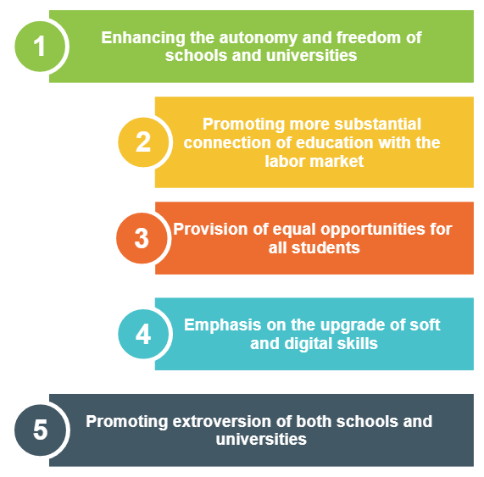
In this context, the main policy goals of the reforms are the following:
Last but not least, currently a holistic reform is being attempted in Vocational Education and Training and Lifelong Learning. In this context, a new law has been introduced (law 4763/2020), which attempts to make vocational education and training a conscious, quality choice for many students and especially for those who wish to enter the labor market early with increased professional qualifications. Through this reform the country attempts to align its policies with those of the European Union, recognizing that Vocational education is directly linked to employment, economic prosperity, social cohesion and individual participation in society.
In its attempt to align with the European directives, the reform took several sources into account, including:
- the recommendations of the European Commission related to skills development,
- the European Framework for Quality and Effective Apprenticeship Schemes,
- the Draft Recommendation concerning Vocational Education and Training,
- the European Semester,
- the European Skills Agenda,
- CEDEFOP studies,etc

1.2 Policy vision, aims and objectives
As stated above, following the evaluation of Greece by the UN committee on the Rights of Persons with Disabilities (CRPD), the following Action Plans have been formulated and are currently being implemented:
A. The National Action Plan for the Rights of Persons with Disabilities
B. The Strategic Action Plan for the Equal Access to Education of Persons with Disability
Moreover, wide ranging reforms are currently taking place at all levels of the educational system, which attempt to upgrade the quality of education for all pupils.
Indeed, in both Plans as well as in the wider reform that is taking place there is a clear provision for the promotion of inclusive education, as defined by UNESCO, that is “a process that addresses and responds to the diversity of needs of all children, youth and adults through increasing participation in learning, cultures and communities, reducing and eliminating exclusion within and from education”.
In this context, our shared vision is that every student in the Greek state & private schools and Universities receives the support they need to belong to the school community, engages purposefully in learning and experiences academic success. Therefore we are attempting to support the right for students of all social, cultural, community and family backgrounds, and of all identities, and all abilities to receive high quality education, supported by reasonable adjustments and teaching strategies tailored to meet their individual needs.
In order to achieve our mission, one of the main aims of the Greek Ministry of Education is to introduce significant reforms at the level of educational policy that touch on all aspects of the educational system, based on Strategic Plans with specific objectives, projects and indicators. Indicatively it is worth mentioning the following government objectives and initiatives:

1.2.1 The development and implementation of the Strategic Action Plan for the Equal Access to Education of Students with Disability
As mentioned above the Strategic Action Plan, is currently being implemented as an extension of the National Action Plan for Disability in the field of Education.
The Plan aims at the following:
a) To support the right of Persons with Disabilities to equal access to education,
b) To contribute to the removal of barriers to learning and the creation of safe learning environment that can meet the diverse needs of children and young people with disabilities,
c) To contribute to putting into practice the constitutional requirement that guarantees that Persons with Disabilities "have the right to enjoy provisions that ensure their autonomy, professional integration and participation in the social, economic and political life of the country" (Article 21, par. 6).
In other words, the National Action Plan for the Rights of Persons with Disabilities (hereinafter ‘ESD’) is a ‘roadmap’ that provides a clear, coherent and systematic framework for action mainly for the period 2020-2023. It comprises 13 operational objectives, which are further analyzed in projects and actions, with a clear implementation deadline in the following key areas of intervention:

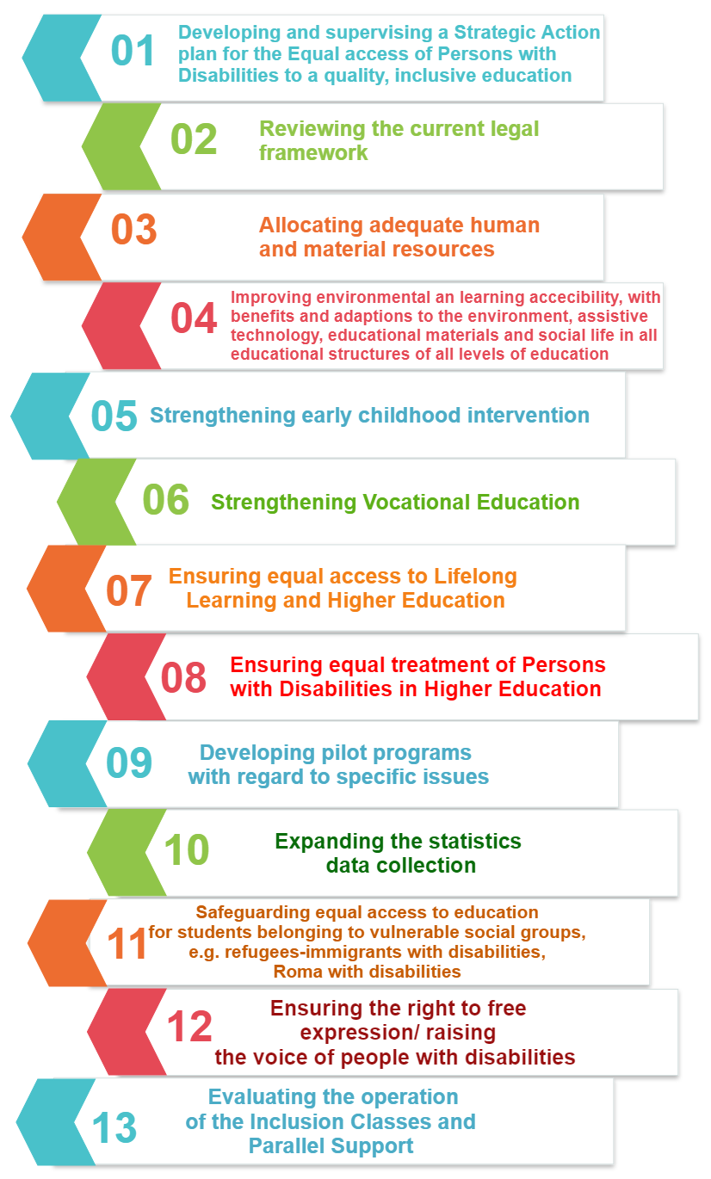

1.2.2 The implementation of universal reforms at all aspects of the system for the promotion of inclusive education
Apart from the formulation and implementation of the above mentioned action plan, important reforms are taking place at this period of time in the Ministry. The main goal of these reforms is to create an inclusive educational system that will effectively act as a lever of social mobility for every child, will support inclusive development in the era of the global knowledge-based society and will shape creative, extroverted and responsible citizens.
The main axes of the policies currently being implemented in this direction are the following:
- Strengthening the provisions of all students, aiming at the transition to an inclusive educational model
- Emphasing the cultivation of "21st century skills" / Skills upgrade
- Investing in teachers' capabilities (training - evaluation):
- Emergency management of the pandemic and identification of new opportunities
- Digital transformation
- Prioritizing and investing in upgrading vocational education and training
- Providing greater autonomy and openness in universities
- Strategic planning of an academic map and admission to higher education.

1.2.3 Reforming the National System of Vocational Education, Training and Lifelong Learning
Along with the above reforms, in December 2020 a new law was introduced reforming the National System of Vocational Education, Training and Lifelong Learning. The law attempts to upgrade Vocational Education and Training in our country with a series of decisions that create conditions for the strengthening of healthy economic competitiveness, the improvement of employment, the decrease in unemployment, as well as the elimination of discrimination and social exclusion.

Specifically the main aim of the reform is a new educational example, which:
  - Firstly, will produce multi-level professional qualifications and strengthen human resources to enter the labour market with high expectations.
  - Secondly, will use three basic institutions, in a rationalized way and within a feedback framework:
- 3 parts (state, students / trainees / employees, employers),
- a mechanism for monitoring and weighing of professional qualifications and
- certification of specific qualifications that will enhance the growth potential of businesses and the economy in general and increase productivity as well as economic growth.
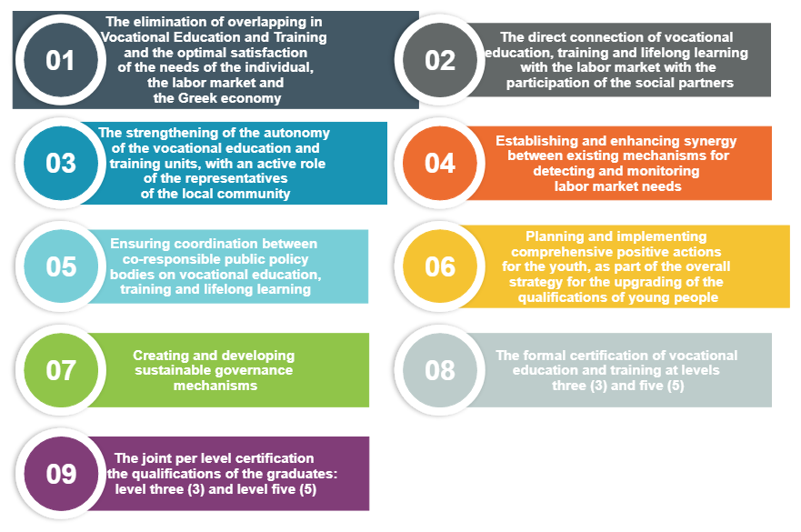
In this context, the new principles of governance of vocational education, training and lifelong learning are as follows:

2. IMPLEMENTATION

2.1 Dates/timescale of developments
Both the National Action Plan for disability and the strategic Action Plan have an implementation timeline that ranges mainly from 2020 to 2023, yet they also include actions that take place over a longer period of time. The individual projects and the actions envisaged in them have distinct and concrete timescales, which may vary depending on case and priorities, but are all developed in this three-year period. The implementation course is monitored by a competent supervisory team.
It should be noted that both Plans have a dynamic character and will be periodically consulted with the disability movement and civil society in order to adapt to the demands of our time and the new needs that are created. In this context, they will be updated, specialized and enriched in accordance with the findings of regular and ongoing consultation.
In relation to the comprehensive reforms implemented in the general and in the vocational education system, which were described above, it is pointed out that most of them have been established and are being implemented. Bills have already been passed on the upgrading of state and private schools, the reform of the country’s vocational education and training system, the establishment of the Hellenic Authority for Higher Education, as well as the entrance into universities and the reinforcement of safety and academic freedom on university campuses.
At present, the submission for voting in the Parliament of a multi-bill is also underway. This will provide:
A. individual evaluation of teachers
B. redefinition of criteria and procedures for the selection of the education leadership
C. strengthening of the autonomy of the school units
D. upgrading of the educational support structures.

2.2 Steps taken in implementation

2.2.1 Strategic Plan
Nine months after the finalization of the Strategic Action Plan for the Equal Access to Education of Students with Disabilities, several steps have been taken for its implementation by all the Directorates of the Ministry. Indicative steps are shown in the table below:

OPERATIONAL OBJECTIVES | ACTIVITIES THAT HAVE BEEN OR ARE BEING IMPLEMENTED
- Developing and supervising a Strategic Action Plan for the equal access of Persons with Disabilities to a quality, inclusive education | - The formation of the Strategic Action Plan has been completed  - A supervisory framework for its implementation has been set up with specific indicators and objectives  - A committee has been set up for the monitoring and evaluation of the progress made with regard to the implementation of the actions of the Strategic Action Plan  - An information campaign is planned concerning the equal access of people with disabilities to education and the promotion of inclusive education
- Reviewing the current legal framework, | - Two Working Groups have been formed and work with the aim of recording and evaluating the existing legal framework as well as mapping the improvements that are deemed necessary for inclusive education.  (one for the general education system on the whole and one dealing more specifically with the additional provisions for persons with disabilities or special educational needs)
- Allocating adequate human and material resources, | - The permanent appointment of 4,500 teachers and special education staff have already been made to support inclusive education and the appointment of another 10,500 teachers is underway.  - Extensive teacher training activities on inclusive education issues are underway
- Improving environmental and learning accessibility, with benefits and adaptations to the environment, assistive technology, educational materials and social life in all educational structures of all levels of education | - 2 physical and digital accessibility committees have been set up which assess the current situation and establish a Universal Accessibility Plan that ensures accessibility to all education services and schools in the country.  - Large-scale actions are being taken to develop accessible material , printed and digital  - An Inclusive Education Guide has been prepared which will be distributed to all schools in the country
- Strengthening early childhood intervention | - An action plan for early educational intervention is currently being prepared, in collaboration with ministries
- Strengthening Vocational Education | - Legislative changes to upgrade the vocational education of students with disabilities are currently underway
- Ensuring equal access to Lifelong Learning and Higher Education, | - Emphasis is placed on upgrading the institution of apprenticeship and improving the connection of students with disabilities to the labor market
- Ensuring equal treatment of Persons with Disabilities in Higher Education | - The legal framework governing higher education with a focus on inclusion and the design of a plan to enhance universal accessibility is in the pipeline  - The accessibility of all higher education structures is recorded  - An Accessibility & Support Committee for Persons with Disabilities has been set up in each Higher Education Institution and a relevant network has been created.  - The inclusive dimension of education is promoted in the University curricula  - Actions are being taken to improve the connection of students with disabilities to the labor market
- Developing pilot programs for specific issues | - Pilot projects are developed on key issues such as: the creation of inclusive school communities, early educational intervention and the upgrading of vocational education
- Expanding the statistics data collection | - The way of collecting data regarding Primary, Secondary and University students with disabilities is upgraded.
- Safeguarding equal access to education for students belonging to vulnerable social groups, e.g. refugees-immigrants with disabilities, Roma with disabilities, | - Statistics have been collected for this vulnerable population and a plan is being prepared to upgrade the educational and psychosocial services provided to them.
- Ensuring the right to free expression/ raising the voice of people with disabilities | - The participation of students in all decisions concerning their educational development is institutionally guaranteed  - The institutions in which a higher percentage of representation of students with disabilities could be secured are being explored
- Evaluating the operation of the Inclusion Classes and Parallel Support | The overall evaluation of the way in which inclusion is approached in our country is underway

*Special Note: Reviewing the current legal framework & devising new legislation
Although much could be said about the implementation of each of the above operational objectives, it might be interesting to have a closer look at the second objective, that is the procedures that are applied in reviewing the current legal framework.
As it has already been stated, Greek Educational Policy casts great emphasis on all students’ right to equal access to education. Within such a framework, one of the priorities of the Hellenic Ministry of Education and Religious Affairs has been the systematic recording and evaluation of the existing legal framework as well as the mapping of the improvements that are deemed necessary for the education of persons with disabilities or special educational needs at all levels of education.
Towards this end, the Minister of Education and Religious Affairs formed a Working Group for Special Education in April 2021. The Working Group commenced its work on the 8th April 2021. With the aim of addressing all education areas, five sub-groups were also formed, that is:
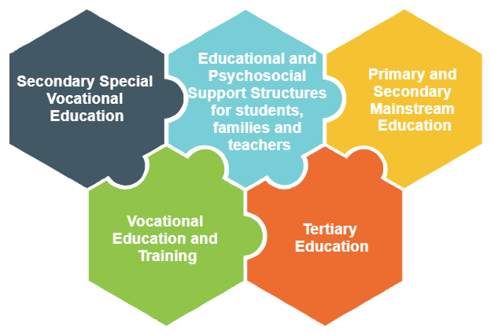
- The sub-group for Secondary Special Vocational Education
- The sub-group for Educational and Psychosocial Support Structures for students, families and teachers
- The sub-group for Primary and Secondary Mainstream Education
- The sub-group for Vocational Education and Training
- The sub-group for Tertiary Education
Within the period between 8th April and 31st May 2021, which was the deadline for the submission of the first deliverable, thirty-six (36) meetings were held in total, both in plenary and sub-groups covering more than one hundred (100) hours of intensive and systematic work via the teleconference mode.

The Working Group presented the following four (4) Draft Provisions.

Draft Provision 1: Programmes of School Transition
Description & Advantages:
- Design and implementation of school transition programmes between (a) different types of school units and (b) different levels of education in each separate school unit
  - The current situation: There is no universal implementation since relevant programmes are being implemented only between pre-primary and primary schools. In this respect, students receive no other transition support.
- Αctive participation of all members of the school community (teachers, special education staff, special support staff, students, parents, guardians) under the Teachers' Board coordination, taking into consideration the official recommendations of the competent Interdisciplinary Educational, Evaluation and Support Committee (EDEAY) or the competent Centre for Educational and Counselling Support (KESY) or the competent Education Advisor, who bears the pedagogical responsibility for inclusive education or the School Life Advisor and/or the Special Education Staff Advisor (E.E.P.).
  - What is the current situation: It is only the teachers of the school of origin and reception that participate with the optional support of the competent Centre for Educational and Counselling Support (KESY)
- Assessment of the programmes in the context of school evaluation
Issues that need to be addressed:
- As the proposal is based on existing structures, the only cost concerns the travel expenses of the staff and students for the visits to school units (origin and reception).
- Detailed issues of the implementation of the school transition programmes are currently being addressed in collaboration with the Institute of Educational Policy (IEP).

Draft Provision 2: Early Intervention Programmes
Description & Advantages:
- Design and implementation of early intervention programmes through the interdisciplinary cooperation of teachers, special education and special support staff of primary schools, the Interdisciplinary Educational, Evaluation and Support Committees (EDEAYs), the Centres for Educational and Counselling Support (KESYs), and with the participation and corresponding cooperation of students’ parents/ guardians.
  - The current situation:
    - The parents’/ guardians’ participation is limited, despite the key role that they play in their children’s development.
    - The component of interdisciplinary cooperation is not considered to be sufficient (eg the contribution of KESY is optional), rendering the collection of opinions from the family a complex process.
- Providing parents/ guardians with the opportunity to submit an application to the competent KESY for the investigation and evaluation of a child's needs, one year earlier than the year of the first enrolment in the pre-primary education level [ prompt measures to support families and students at the beginning of their school life]
  - The current situation: Competent structures intervene only after the child has enrolled in pre-primary education, reducing the effectiveness of the intervention and leading to exclusions in the mainstream school structures.

Connection with the Draft Law: School Structures
Issues that need to be addressed:
- Cooperation/ Coordination with other Ministries: Ministry of Labour, Ministry of Health and Ministry of Digital Governance (General Data Protection Regulation)
- Framework of Pedagogical principles A study with regard to early intervention has already been assigned to the Institute of Educational Policy (IEP) through an National Strategic Reference Framework (NSRF) project.
- Staffing of Interdisciplinary Educational, Evaluation and Support Committees (EDEAYs) and Centres for Educational and Counselling Support (KESYs) with pre-primary school teachers (specialisation PE60/61) as well as special support staff for students who cannot serve themselves.
Draft Provision 3: Establishment of the role of the “Liaison with Apprenticeship” at the Unified Special Vocational Lower- and Upper-Secondary Schools (ENEEGY-L) (for the preparation of students for their participation in the Post-Secondary Year - Apprenticeship Class)

Description & Advantages:
- Introduction of the role of “Liaison with Apprenticeship”, through which an educator at the Unified Special Vocational Lower- and Upper-Secondary Schools (ENEEGY-L) will provide support in order for the students of the 4th grade of EN.E.E.GY-L to make the most of the available opportunities during the next stage which is the "Post-secondary Year - Apprenticeship Class". The opportunities present in this stage often remain unexploited, due to the lack of appropriate guidance.
- «The Liaison with Apprenticeship»:
(α) will ensure the interconnection of a school unit with various employment agencies with the aim of providing Apprenticeship, through finding, preparing and informing employers
(β) will guide and support students and their families both during their studies and during their transition and stay in the employment stage

Connection with the Draft Law: Autonomy of school units

Issues that need to be addressed:
- Provision of motives to take on increased duties

Draft Provision 4: Access to school units’ websites and to the services of the Ministry of Education and Religious Affairs

Description & Advantages:
Ensuring that the content of the school units’ websites and of the services of the Ministry of Education meets the necessary access requirements
- Alignment with the directions of the Minister of the State, Mr. Gerapetritis, regarding the need for access to the school units’ websites and the services of the Ministry of Education

Connection with the Draft Law: Autonomy of school units

Issues that need to be addressed:
- There should be provision for a transitional period
- Costs for creating accessible websites - e.g. for practical instructions, software, certification method, training

2.2.2 Wider reforms
AXES | POLICIES
1) Strengthening the provisions of all students, aiming at the transition to an inclusive educational model | - Reforming the 453 curricula in accordance with the principles of differentiated teaching  - Updating school textbooks in general and vocational education and providing accessible digital content compatible with the reformed curricula  - Ensuring the two-year compulsory education in kindergartens from the age of 4 in all the Municipalities of the country  - Introducing the English language in kindergartens through creative activities  - Strengthening and expanding the institution of model and experimental schools  - Differentiating the methods for assessing student progress (eg introducing project work) in order to make monitoring, evaluation and redesign of the following teaching standards more effective  - Providing more freedom to private schools to develop their educational activities - Building a new relationship of trust in the context of state supervision  - Improvement interventions are currently being carried out for:  - the selection of training staff  - the formation of support structures for the educational work which are closer to the school units
Emphasis put on the cultivation of "21st century skills" / Skills upgrade | Introduction in all primary and secondary schools of the "skills labs" which are structured in 4 thematic pillars (Well-being, Environment, Social Awareness and Responsibility, Creative Thinking and Initiative). Major investments in the digital transformation of the education system and the upgrading of the digital skills of students and staff, building on the universal implementation of synchronous distance learning during the COVID-19 pandemic.
Investing in teachers' capabilities (training - evaluation): | - Crash teacher training courses on distance education  - Systematic strengthening of teachers' skills in basic literacy, skills workshops, new curricula, ICT application in teaching practice, differentiated teaching, vocational training and apprenticeship and issues regarding vulnerable social groups  - Establishing a coherent framework for the evaluation of the school unit and teachers
Emergency management of the pandemic and identification of new opportunities | - Actions to bridge the digital divide during the COVID-19 pandemic (e.g. provision of equipment to schools, zero-rating agreement with telecom companies for data used to access the Education Ministry’s websites)  - Universal implementation of synchronous distance learning at every classroom in Greece from the age of 4 until University and Life Long Learning, whenever educational institutions had to suspend their face-to-face operation during the COVID-19 pandemic. This led to a major digital leap in education. While before the COVID-19 crisis, of 1.4 million students in total, only 95.000 were registered in the digital school network, by now, all 1.4 million students are registered and are using the digital school network.  - Strengthen human resources by hiring 50,000 teachers, including psychologists and social workers
Digital transformation | Strategy for the digital transformation of education- 3 axes:  - digital transformation of the classroom - upgrading public infrastructure  - cultivating and enhancing the digital skills of all those involved in the educational process  - digital transformation in education administration
Prioritization and investment in upgrading vocational education and training | - Direct and effective link between vocational education and training and the labor market.  - Development of specialties and curricula based on the real needs of the market, both at national and local / regional level / the contribution of the social partners in the detection of needs is crucial
Provision of greater autonomy and openness in universities | More autonomy and openness in universities, where accountability is ensured by:  - The establishment of the National Higher Education Authority (ETHAAE)  - Implementation of targeted interventions to enhance the openness of universities
Strategic planning of an academic map and admission to higher education: | - rationalization of the existing academic charter, in collaboration with ETHAAE and guided by the national strategic program for higher education  - strengthening the academic requirements for the admission of candidates to higher education institutions.

2.2.3 Vocational Education and Training
In the field of Vocational Education and Training several initiatives have been taken to promote inclusive education such as:

- The establishment of the Central Council for Vocational Education and Training (K.S.E.E.K.), | A Central Council for Vocational Education and Training (K.S.E.E.K.) is set up in the General Secretariat for Vocational Education. The mission of the Central Council is to submit proposals and suggestions to the Minister of Education and Religious Affairs for the design of a national policy on e-vocational education, training and lifelong learning, in particular with regard the promotion of knowledge, sustainable development, the utilization of human resources and the link between education and the labor market and employment.  Until the end of September of each year, an annual report is conducted by K.S.E.E.K. on the activities of Ε.S.Ε.Ε.Κ. and the planning of the following year which is then submitted to the Minister of Education. The Minister of Education submits the report to the Chair of the Parliament and the report is introduced for discussion in the competent Committee of the Parliament, in accordance with the Rules of Procedure of the Parliament.  Every three years, the K.S.E.E.K. submits to the Minister of Education and Religious Affairs a Strategic Plan on Vocational Education, Training and Lifelong Learning. The Minister of Education and Religious Affairs submits the Strategic Plan to the Chair of the Parliament in order to be discussed in the competent Committee of the Parliament, in accordance with the Rules of Procedure of the Parliament.
- The Linking Production and Labor Market Association (S.S.P.A.E.) and Central Scientific Committee (K.E.E.), | In each region of the country, a twelve-member Linking Production and Labor Market Association (S.S.P.A.E.) is set up. In the Region of Attica and the Region of Central Macedonia, more than one S.S.P.A.E. might be set up.  The setup of councils is provided with the participation of all partners (General Confederation of Greek Workers (GSEE), the Supreme Administration of Greek Civil Servants Trade Unions (ADEDY), The Hellenic Confederation of Professionals, Craftsmen & Merchants (GSEVEE), etc. that will detect the specific needs of the labor market both nationally and locally.  The S.S.P.Α.Ε. exercise, in particular, the following responsibilities:  a) detect the local needs of the respective region, in matters of vocational education, training and lifelong learning,  b) submit suggestions to K.S.E.E.K. to meet the needs of the relevant region in matters of vocational education, training and lifelong learning.  c) submit suggestions to K.S.E.E.K. for the sectors, specialties, special courses, programs and activities that must operate in the Institute of Vocational Training (I.E.K.), in the Postsecondary Year – Apprenticeship Class, in Vocational Schools (EPA.L), in the Vocational Training Schools (E.S.K.) and in the Vocational Schools, Vocational Apprenticeship Schools (EPA.S.) of the Employment Service (O.A.E.D.) of their region,  d) submit to K.S.E.E.K. proposals for the development of educational activities of entrepreneurship and innovation, as well as suggestions for conducting studies on issues of vocational education, training and lifelong learning related to the respective region,  e) communicate with , inform and motivate the local companies on matters related to practical training or apprenticeship of the trainees at the levels of vocational education and training three (3) and five (5), based on the directions of K.S.E.E. .Κ.,  f) support the apprenticeship in each region of the country, based on the directions of Κ.S.Ε.Ε.Κ.
- The establishment of vocational training schools, Experimental and Thematic Institutes of Vocational Training (I.E.K.), | - In the Ministry of Education and Religious Affairs, a Central Scientific Committee (K.E.E.) is established, which scientifically supports the General Secretariat for Vocational Education, Training, Lifelong Learning and Youth, as well as the K. S.Ε.Ε.Κ. Its task is related to the scientific research, study and documentation on issues related to improving the quality and effectiveness of vocational education and training, as well as lifelong learning programs.  The Central Scientific Committee (K.E.E.) suggests, proposes or gives an opinion to the Secretaries-General upon their request, on the following matters:  a) the scientific documentation of the suggestions or proposals of K.S.E.E.K.,  b) the developments of the educational pathways and the educational methods of the Institutes of Vocational Training (I.E.K.), of the Post-Secondary Year – Apprenticeship Class, of the Vocational Schools (EPA.L.), of the Vocational Apprenticeship Schools (EPAS) of the Employment Service and E.S.K., including the sectors and specialties of E.E.K., the Vocational Apprenticeship Schools (EPA.S.) of the Employment Service (O.A.E.D.) as well as of the Vocational Training Schools (E.S.K.), including the sectors and specialties of Vocational Education and Training (E.E.K.)  c) the consideration of the educational needs of adults and the development of new pedagogical methods,  d) the proposal for conducting researches and studies on issues of Vocational Education, Training and Lifelong learning and their link to the labor market,  e) conducting the evaluation for the characterization of Vocational schools (EPAL.) which already operate in Experimental Vocational schools (PE.PAL), in accordance with par. 2 of article 17 and the drafting of a relevant proposal to the K.S.E.E.K.,  f) the criteria for the selection of the Heads of PE.P.AL. . and for the renewal of their term of office, g) the criteria that would be used to draw up the evaluation tables for the classification of teachers for placement in the PE.P.AL.  h) the topics of the Educational Guide  i) the provision of the evaluation framework of PEPAL, Experimental and Thematic Institutes of Vocational Training  To fulfill its purpose, K.E.E. may cooperate with Chambers, Institutions, Scientific Bodies and Institutes of the social partners, Research and Studies Organizations and other Bodies. It may also invite various experts or officials of competent Ministries or representatives of bodies to its meetings, to provide additional information related to the issues under discussion.
• The option given to I.E.K. graduates to enter higher education, the expected updating of the study guides and specialties, | The Institutes of Vocational Training (IEK) are supervised by the General Secretariat of Vocational Education, Training, Lifelong Learning and Youth of the Ministry of Education and Religious Affairs and their aim is:  (a) to provide initial vocational training to graduates of secondary education and  b) to ensure qualifications, by providing scientific, technical, professional and practical knowledge and by cultivating skills necessary for professional integration  Their goal is to update and modernize the qualifications of human resources and their mission is to provide substantial and standard professional supplies and qualifications in order to facilitate the mobility of workers, strengthening at the same time the economy of the country, by increasing productivity and economic growth.  The I.E.K. can be public or private, Experimental or Thematic.  The mission of the Experimental I.E.K. is to promote the development and experimental implementation of an innovative operating model based on specific requirements, in particular educational methodology, teaching staff, targeted specialties, infrastructure, laboratory equipment and quality management system.  The mission of each Thematic IEK in particular is the pilot development and promotion of vocational training specialties that correspond to a targeted case-by-case development sector of the economy, applying innovative operating methods and adopting good international practices.  Vocational training in I.E.K. starts during the winter or spring semester, lasts at least four (4) semesters and may not exceed five (5) semesters in total, according to the Training Guides of the specialty, including those of the internship or apprenticeship period.  In I.E.K, the training of the graduates of the secondary vocational education lasts from two (2) to three (3) semesters, including an internship or apprenticeship period, in case of graduates of EPAL that hold a certificate in the respective professional field or equivalent structure of secondary vocational education.  The graduates of public and private I.E.K. and the graduates of the Post-Secondary Year – Apprenticeship Class of EPAL. May be classified in related specialties of I.E.K., and are exempted from attending courses that have already been taught, or are classified in semesters beyond the first one and in related specialties of I.E.K.  The trainees of I.E.K. may carry out the internship or apprenticeship in natural persons, legal entities, public services, local authorities and companies under the responsibility of the I.E.K. in which they study.  In the case of Apprenticeship, the dual model is applied, which is 4 days in the workplace with an eight hour employment and 1 day in the I.E.K. for theoretical training. Apprenticeship students are entitled to compensation equal to 75% of the unskilled worker. Practitioners and apprentices have social insurance and are registered by the employer in the “Ergani” information system of the Ministry of Labor for the period of internship or Apprenticeship.  The trainees of the I.E.K., who have completed at least one hundred and twenty (120) salaries or insurance days in the specialty they are enrolled in, are exempted from the obligation to attend the internship or apprenticeship period.  In the I.E.K. specializations are provided which are determined based on the needs of the local labor market and the development priorities of the national economy. The specialties are classified in the following Orientation Groups, which in turn specialize in individual areas and specialties:  - Technological Application  - Administration and Economy  - Agriculture, Food Technology and Nutrition  - Communication and Mass Media  - Tourism  - Health and Well-being  Since 2021-2022 the supervision, the coordination, the quality assurance and the evaluation of the internship or apprenticeship will be carried out by the Office of Professional Development and Career (G.E.A.S.) of I.E.K. under the responsibility of the Head of I.E.K. or the Coordinating Advisor.  Trainees can carry out part of their theoretical or laboratory training at certified training institutions of a similar level based in EU Member States and receive the credited points according to the Training Guides.  It is also possible to carry out the internship or part of it in production units of EU countries.  When the graduates of I.E.K. succeed in the certification exams of I.E.K. they receive a Diploma of Vocational Specialty, Education and Training, level 5, of the National and European Qualifications Framework.
Vocational Training Schools (E.S.K.) and the Vocational Apprenticeship Education Schools (EPA.S.) of the Employment Service (O.A.E.D.) | Vocational Training Schools (E.S.K.) and the Vocational Apprenticeship Education Schools (EPA.S.) of the Employment Service (O.A.E.D.)  The objective of Vocational Training Schools (E.S.K.) is:  (a) to provide initial vocational education and training services to compulsory education graduates  (b )to tackle school drop-outs, upgrade the basic skills of compulsory education graduates and bring them into the labor market, and  c) to provide the inclusion of vulnerable social groups in the professional life as far as the Vocational Training Schools (E.S.K.) are concerned  d) in particular, the Vocational Apprenticeship Schools (EPA.S) of the Employment Service (OAED) provide post-secondary vocational training level three (3), applying the dual system, which combines theoretical and laboratory training in the classroom with apprenticeship in the workplace.  The Vocational Training Schools (E.S.K) can be public or private, day or evening.  Attendance at Vocational Training Schools (E.S.K.) as well as at the Vocational Apprenticeship Schools (EPA.S)of the Employment Service (OAED) lasts two years and comprises classes A ‘and B’. The holders of a lower secondary school diploma are enrolled in Class A’ without taking exams.  Classes are organized in specialty classes which include “Learning program in the educational structure” and “internship” or “Workplace learning program”, according to the Training Guide.  In Vocational Training Schools (E.S.K.), the “Workplace Learning Program” is governed by a contract, which is concluded between the operating body of E.S.K. and the employer and which also provides hiring incentives after the end of the apprenticeship.  A level three (3) Vocational Education and Training Diploma is awarded to graduates of Vocational Training Schools (E.S.K) as well as of the Vocational Apprenticeship Schools (EPA.S) of the Employment Service (OAED), after attestation.  The Vocational Training Schools (E.S.K.) of the Ministry of Education will be operational from September 2021. They are classified at level 3 of the National and European Qualifications Framework and based on the International Standard Classification of Education (ISCED) are classified in category 3.  Attendance at public Vocational Training Schools (E.S.K.) as well as in the Institutes of Vocational Training (IEK) is free.
Other initiatives | - The establishment of the Offices of Professional Development and Career (.G.E.A.S.),  - The provision of distance learning (synchronous, asynchronous or mixed)  - The cooperation with local bodies and social partners  - The provision of scholarships based on social and economic criteria  - The cooperation with Higher Education Institutions,  - The signing of Memoranda of Cooperation with higher education institutions provider

All The above indicate the effort made so that the Vocational Education and Training System as a whole is competitive and equal to that provided in other EU member states.

*Special Note
Αpprenticeship opportunities:
The introduction of the Postsecondary Year-Apprenticeship Class is one of the main reform efforts that have been made over recent years to upgrade the connection between school and the labour market and to enhance young people’s qualifications and skills to enter the labour market. The term apprenticeship is used to define the educational system in which the school year alternates between the workplace and the school unit. Apprenticeship takes place according to a learning scheme which is allocated between the workplace (4 days) and the school unit (1 day).
More specifically, in the Postsecondary year- Apprenticeship Class, the apprenticeship methodology which is applied, includes:
a) Apprenticeship at the workplace at a rate of at least fifty percent (50%) of the total duration and
b) laboratory courses of specialty, which are carried out in the School Laboratory of the Vocational schools or the Laboratory Centres.

The Postsecondary Year-Apprenticeship Class regards the graduates of vocational schools (EPAL) and since the school year 2018-19 the graduates of the Unified Special Vocational Lower and Upper Secondary Schools (ENEEGY-L) have also been given the opportunity to participate in this course as well.

The Postsecondary year- Apprenticeship Class is optional. it is part of the post-secondary vocational training and is an educational pathway, the completion of which, after taking exams, leads to a level five (5) title of the National System of Vocational Education and Training (E.S.E.E.K.)
The objective of the Postsecondary Year – Apprenticeship Class is:
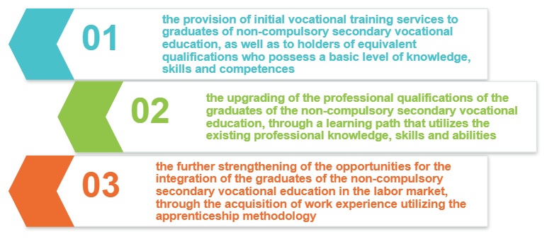
For the implementation of the Postsecondary year-Apprenticeship class, the needs of the labor market are taken into consideration, through the selection of Apprenticeship specialties. The selection of the apprenticeship specialties is made after a suggestion of the Central Council of Vocational Education and Training, with the contribution of the social partners using the same approach as in the Institutes of Vocational Training (I.E.K)
Laboratory course may also be carried out online using (synchronous or asynchronous distance learning methods) or a mixed type.
The Apprenticeship can be implemented in host institutions and production units located in the Member States of the European Union, while the access of certified graduates of EPAL Apprenticeship, as well as the certified graduates of I.E.K., to Higher Education is established, after taking entrance examinations.
Both public and private enterprises as well as social enterprises (KoinSep) may take part in the implementation of the Apprenticeship programme and may appoint a trainer for the trainees.
The school teachers (EPAL-ENEEGY-L) are responsible for the cooperation with the trainer of the enterprise, as regards each pupil’s progress, and cover any identified educational needs. The acquisition of knowledge and skills is achieved through constant feedback and offer the trainee the opportunity to enter the labour market as a licensed professional.
The school is responsible for allocating the pupils to the enterprises as well as for preparing them to join the enterprise learning course.

The pupils who participate in the Apprenticeship programme receive a compensation in the form of a wage which equals the 75% of the minimum wage of unskilled workers (under 25 years old). These pupils are also insured.

Specifically as regards pupils with disability, there are special provisions so that they have equal apprentice opportunities. They are supported by:
1. a second teacher of a same specialty from their Special Vocational Lower and Upper Secondary Schools during the lesson that takes place in the school lab once a week.
2. a social worker or a psychologist from the ENEEGY-L who visits the enterprise or the organization every day during the first week of the pupil’s placement at work and later once a week, to ensure the pupil’ s smooth adjustment in the work place and inform the employers about the reasonable adjustments to be made.

2.3 Key participants/partnerships
Both the National and the Strategic Action Plan are the result of systematic work of many stakeholders. Indicatively, in this regard, it is mentioned that the National Action Plan was set up under a special Technical Committee with members of the executive staff as well as political leadership officials from all the Ministries, taking into account:

A) The Convention on the Rights of Persons with Disabilities
(B) the comments of the UN Committee which examined the country with regard to the compatibility of its education system with the provisions of the Convention
(C) the key systemic dysfunctions but also the proposals and positions of disability organizations, the Ombudsman, the National Commission for Human Rights and representatives of civil society.
(D) the findings of the mapping of the existing situation carried out by the Special Technical Committee

Immediately after its drafting, the National Plan was put to an online public consultation. All proposals and comments submitted to the consultation were analyzed, communicated to all relevant bodies, studied, processed and used in the final text. At the same time, by decision of the Minister of State, the initial group was enlarged with more than 100 members, representatives of the political leadership and officials of all Ministries, as well as representatives of various bodies, All of whom were committed to the implementation of the National Plan. In this context, an extensive series of partnerships between Ministries, disability organizations and civil society have been designed and are currently being implemented to achieve the goals.

Similar consultation procedures are followed at all levels in the Ministry of Education as well, both at the level of formation and implementation of the Strategic Action Plan as well as for the implementation of multiple reforms at the level of general and vocational education. Indicatively in this regard, it should be mentioned that for the implementation of the sub-axes of the Strategic Action Plan for the Equal Access to Education of Persons with Disabilities, working groups have been created which, depending on the case, include representatives from:

- the political leadership officials as well as officials from all Secretariats General of the Ministry
- Education officials, teachers and special educational staff
- Organizations of Persons with Disabilities and Organizations of Parents with Children with Disabilities
- Universities
- The Institute of Educational Policy
- The Computer Technology institute & Press “DIOPHANTUS”
- The following Ministries:
-Ministry of Education and Religious Affairs
- Ministry for the Environment and Energy
- Ministry of Labor & Social Affairs
- Ministry of Health
- Ministry of Interior

3. DEVELOPMENT

3.1 Challenges, opportunities and lessons learned

3.1.1 Challenges
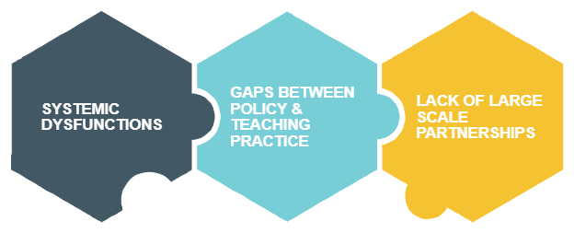
According to UNESCO (2015), inclusive education is an ongoing journey that questions societies' values and policies. In this context, the Strategic Plan for the Equal Access of Students with Disabilities to Education offers an interesting framework in which to promote democracy in education and points out that authorities, professionals and students should constantly and continuously embark on voyages of collaboration. These voyages seek to improve schools' capacities through the twofold aim of responding to diversity and of putting into effect inclusive values.

In this journey, 3 main challenges have had to be overcome:
1) The existence of a number of systemic “dysfuntions”. The dysfunctions which were highlighted by the Technical Committee, the United Nations Commission, the Ombudsman, the National Commission for Human Rights, the National Confederation of Disabled People and civil society included, for example the following:
a) There was a lack of strategy for the effective implementation of the Convention,
b) The national curriculum and its associated assessment systems were not designed to respond effectively to all learners,
c) There was not a clear role for special provision, such as special schools and units, in promoting inclusion and equity in education
d) Although governments are moving to address the issue of the education of children with disabilities, there is in some contexts a view of disability as being a “special/clinical” issue
d) There was a lack of Intraministerial and interministerial collaboration on issues of inclusion.
e) Inclusive provision for pupils with disabilities was fragmented and were linked only to a limited extent to other parts of the national education and training system.
      - The need to bridge the gaps that existed between educational policy and teaching practice in the field of inclusive education
      - The need to create large-scale partnerships and to raise awareness of all stakeholders and competent services both within the Ministry and in the wider community.

3.1.2 Key success factors
With regard to key factors that from our experience proved important in the implementation of the reform we can mention the following:
- At a theoretical level, a key success factor was the gradual development of a set of common principles on policies, practices, culture, which have helped us leave a series of outdated approaches that were embedded in the educational system and move towards reforms that have to do with responding to the diverse needs of all learners.
- At policy level, a key success factor was definitely the comprehensive way in which the reform was approached. The comprehensive way in which the reform was approached was a result of a clear political will at the government and the ministry level to make meaningful and systematic changes in the direction of inclusion.In this context the holistic approach of the new legislation and even more importantly the fact that Greece has currently and for the first time acquired two comprehensive policy documents setting clear and measurable targets for dealing with the complex issue of inclusion has proved to have an added value. The fact that the Strategic Action Plan of the Ministry encompasses both legislative reforms and investment projects has also helped approach the subject of inclusive education in a rounded way, encompassing both relevant legal reforms that should be considered with the passage of every new bill, and investment projects that should be included in every major investment package, whether through the EU’s structural funds (NSRF), the Recovery and Resilience Facility (RRF), or through domestic funding programmes.
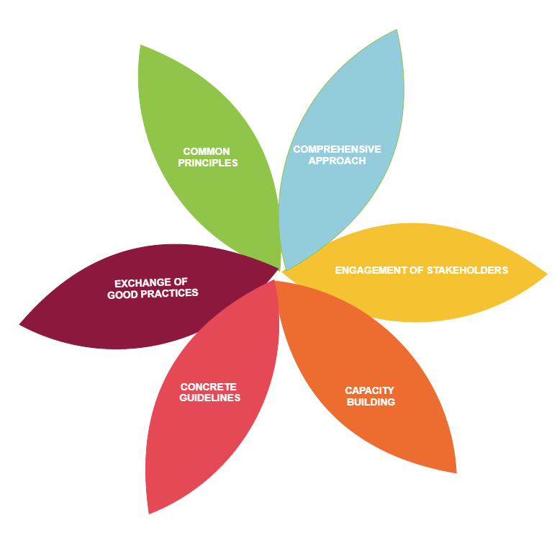
- Moreover, we believe that another key factor in initiating change has been the engagement and broad participation and collaboration that was achieved by all stakeholders, including public and private educational establishments, teachers' associations, professionals of the educational community, professional associations, parent and disability organisations, federations and civil society associations. The investment of teacher training and capacity building of relevant selected stakeholders, who in turn acted as multipliers within the educational community.
- At school level, the provision of clear, concrete guidelines to support schools in their strategic planning for inclusion.
- Last but not least, a key factor may be considered the opportunity we had to exchange ideas and identify good European practices in relation to inclusive education in the context of our networks and participation in actions organized by the European Committee and the European Agency for Special Needs and Inclusive Education.

3.2 Evaluation and plans to sustain/further develop the work.
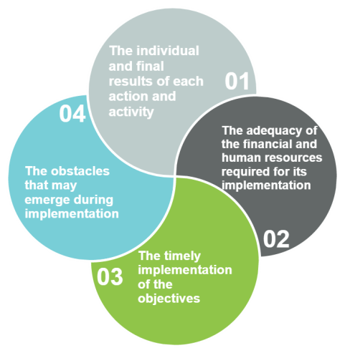
The Strategic Action Plan is monitored and evaluated in terms of its implementation by the competent Directorates of the Ministry of Education. The Directorates are in charge of planning and monitoring the implementation of the Strategic Action Plan various projects and actions. For the effective evaluation of the progress of the each objective, a supervisory framework for the implementation of the Strategic Plan has been setup with specific indicators. Based on these indicators, the following are examined and evaluated on a monthly basis:
(a) the results of each action and activity
(b) the adequacy of the financial and human resources required for its implementation,
(c) the timely implementation of the objectives; and
(d) the obstacles that may emerge during implementation.

The supervision results of the individual projects and actions are uploaded on the Integrated Information System for the Monitoring and Evaluation of the Government Work “MAZI" of the Prime Minister’s Office. In this way, the smooth and effective implementation of the objectives and actions of this Strategic Plan is ensured, as well as the coordination with the overall public policy of the country with regard to the Persons with Disabilities and the synergies with other competent Ministries.

A NOTE OF CONCLUSION
Diversity is a characteristic of human development. Therefore, inclusive education is linked to the recognition and appreciation of human diversity. It challenges us as citizens and as educators about what kind of society we want future generations to live in, how we all want to live together and what values underpin that purpose (Ballard 2013; Dyson, 2011)

