LUXEMBOURG

Prepared by:
Ms. Joëlle Faber and Mr. Lucien Bertrand

The information in this report was finalised May 2006

Contents

PREAMBLE 2
Definitions 2
Description 2
Educational policy on inclusive education 2
Admission to special schools is decided by a national commission (CMPPN – Commission médico-psycho-pédagogique nationale). 3

ASSESSMENT WITHIN THE EDUCATION SYSTEM IN LUXEMBOURG 4
1. Legal system for assessment 4
2. Implementation of assessment policy 4
3. Challenges and tendencies 4
4. Innovation and developments 5
5. Conclusions 5

ASSESSMENT PRACTICE IN LUXEMBOURG 6
1. Assessment in inclusive classrooms 6
2. People involved in assessment 6
3. Learning and teaching 6
4. Innovative assessment tools and methods 7
5. Conclusions 7

OVERALL CONCLUSIONS 7

FEATURES OF BEST PRACTICE IN INCLUSIVE PRIMARY SCHOOLS 8

Index of Key Terms 11

PREAMBLE

Definitions

Test: Individual written or spoken tests made in the classroom. Children have to learn at home and are tested at school. Tests generally are calculated on 60 points.
Evaluation: In school we call evaluation an act where the performance of a child is judged to a norm. Evaluation is made during the whole school year with tests in the different subjects. At the end of each term children get an end evaluation of their different works and tests (end of term report).
Assessment: No evident difference between evaluation and assessment in Luxembourg.
Diagnosis: If necessary made by specialised services (Service de Guidance de l’Enfance; Service Ré-Educatif Ambulatoire).

Description

In Luxembourg school is compulsory for children between 4 and 15 years. Parents can decide where their children should go (i.e. ordinary school, special school, private school …). But normally they go to the public school nearest to their home. Ordinary school is cost free for every child living in Luxembourg.

At the age of 3, children may go to “éducation précoce” (early education classes). But it is up to the parents to decide. Children are grouped in classes and learn by playing together with other children. The social aspect is very important in these classes.

From 4 to 6 years of age children go to “éducation préscolaire” (Kindergarden). Here they learn how to live, play and work together with other children. In these two years they can work with drawing, colours, scissors and several other games and exercises preparing them for writing, reading and calculating at primary school.

At the age of 6 they enter primary school for 6 years. They learn writing and reading, mathematics, biology, geography, history; they have gym, swimming, music and painting hours. We have Luxembourgish hours, but children learn to read and write in German. At the middle of the second year they also begin to learn French.

After 6 years of primary school children go to post-primary school. Normally this will be for 7 years, but it depends on the training young people choose (classical, technical or basic). Here they learn English and may choose other languages, but it depends on their orientation (i.e. scientific orientation, language orientation, …).

Educational policy on inclusive education

Parents, inspectors of primary education and teachers are invited to identify and report children with special needs to a local commission (CMPPR - Commission médico-psycho-pédagogique régionale).

The organisation of the participation of children with special needs in mainstream schools involves a functional diagnostic assessment based on multidisciplinary observations.
The law of June 28th, 1994 changed and completed former laws in favour of the participation of children with SEN in mainstream schools and of their social inclusion.

The Commission médico-psycho-pédagogique ensures a child is examined by experts. The same board selects one or more qualified persons in order to hear the parents or the responsible person’s opinion about the optimal education for the child. These qualified persons give the board a report of the results obtained. The board makes proposals of orientation for the child taking the reports into consideration. These proposals are passed on to the parents or the person responsible, who can decide among these possibilities in the two months following the proposals. If after this delay parents have taken no decision, the child can be admitted into an institution or service of special education by decision of the board.

In accordance with the law of 1994 the “Service Ré-Educatif Ambulatoire” (SREA) was created, which, in agreement with the inspector of primary education and the local authorities or the concerned director of post-primary schools, organises the support for these children who, because of their intellectual, motor, sensory or emotional difficulties, have special needs and require specific pedagogical help during their school time.

Admission to special schools is decided by a national commission (CMPPN – Commission médico-psycho-pédagogique nationale).

ASSESSMENT WITHIN THE EDUCATION SYSTEM IN LUXEMBOURG

1. Legal system for assessment

Primary school helps children to develop their aptitudes, attitudes, behaviour, competences and basic knowledge.

In Luxembourg teachers have to do regular tests at school to assess the children. The test results help themselves to orientate the pupil for the next school year. This means that they know if a pupil is to advance to the next class or if the pupil will have to repeat a year.

The tests are evaluated using 60 points. If pupils attain between 60 and 50 points it is a very good result. If they get between 49 and 40 points it is good, between 39 and 30 points the test is satisfactory. Scores between 29 and 20 are insufficient and under 20 points the test is poor.

In complementation to these tests teachers have the possibility to assess the children much faster. The evaluation points are an appreciation and are noted between 1 and 5, whereby 1 means very good and 5 means bad or insufficient.

At the end of each term a child gets his end of term report, where the average points for tests in each subject are calculated. The points of the appreciations may increase or pull down the average for some points. Separate evaluations exist between oral and written languages.

After one school year the average is calculated from the three end of term reports and if the child has 2 or more results less than 30 points it may be decided that she/he has to repeat the class.

2. Implementation of assessment policy

During the 6 years of primary school, pupils will do regular tests in the different subjects. The teacher evaluates their progression. In a non written rule it is said that you have to do as many tests per subject as the hours you teach it during one week. This means that if children have 6 hours of German per week, they will have to do 6 tests per term. In practice you can say that there is at least one test per week for all subjects combined.
Normally teachers tell the pupils what they have to learn a couple of days before the test. However it is not unusual that the pupils have to learn for every day and that the teacher gives a test without warning.

The results of the tests are often compared with results of the other pupils. Teachers calculate the average of the class. Sometimes they even write on every test how many pupils have points between 60 and 50 points, how many have between 49 and 40 points, etc. The pupil is compared to the other pupils in his/her class.

3. Challenges and tendencies

Tendencies in Luxembourg school system depend a lot on the attitude of the concerned minister. While former ministers thought “back to rules” was the best, nowadays they think that it is beneficial for all children to organise their work for themselves. It is still up to the parents to decide where their child goes to school, but actually the ministry tries to put classes of different levels on the same campus. This means that classes, who have pupils with SEN, are brought closer to mainstream classes.

Teachers also seem to be warming to the idea of inclusion. The work between SREA assistants and concerned teachers improves. Teamwork is accepted and considered as beneficial for the pupils. The multidisciplinary group of SREA (speech therapists, teachers, occupational therapists …) is helpful for the class teachers in their work with a pupil with SEN.

The main idea is to include pupils with SEN as much as possible in mainstream classes. The social contact shows that it is beneficial for both disabled children and healthy children.

4. Innovation and developments

During recent years the ministry has begun to reconsider the school system. The poor results from the PISA study might be responsible for this new tendency.

i. The first change is that a new end of term report in 2003/2004 was introduced for children aged 6 and 7 years. Normally teachers note only the average of every subject, but actually they have to add other skills, such as attitude to work, participation, concentration, co-operation in group work, and respect of rules. Teachers have to consider how the pupil affronts difficulties, manage his time, listen to explications, does corrections and homework.

At the end the teacher and the support personal also have the possibility to add some personal comments on the pupil’s work in class.

The new end of term report is considered as a communication tool between parents, children and school. It describes the pupil’s performances in relation to a list of targets and his/her school career.

ii. Team teaching classes with 3 teachers in 2 classes (for the moment only in some classes in the first and second year of primary school) are newly organised so now teachers have more possibilities to help pupils with specific problems. The pupils work in groups but with the possibility of being taught more individually thanks to a better support for each pupil.

5. Conclusions

New ways in organising schools have opened up. It means less tests, less books, less subjects and more involvement of pupils, more personal initiative and more active co-operation.

ASSESSMENT PRACTICE IN LUXEMBOURG

1. Assessment in inclusive classrooms

The most important difference between pupils with SEN and non SEN pupils is that for the first group specialists organise an educational plan (IEP) at the beginning of the school year. Aims to reach during a year are defined with the goals to reach. No rules exist on how and when these children at the end of the year have to be tested. Normally at the beginning of each school year the teacher, the SREA assistant and the parents decide, by working together, how to assess the child at school.

During the whole school year and especially at its end, teachers, parents and the SREA assistant discuss the child’s situation. They find out whether or not the individual educational plan was reached. If not, to find the reason for this. The discussion turns also towards the next school year, should the child repeat the same year or not. It is decided if the same way should be continued or not. If there are problems during the year or different opinions between the people involved, they may ask help from the school inspector and a responsible person from SREA. Together they try to find solutions to these problems.

Pressure from parents concerning assessment is not increasing because the official assessment of the pupil’s performances is rather comparative for children without SEN. For children with SEN, professionals (of SREA) use a descriptive form of assessment. This description is added as an integrative part to the assessment booklet of the child.

Assessment of pupils with SEN is used for all the skills that can be trained with a particular pupil. No comparison is made between the different pupils with SEN.

2. People involved in assessment

The main people involved in assessment are the teacher and the pupil. In case of disagreement parents or other specialists get involved.

If this occurs, it is a benefit to the child that his/her parents are in contact with the teacher to discuss the reasons for the problems and how they can be solved.

The teacher thinks that he/she remains the captain of the ship in the classroom, but more and more legal rules intend to give the responsibility to a pedagogical team. So the teacher refers for assessment mainly to the assistants of the pupils with SEN.

Teachers have no particular role in diagnosis which is left to regional centres for psycho-pedagogical diagnosis and the responsibility of diagnosis is left to this external team.

Parents of pupils with SEN are more involved. They are advised as to what they can do at home to promote the child’s development. Teachers and the SREA assistants notice better results when parents are involved in the work with the pupil.

3. Learning and teaching

Even if teacher led/directed (frontal) teaching is still a widespread method of teaching in Luxembourg, we have observed that more and more teachers are changing their attitude and involving the pupils in the organisation of their lessons. This means also that team teaching is going to be more popular. The objective is to get the pupil more involved. The teacher will not be the principal actor in the class; the pupils will also be responsible for what is going on in the classroom.

In general we can say that teaching is no more the most important part of schooling, learning is more important. Teachers are still the leaders, but the pupils are not only the receivers of information, they have to co-operate and search themselves for getting answers to their questions. In groups they pick up information, help each other and learn together. Everybody is involved and no pupil is left behind. This helps to create a better group feeling and the pupils learn how to help each other to reach an aim.

4. Innovative assessment tools and methods

In Luxembourg having many tests at school is still a very normal thing. We have only just started thinking about other methods of assessment. This will be a long and difficult way and it will not be easy to persuade the politicians and the population of Luxembourg. The idea is linked to the methods and approach of differentiating teaching. Pupils get more involved in the school’s organisation; it is also their “job” to self-assess themselves by writing a portfolio. From the beginning of their school career they are given more responsibility just by the fact that they take an active part in their schooling.

5. Conclusions

It is rather hard to draw a conclusion of the new tendencies in Luxembourg’s schools. In fact we have only now started re-thinking teaching and assessment methods. For the moment we don’t have any concrete results of this new way of teaching.

OVERALL CONCLUSIONS

Differentiating methods are being applied more and more in Luxembourg’s schools. This means that the assessment of pupils must also be seen in a differentiated way. The new concept gives each pupil the chance to attend the same school as all other children.

FEATURES OF BEST PRACTICE IN INCLUSIVE PRIMARY SCHOOLS

The End of Term report in Luxembourg

In the first class every pupil is given a booklet where the results of each school year will be noted. The book stays with the child during the 6 years (or more) of primary school. It is an official document with a description of the pedagogical goals of each school year.
Examples: a goal of the first two school years is to be able to count to 100; another is to be able to copy a written text.

For each school year you have two pages: One where the teacher expresses in marks (between 0 and 60) the pupil’s results in the different subjects and a second one where the teacher or the assistant gives some comment. This second page is not compulsive. The teacher and the assistant from SREA always have the possibility to add some personal notes to the results in the booklet on a separate sheet.

For a better understanding please find here an example of a Year 3 report:
The pupil’s each end of term results:
- The 3 principal subjects: German, French and mathematics. For languages a first assessment is made for oral work (understanding, expression and reading), a second on writing (expression and managing of the language). In mathematics teachers assess the pupil’s capacities in numbers, measuring of lengths, surfaces and volumes.
- Other secondary subjects: science, Luxemburgish, painting, handicrafts, music, sports and religious or non religious course.

- Behaviour of the pupil: The teacher has a scale where he/she can choose between “often” or “rarely”. Assessment is done according to different items:
- Does he/she respect the rules of common living?
- Does he/she partake socially in class?
- Is he/she attentive and participating in work?
- Does he/she take an active part in group work?
- During individual work does the pupil try to solve problems by him/herself, is the pupil able to organise their own time, does the pupil listen to the teacher, does the pupil correct their faults and does he/she do their homework?
- And finally the teacher has to assess whether the pupil takes care with writing and respects school material.

This official end of term report is signed by the teacher and is given to the pupil’s parents for their signature. Parents can then see the child’s progression. This is unfortunately not always used to adapt assessment to the needs of each child. For pupils with SEN the assessment booklet is a part of the educational plan for the next term or school year.
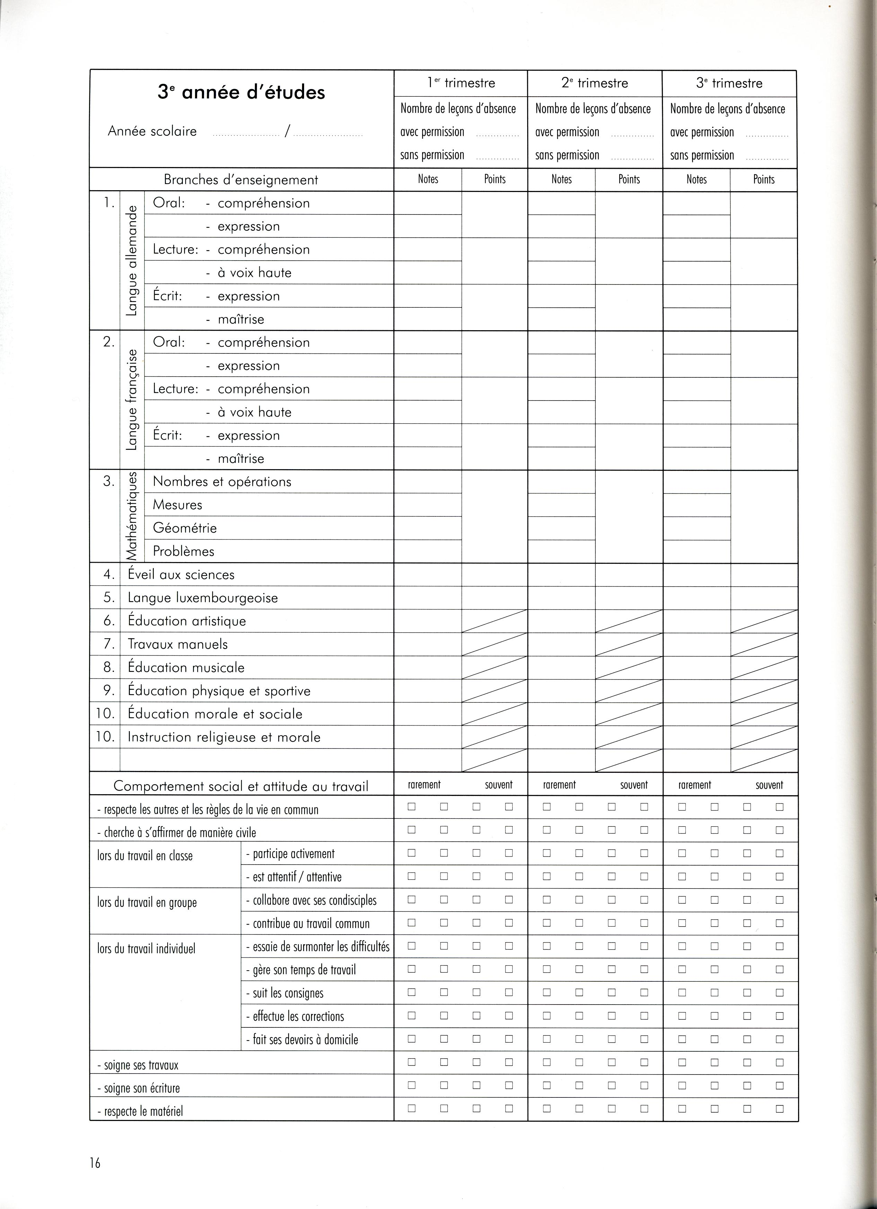
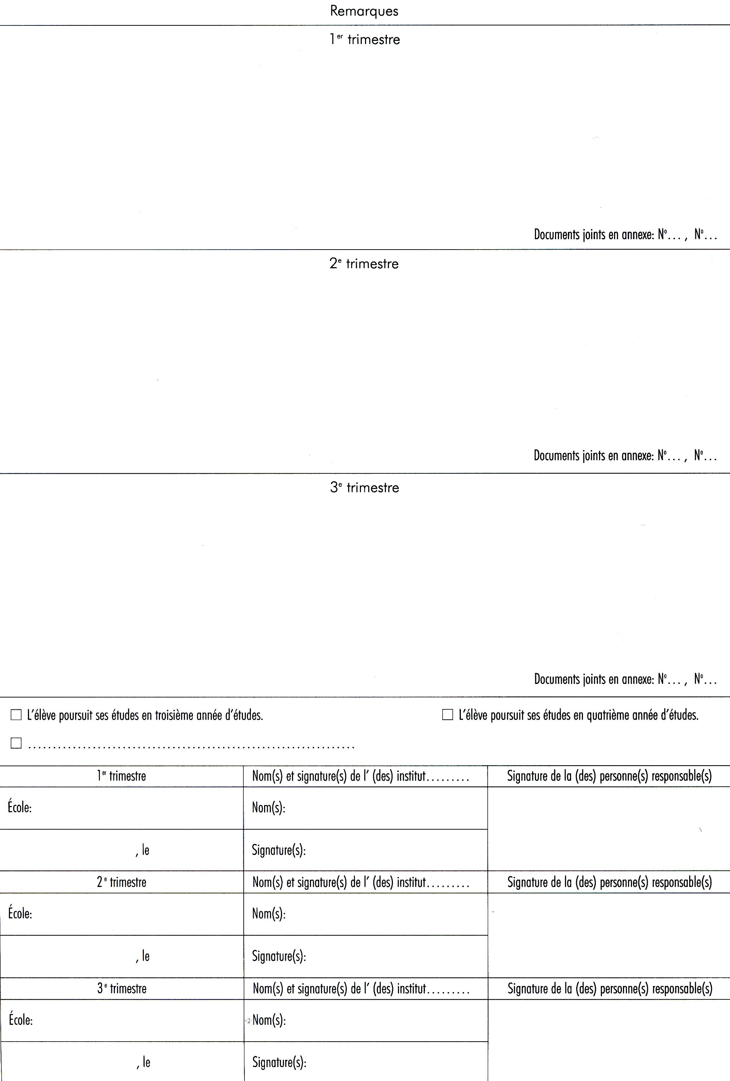

Index of Key Terms

Diagnosis, 2, 6

Evaluation, 2
IEP, 6

Parents, 2, 6, 8
PISA, 5
portfolio, 7

self-assess, 7

teachers, 2, 4, 5, 6, 8
Test, 2

